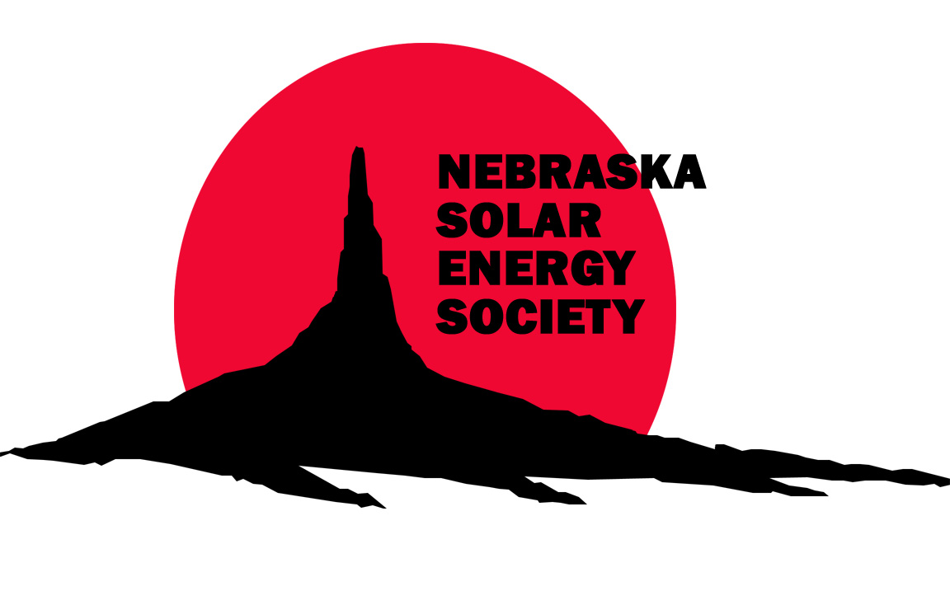
Nebraska Solar Energy Society – NSES
517 N. 74 Street
Omaha NE 68114

Contact:
Gary Boe
402-321-2797
g.boe@cox.net
http://www.ceen.unomaha.edu/nses/

NSES
Membership
Application

____________________________
Date
___________________________ ____________________________
Name Telephone: work and/or home
___________________________ ____________________________
Address email address
___________________________ ____________________________
City / State / Zip Company name: Contributor / Corp

Membership: (circle one) Corporate Sponsorships: $200 +

Student $10 Individual $15 Family $25 Business (< 10 employees) $100

If you would like to offer your time as a volunteer, tell us your areas of interest:___________________________________________________________________________________________________________________

Please send your check made out to "NSES" to the address above.
Retain the receipt below and the cancelled check for tax purposes.

RECEIPT FOR: THE NEBRASKA SOLAR ENERGY SOCIETY – NSES

NSES is a nonprofit incorporated in Nebraska.

Membership level: $_________

___________________________ ___________________________
Name Date

