SPIRIT 2.0 Lesson:
Product Disassembly

===============================Lesson Header==============================
Lesson Title: Product Disassembly
Draft Date: December 29, 2008
1st Author (Writer): Lisa Tingelhoff
2nd Author (Editor/Resource Finder): Derrick Nero
Grade Level: Middle School

Content (what is taught):
- Technological systems
Context (how it is taught):
- Students will be given definitions of six common systems: electrical, mechanical, chemical, thermal, hydraulic and pneumatic.
- Students will be asked to find examples of each type of system in their daily lives.
- Students will conduct a product disassembly project by which they will identify various systems found in common objects.
Activity Description:
This lesson will begin with assessing students’ prior knowledge of how common items work. Students will then receive an introduction to common technological systems. Students will use the introduction to explore their world and to identify examples of each type of system in their daily lives. Groups of students will be given a product to disassemble and will identify systems within the product. Finally, students will identify how various biological systems relate to common technological systems.

Standards:
- Science—B1, B3, E1
- Technology—A3, B1, F1

Materials List:
  - Common objects (car jack, clock and bike)
  - Digital camera
  - Discarded products for disassembly (fans, alarm clocks, computer towers, coffee pots, hair dryers, etc.)

ASKING Questions (Product Disassembly)

Summary:
In this activity, students will examine how things work.

Outline:
- Present students with various common objects and ask the students to write a description of how the object works.

Activity:
This activity will activate students’ prior knowledge of how objects in their world work. During this introductory experience, students will be presented with various common objects and be asked to write a description of how the object works. Allow students to share their descriptions as their understanding may differ significantly from one another. At this point, it will not be necessary to confirm any description.

Questions | Answers
How does a car jack work? | Answers will vary depending on prior knowledge.
How does a clock work? | Answers will vary depending on prior knowledge
How does a bike work? | Answers will vary depending on prior knowledge

12
3
6
9
1
2
4
5
7
8
10
11
EXPLORING Concepts (Product Disassembly)

Summary:
Students will disassemble a product to examine how it functions.

Outline:
- Groups will choose their product from the selection available (fans, alarm clocks, computer towers, coffee pots, etc.)
- Groups will carefully disassemble their product.
- Groups will document the disassembly in their engineering notebook through drawings and writing as well as by taking digital pictures of the disassembly process.

Activity:
This activity will allow students to disassemble a common object and examine how it works. Students will work in groups to complete this project. Students will document in their engineering notebook the step-by-step disassembly with both words and pictures. Each group will also have a digital camera available to document the disassembly process (to be used as an extension possibility). Students should label known parts during documentation of the disassembly.

Product Disassembly Worksheet
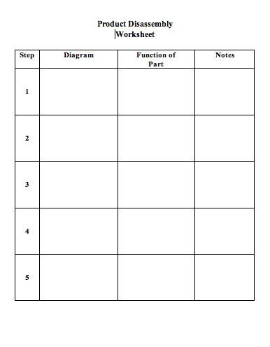
INSTRUCTING Concepts (Product Disassembly)
Technological Systems
A technological system is a group of interrelated components designed collectively to achieve a desired goal. There are six main types of technological systems. Often more than one system is present in a piece of technology. Take a car for instance there are mechanical (steering/gears/etc), electrical (create/deliver electricity), chemical (battery), thermal (cooling), pneumatic (shock absorbers), and hydraulic (steering) systems in place. Below is a definition of these basic technological systems.

Electrical System
An electrical system is a system of wiring, switches, and power associated with receiving and distributing electricity. Any object that uses electricity will have an electrical system. This includes all electric appliances, vehicles with an engine, the power grid, etc. In your car the electrical system delivers electricity to the sparkplug that ignites the gasoline.

Mechanical System
A mechanical system a system of simple machines associated with controlling motion or forces. If an object uses or transfers mechanical energy a mechanical system is present. This includes ventilation systems, assembly lines, bicycles, etc. Your car has many mechanical systems including the steering, drive train, and wheels and axles

Chemical System
A chemical system is a system that relies on chemical reactions to achieve a desired goal. These systems are not as well known as some of the other systems. Examples include batteries, film, photosynthesis in plants, and many common household cleaners. Your car battery is a chemical system because it uses a chemical reaction to create electrons.

Thermal System
A thermal system is a system that transfers heat from one point to another. These systems most commonly are found in places where temperature is regulated like air-conditioning units, boilers, humidification systems, and fans. In your car a thermal system is the radiator/cooling system that maintains engine temperature.
Hydraulic System
A hydraulic system is a system that uses fluid pressure to control motion or forces. These systems use high-pressure fluid to create mechanical advantage. They are employed in hydraulic cylinders, backhoes, car brakes, and garbage compactors. In your car there are two major hydraulic systems: brakes and steering.

Pneumatic System
A pneumatic system is a system that uses air pressure to control motion or forces. These systems use high-pressure air to create mechanical advantage. They are employed in tire changing machines, dentist drills, hand air tools, and vacuum cleaners. Your car uses air pressure inside of the shock absorbers to reduce the impact from driving on rough roads.
ORGANIZING Learning (Product Disassembly)

Summary:
Students will record common technological system terms and definitions as well as daily life examples on a graphic organizer. They will then revisit their object and try to identify examples of technological systems. Finally, they will take their organizer home and look for examples there.

Outline:
- Students will use a graphic organizer to record common terminology, definitions, and class examples.
- Students will add to the graphic organizer by collecting examples that they find in their daily lives.

Activity:
Students will record teacher given definitions and examples on a graphic organizer. The teacher will present the information using an overhead projector or computer and LCD projector. As instruction is given, a discussion will be held that gives examples of each type of system. After completing the instruction, disassembly groups will revisit their object and work to identify examples of each system. Groups will document and take digital pictures of each identified system (to be used as an extension possibility). At the conclusion of the discussion, students will be asked to take the graphic organizer home and collect other examples of each system (at least 2 for each type of system).

Extension:
Upon completion of the disassembly portion of the project, groups will assemble a digital presentation of their findings that describes how the object works and that identifies systems of their object.

Robotics Connection:
To further the discussion of technical systems, ask students to examine the CEENBot and identify its different systems.

Common System Terminology
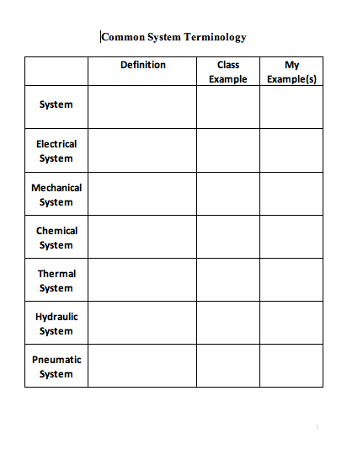

UNDERSTANDING Learning (Product Disassembly)

Summary:
For this activity, the teacher will ask students to relate common technological systems to systems of the human body.

Outline:
- Students will review the six common technological systems: electrical, mechanical, chemical, thermal, hydraulic, and pneumatic.
- Teachers will ask students to relate these technological systems to the systems of the human body through a written essay.

Activity:
Formative Assessment
As students work through the project, ask the following questions:
- How is this component an example of a ____________ system?
- What is a ________________ system?
- Can you give me an example of a ______________ system?

Summative Assessment
Students will write a five-paragraph essay that relates three common technological systems to systems of the human body. The essay will have a clear introduction, three body paragraphs, and a conclusion. Examples of essay topics include the following: pneumatic/respiratory, mechanical/skeletal/muscular, electrical/nervous, etc.

Robotics Connection:
Students will write a technical essay that identifies and explains at least three systems that are found on the CEENBot. The students will then relate these systems to the systems of the human body as part of the technical essay.

