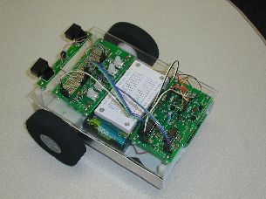 | The SPIRIT Project  Educational Robotics  Lesson Building Block Template  Author: _____________________________  Grade Level: ____ Date: ______________

Directions: The SPIRIT Institute is striving to put “lesson building blocks” up on the web for the potential use of teachers to help them prepare more formal educational lessons using the TekBot. A lesson building block is in essence an educational activity idea that might be turned later into a more formal classroom lesson by a creative teacher.

I. Concepts (Give a list of one or more concepts that might be taught using this activity)

II. Standards
(Give a list of one or two local, state or national standards that appear to apply)

III. Learning Activity Context (Describe the overall context for the learning activity)

Context: __ Moving TekBot __ Building a TekBot __ Engineering / Notebook __ Other
Abstract: (Give a 1 paragraph abstract of the activity)

IV. Teacher and Student Suggestions/Tips
(Provide some general tips or suggestions for trying the activity)

V. Teacher Questions
(Give a list of questions that teachers might ask students during the activity)

VI. Assessment Ideas
(Give an idea or two about how the lesson activity might be assessed)

VII. Other Information
(Give any other information that might be useful or a visual or two)

Note: Completed lesson building block drafts need to be e-mailed to Bill Schnase in a word-processing format for an initial editing and peer review process. The edited building blocks will then be posted to the SPIRIT website.

