Programming the CEENBoT Challenge Solutions

Challenge - Robot Geometry
What geometric shape can you make?
- Triangle? Square? Star? Circle? Figure Eight?
- Can you use modules and loops to simply the progarmming?

Challenge - Modular Path Follower
Can you program the robot to follow a path created from modular sections
- Tape a path on the floor made of segments of a given length. (0.3 m)
- Include turns that are multiples of a given angle. (45 degrees)
- Calibrate modules to move the given length or turn the given angle
- Create a main module to call the move and turn modules in the proper order to complete the path.

Challenge - Robot Snow Plow
Create a program to clear the "driveway" of "snow".
- The "driveway" is an area 3 feet by 5 feet that is taped off on the floor.
- For "snow" use wads of paper or other objects that are randomly placed on the "driveway".
- You may choose the location to start and when to stop your robot "snow plow".
Hint: If you use paper wads as snow, you may notice the snow gets stuck under the wheels. You may need to modify the front of the CEENBoT using cardboard and tape to better push the "snow", or you can program the CEENBoT to plow the driveway backwards.

Additional Programs
These programs illustrate advanced programming methods and robot behaviors. If you have some programming experience, you may wish to try programming these as challenges. If you are relatively new to programming, you may wish to use these programs as examples. Solutions are given after problem statements.

Zeno's Paradox
A runner in a 100 m race must run half way (50 m), then they must run half the remaining distance (25 m), then half of that remaining distance, and so on. If you assume the runner must take a finite amount of time to travel a given distance, and if you can keep dividing the distance in half forever, then you conclude the runner will take an infinite amount of time to complete the race.
Can you program the robot to move according to Zeno's Paradox?

Object Avoidance
The robot has infrared sensors on the front to detect objects. The robot can move forward until it detects an object. The robot moves in the freerunning mode until a proximity sensor is activated. To avoid the object the robot could backup enough to allow it to turn, do a spin of a random angle, and then continue moving until the next object is encountered.
Can you program the robot to use the sensors and a random spin to avoid objects?
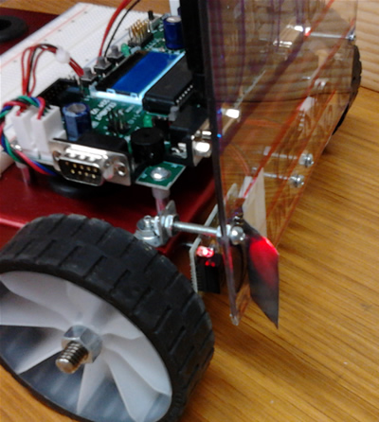
Wall Follower
Infrared waves are electromagnetic waves like the visible light we can see. Infrared waves behave like visible light in many ways including reflection. In this program you are to get the robot to follow a wall by taping a shiny piece of aluminum foil in front of the infrared sensor to reflect the infrared waves sideways. As the robot travels parallel to a wall it will sense the wall when it moves close to the wall. Program the robot to turn toward the wall when it does not sense the wall, and to turn away from the wall when it does sense the wall. In this way the robot will follow the wall.
Can you program the robot to follow a wall?

Robot Pachinko
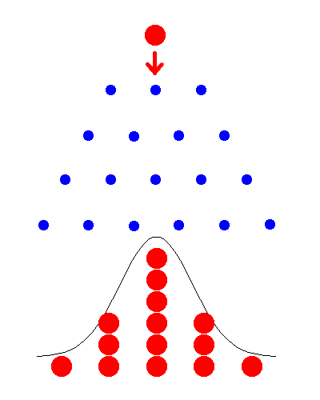
Pachinko is a Japanese game where balls dropping onto an alternating array of pegs are diverted to the left or right of each peg. For a large number of balls, if you count how the balls exit the array of pegs, the resulting counts will follow a normal distribution. Using a loop, a random number, and a conditional statement, the robot can be programmed to follow the path of a ball though a pachinko machine. Inside the loop, get a random number that is either 1 or 2, check the random number with a conditional and when it equals 1 go to the right, otherwise go to the left.
Can you program robot pachinko?

Random Walk
The random walk is an important mathematical model for processes such as the path of a molecule through a liquid or gas, the search path of a foraging animal, or the fluctuating price of a commodity. There are many different random walks that could be used for the robot. You might try having the robot move randomly in any one of four directions: ahead, back, left, or right.
Can you program a four directional random walk?

Robot Cruise Control
Some automobile cruise controls use sensors to monitor the cars in front and behind and to adjust the speed to keep a safe distance. A maximum speed limit can be set like any cruise control, but in heavy traffic the sensors can moderate the speed to match the surrounding cars. Using the front sensors, speed up the robot to a maximum when there is nothing in front of the robot, and slow down the robot when there is something sensed.
Can you program the robot cruise control?
Additional Programs - Descriptions
You can use the program descriptions below to help you create the additional programs. You might try looking at the pseudo code first to get the idea of how the program might be structured, and that may be enough. A possible solution to each program is also included which you can try as well.

Zeno's Paradox
- Create numeric variables for switch S4 status and Zeno distance (e.g. statusS4 and zenoDist)
- Go to the wait for switch S4 module
- Go to the Zeno movement module
- Set the initial Zeno distance to a value like 64
- Use a conditional loop that continues while Zeno distance is greater than zero
- Inside the loop, use the math tool to divide the Zeno distance by 2
- You can display Zeno distance using brackets on the variable: [zenoDist]
- Also inside the loop, move the robot forward using the Zeno distance
- When the loop ends, the robot should be stopped

zeno_main | waitS4 | goZeno
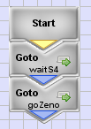 | 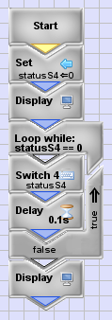 | 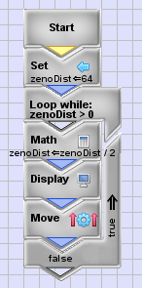
Object Avoidance
- Create numeric variables for switch S4, IR sensor status, and a random number (e.g. statusS4, eitherIR, and randomNum)
- Go to the wait for switch S4 module
- Go to the object avoidance module
- For object avoidance, use an infinite loop to continue avoiding objects forever
- Inside the infinite loop, start the robot moving in freerunning mode and then go to the wait for sensor module. Once the sensor is activated, go to the random spin module to backup and spin the robot a random amount.
- To wait for the sensor, the module should first set the IR sensor status variable to zero, then use a conditional loop that will continue while the IR sensor status variable remains zero, that is, the sensor is not activated.
- The random spin moves the robot backwards, assigns a random number to a variable, then uses the random number variable as the distance to move the robot wheels forward and backward to spin the robot a random amount.

avoidance_main | loopAvoid | loopSensor | randomSpin
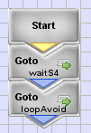  Note: The waitS4 module is not shown but can be found in Zeno's Paradox | 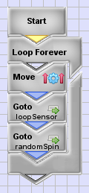 | 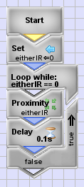 | 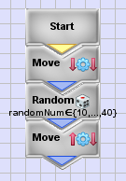

Wall Follower
- Create variables for the status of switch S4, left proximity, and right proximity, and create variables to be used a constants for a slower and faster speed.
- The slow and fast speeds are used to turn the robot toward or away from the wall, so set values that are close like a slow speed of 46% and a fast speed of 54%.
- In the main you can use an infinite loop to run this program over and over, just go to the switch wait module and then the follow wall module from inside the loop.
- The follow wall module can use the left sensor to stop the robot. You set the left IR status variable to zero then use a conditional loop to continue while the left IR status variable stays zero. When the left sensor is activated we want the robot to stop. To do that, after the loop, use a move with no speed or distance.
- The select move module checks that status of the wall following sensor, the one with the aluminum reflecting the IR to the right. The module will check the status of the right proximity sensor, delay at bit (50 microseconds) to allow the variable to be assigned the value, then will use a conditional to select a move command.
- If we detect the wall on the right, we want to turn away, so use the slow speed variable for the left motor speed and the fast speed for the right motor speed.
- If we do not detect the wall on the right, we want to turn toward the wall, so use the fast speed on the left motor and the slow speed on the right motor.

wallFollower_main | waitS4 | followWall | selectMove
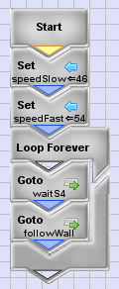 | 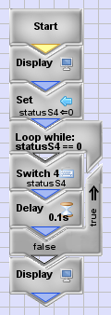 | 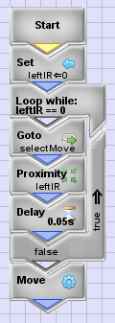 | 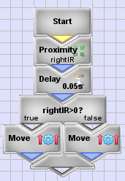

Robot Pachinko
- Create variables for switch S4 and either IR proximity status, and the random value, and create variables as constants of distance, speed, and turn values.
- The distance, speed, and turn values are used to move the robot like the pachinko balls, turning left or right randomly and moving the distance forward. Making these values constants makes it easy to adjust the robot movement.
- Use a conditional loop that with continue while either IR sensor is not activated this way the robot will stop when it encounters an object. Inside the loop assign a random number of 1 or 2 to the random value variable and check the value with a conditional statement. If the value is 1 go left, otherwise go right. Check the proximity sensor just before the end of the loop and add a small delay to allow the values to be assigned. When either IR proximity sensors activate the loop will end and a move command after the loop will stop the robot.
- To go left, display the message "Go Left", then have the left wheel go backwards the turn distance and the right wheel go forward the turn distance, then move both wheels forward the distance value, then reverse the turn. To go right do the opposite of what was done to go left.

pachinko_main | loopSelect | goLeft | goRight
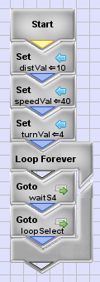 | 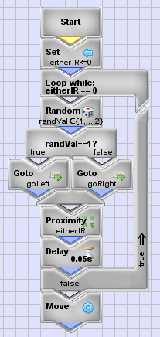 | 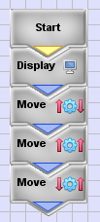 | 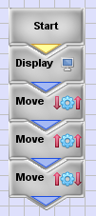

Random Walk
- Create variables for the switch S4 status, the random value, and create variables as constants of distance, speed, and turn values.
- The turn value should make the robot turn 90 degrees when the value is used for distance in making the left motor and right motor move in opposite directions.
- The loop select module uses an infinite loop to make steps in random directions. First a random value is used with a conditional to decide to go in the current robot direction (ahead or back), or to turn before moving (left or right). Nested inside of the first conditional result is another random value and conditional to select the way the robot should actually move, that is to pick ahead or back, or to pick left or right.
- You can define modules for each motion: ahead, back, left, and right. The ahead or back modules will move the robot forward or backward using the distance value constant. The left or right modules will turn the robot left or right using the turn distance value, turning the wheels in opposite directions, then the ahead module could be used to move the robot after the turn.

main | loopSelect | move
 | 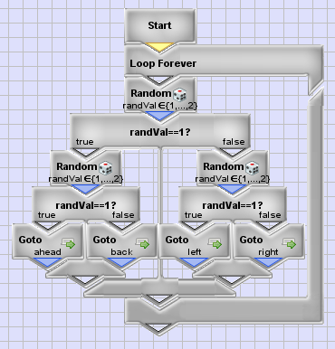 | ahead  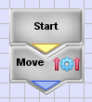  left  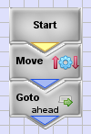

Robot Cruise Control
- Create variables for switch S4 and either IR status, create a variable for speed which will be a changing value, and create variables for the speed change (speedDelta) and speed maximum (speedMax) which will be constant values.
- The main module uses the module to wait for switch S4 then starts the module with the follower loop.
- The follower module initializes the either IR and speed values to zero and sets the speed change (speedDelta) and maximum speed (speedMax) values. In the follower module an infinite loop is used to continue the follower action. Inside the loop the proximity check module is used, and then a freerunning forward move command is used that sets the motor speeds to the value in the speed variable.
- The proximity check module will change the speed depending on the IR sensors, if either IR sensor is activated, the speed will be reduced, otherwise the speed is increased. A nested conditional will check the speed change so that if the speed was made less than zero it will be set to zero, and if the speed became greater than the maximum speed (speedMax) then the speed will be set to the maximum.

main | loopFollower | checkProximity
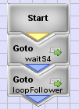 | 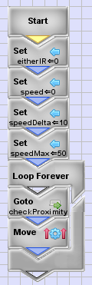 | 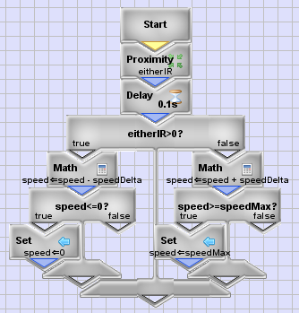

Additional Programs - Possible solutions
You can use the pseudo code or the possible program solutions below to help you create the additional programs. You might try looking at the pseudo code first to get the idea of how the program might be structured, and that may be enough. A possible solution to each program is also included which you can try as well.

Zeno's Paradox
- Create numeric variables for switch S4 status and Zeno distance (e.g. statusS4 and zenoDist)
- Go to the wait for switch S4 module
- Go to the Zeno movement module
- Set the initial Zeno distance to a value like 64
- Use a conditional loop that continues while Zeno distance is greater than zero
- Inside the loop, use the math tool to divide the Zeno distance by 2
- You can display Zeno distance using brackets on the variable: [zenoDist]
- Also inside the loop, move the robot forward using the Zeno distance
- When the loop ends, the robot should be stopped

zeno_main | waitS4 | goZeno
Object Avoidance
- Create numeric variables for switch S4, IR sensor status, and a random number (e.g. statusS4, eitherIR, and randomNum)
- Go to the wait for switch S4 module
- Go to the object avoidance module
- For object avoidance, use an infinite loop to continue avoiding objects forever
- Inside the infinite loop, start the robot moving in freerunning mode and then go to the wait for sensor module. Once the sensor is activated, go to the random spin module to backup and spin the robot a random amount.
- To wait for the sensor, the module should first set the IR sensor status variable to zero, then use a conditional loop that will continue while the IR sensor status variable remains zero, that is, the sensor is not activated.
- The random spin moves the robot backwards, assigns a random number to a variable, then uses the random number variable as the distance to move the robot wheels forward and backward to spin the robot a random amount.

avoidance_main | loopAvoid | loopSensor | randomSpin
Note: The waitS4 module is not shown but can be found in Zeno's Paradox

Wall Follower
- Create variables for the status of switch S4, left proximity, and right proximity, and create variables to be used a constants for a slower and faster speed.
- The slow and fast speeds are used to turn the robot toward or away from the wall, so set values that are close like a slow speed of 46% and a fast speed of 54%.
- In the main you can use an infinite loop to run this program over and over, just go to the switch wait module and then the follow wall module from inside the loop.
- The follow wall module can use the left sensor to stop the robot. You set the left IR status variable to zero then use a conditional loop to continue while the left IR status variable stays zero. When the left sensor is activated we want the robot to stop. To do that, after the loop, use a move with no speed or distance.
- The select move module checks that status of the wall following sensor, the one with the aluminum reflecting the IR to the right. The module will check the status of the right proximity sensor, delay at bit (50 microseconds) to allow the variable to be assigned the value, then will use a conditional to select a move command.
- If we detect the wall on the right, we want to turn away, so use the slow speed variable for the left motor speed and the fast speed for the right motor speed.
- If we do not detect the wall on the right, we want to turn toward the wall, so use the fast speed on the left motor and the slow speed on the right motor.

wallFollower_main | waitS4 | followWall | selectMove

Robot Pachinko
- Create variables for switch S4 and either IR proximity status, and the random value, and create variables as constants of distance, speed, and turn values.
- The distance, speed, and turn values are used to move the robot like the pachinko balls, turning left or right randomly and moving the distance forward. Making these values constants makes it easy to adjust the robot movement.
- Use a conditional loop that with continue while either IR sensor is not activated this way the robot will stop when it encounters an object. Inside the loop assign a random number of 1 or 2 to the random value variable and check the value with a conditional statement. If the value is 1 go left, otherwise go right. Check the proximity sensor just before the end of the loop and add a small delay to allow the values to be assigned. When either IR proximity sensors activate the loop will end and a move command after the loop will stop the robot.
- To go left, display the message "Go Left", then have the left wheel go backwards the turn distance and the right wheel go forward the turn distance, then move both wheels forward the distance value, then reverse the turn. To go right do the opposite of what was done to go left.

pachinko_main | loopSelect | goLeft | goRight

Random Walk
- Create variables for the switch S4 status, the random value, and create variables as constants of distance, speed, and turn values.
- The turn value should make the robot turn 90 degrees when the value is used for distance in making the left motor and right motor move in opposite directions.
- The loop select module uses an infinite loop to make steps in random directions. First a random value is used with a conditional to decide to go in the current robot direction (ahead or back), or to turn before moving (left or right). Nested inside of the first conditional result is another random value and conditional to select the way the robot should actually move, that is to pick ahead or back, or to pick left or right.
- You can define modules for each motion: ahead, back, left, and right. The ahead or back modules will move the robot forward or backward using the distance value constant. The left or right modules will turn the robot left or right using the turn distance value, turning the wheels in opposite directions, then the ahead module could be used to move the robot after the turn.

main | loopSelect | move
ahead

left

Robot Cruise Control
- Create variables for switch S4 and either IR status, create a variable for speed which will be a changing value, and create variables for the speed change (speedDelta) and speed maximum (speedMax) which will be constant values.
- The main module uses the module to wait for switch S4 then starts the module with the follower loop.
- The follower module initializes the either IR and speed values to zero and sets the speed change (speedDelta) and maximum speed (speedMax) values. In the follower module an infinite loop is used to continue the follower action. Inside the loop the proximity check module is used, and then a freerunning forward move command is used that sets the motor speeds to the value in the speed variable.
- The proximity check module will change the speed depending on the IR sensors, if either IR sensor is activated, the speed will be reduced, otherwise the speed is increased. A nested conditional will check the speed change so that if the speed was made less than zero it will be set to zero, and if the speed became greater than the maximum speed (speedMax) then the speed will be set to the maximum.

main | loopFollower | checkProximity

