Delay, LED, and Move Tools
Remember that programs start immediately after being downloaded, or after the CEENBoT power is turned on, or after the reset button is pressed. You may wish to include a delay at the start of your program so the CEENBoT will wait a second or two before starting to move.
The LED tool can be used to provide visual feedback of the program. You can set (turn on), clear (turn off), or toggle (change) the red or green LEDs located near the reset button. The Move tool is one of the more complicated tools since it has many different options and modes. You can set the direction, distance, and speed of each motor. You can also specify the run mode as blocking, non-blocking, or freerunning.
Use the Move tool blocking mode when you want the move command to use the full distance specified, like if you want to make a geometric shape or solve a maze. The sample program below shows movement with the blocking mode and use of delays and LED changes.

Program Description
- Start with no variables defined
- Delay 500 milliseconds
- Set the green LED
- Move both motors forward 30 deci-revs with a speed of 50 and use the blocking mode
- Delay 500 milliseconds
- Toggle both LEDs to turn off green and turn on red
- Move motors in opposite directions 30 deci-revs with a speed of 50 using blocking mode
- Delay 500 milliseconds
- Clear both LEDs to turn them off
- Move both motors forward 0 deci-revs with 0 speed to stop the robot even if using non-blocking or freerunning

Program Challenges
1. Create and test this program using the program description.
2. Modify the program so the second move command will turn the robot around 180 degrees so that it faces you.
3. Modify the program by adding and modifying move commands at the end so that the robot will return to the starting point and turn to face the starting direction.
4. Create a new program that will instruct the robot to trace a geometric shape like a triangle or a square. You could use masking tape to layout the shape on the floor and try to follow the tape.
5. Create a program to flash one of the LEDs using the Morris Code for SOS, three short flashes, three long flashes, and then three short flashes again. The robot could also move about frantically.

Non-blocking Movement
When using the Move tool, you can set the direction, distance, and speed of each motor, and specify the run mode as blocking, non-blocking, or freerunning. The blocking mode is used when you want the move commands to use the full distance specified.
Use the non-blocking or freerunning modes when you want other commands that follow the move command to execute immediately. In non-blocking mode you enter the speed and distance; in freerunning mode you enter only the speed.
A non-blocking or freerunning move command will operate until another move command occurs. A delay command following a non-blocking move will cause the delay time to control how long the move command operates. A move command after the delay acts after the delay time is done.
The non-blocking move allows you to enter a limiting distance so if the delay time is too long, the move command eventually stops, the freerunning move runs forever. The sample program below shows a non-blocking move command that is controlled by a delay command.

Program Description
- Start with no variables defined
- Delay 500 milliseconds
- Move both motors forward 40 deci-revs with a speed of 50 using the non-blocking mode
- Delay 1000 milliseconds
- With a Move command, set both motors to movement of none.

Program Challenges
- Create and test this program using the program description. How far does the robot move? Measure and record your findings in the table below.
- Modify the delay between the moves to 2000 milliseconds. How far does the robot move now? Measure and record your findings in the table below.
- Continue to modify the delay between the move commands to complete the table. Make a time (X) and distance (Y) graph.

Time  (s) | Distance  (m)
0 | 0
1
2
3
4
5

Loop Until a Condition is Met - Wait for a button press
You may want to have the robot wait until you push a button before it starts moving. This step can be used in place of the 1 second delay at the start of each program.
The switch tool must be used in a conditional loop so that the program will wait until the switch is pressed. The conditional loop is called a while loop and will continue to loop while the condition is true.
The switch tool inside the loop will put a 1 into a variable when the switch is pressed. The switch status variable is used in the loop condition to exit the loop when the variable value changes from 0 to 1. The conditional loop will continue looping while the variable is 0. When the switch is pressed and the variable value changes to 1, the conditional loop will end and the statements following the loop will be done.
The switch tool works more consistently if a small delay like 0.1 s is added after the switch tool and before the end of the loop. This allows a little time for the switch tool to read the switch and set the value in the variable.

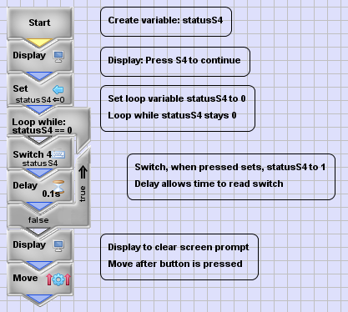
Program Description
- Start by defining the variable: statusS4
- Display the message: Press S4 to continue
- Set the variable statusS4 to 0
- Loop using the while condition: statusS4 = 0
- Inside the loop, read switch S4 and store the status into variable: statusS4
- Include a 0.1 s delay to allow time for the switch tool to set the variable
- After the loop, clear the display
- Start the robot move command(s)

Programming Challenges
- Create and test this program. Use any type or combination of move commands after the loop.
- Can you modify the program so that you can press a switch to stop the robot? Make the move command freerunning so that the robot will keep moving. Add another loop after the move command to check for a switch press to stop the robot. After the second loop add another move command with a speed of zero to stop the robot.
- Can you use the proximity sensor to stop the robot?
Start the robot with a freerunning move command and then use a conditional loop with the proximity tool inside to wait for either infrared sensors to be activated. When a sensor is activated the loop ends and a move command following the loop can be used to stop the robot.
Loop Forever – Blinking LEDs
You may want to have something that repeats forever. One of the real advantages of computer programs is that they can repeat tasks over and over again. In this sample program the light emitting diodes (LEDs) will blink forever.

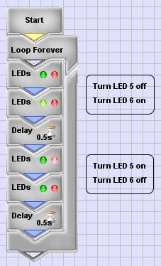
Program Description
- Start with no variables defined
- Use a loop that repeats forever
- Inside the loop, add LED commands to turn LED 5 off and LED 6 on
- Include a delay to allow time for the LEDs to turn on and off
- Turn LED 5 on and LED 6 off and delay again to provide time for the LEDs to change.
- The loop continues causing the LEDs to blink

Program Challenges
- Create and test this program.
- Can you modify the LED commands in the program by using the toggle action to cause the LEDs to blink?
You could set one LED on and one LED off before starting the loop. Inside the loop you would need just one toggle for both LEDs. The LED actions such as set and toggle can be selected at the bottom of the LED tool view.
- Can you make the robot move in a pattern forever?
Use the loop forever tool with some movement commands inside the loop to make the robot follow a movement pattern forever. The movement pattern could involve forward movement and turning.
Modules
A module is a program within the program. It has the same structure as a regular program including the Start tool and other tools. What makes it different is that it can be used again and again in different places.

Using Modules to Move
One use of modules is to repeatedly move the robot a distance using fewer commands.
- Start a new project called “MoveIt”.
- From the Icon Bar, click the green “+” icon to add a new module to the project.

- Enter the Module name: “movement”.

- Notice that tabs are added to the program window showing the modules in the project. There are now tabs for “sampleModule1_main” and “movement”.
- Add a Move command to the “movement” module. Set the move parameters to move forward 10 deci-revs at 50% speed on both wheels.

- Add a new module to current project. Enter the Module name “rewind”.

- Add a Move command to the “rewind” module. Set the Move parameters move in reverse 10 deci-revs at 50% speed on both wheels.

- In the main program, put a GoTo tool to “movement”, and then a GoTo tool to “rewind”.

When you build and download your program, the robot will roll forward one revolution, and then back to where it started.

Using Modules to Make a “U” Turn
One use of counting loops is to make geometric shapes with fewer commands. This task will use two modules to turn your robot to face the other direction.
- Start a new project called “MoveIt”.
If you did the previous sample, you may wish to call this project “MoveIt2”, or you can overwrite the previous project with this one.
- From the Icon Bar, click the green “+” icon to add a new module to the project.

- Enter the Module name: “movement”.

- Add a Move command to the “movement” module. Set the move parameters to move forward 10 deci-revs at 50% speed on both wheels.

- Add a new module to current project. Enter the Module name “turn”.

- Add a Move command to the “turn” module. Set the Move parameters to forward 10 deci-revs at 50% speed on the left wheel.

- Add the Delay, Loop, and Goto modules to the main module. Set the Loop to the Count type that will run 2 times. Set the Goto commands to use the “movement” and “turn” modules.

When you build and download your program, the robot will roll forward one revolution, and then back to where it started.

Advanced Challenges

Challenge - Robot Geometry
What geometric shape can you make?
- Triangle? Square? Star? Circle? Figure Eight?
- Can you use modules and loops to simply the progarmming?

Challenge - Modular Path Follower
Can you program the robot to follow a path created from modular sections
- Tape a path on the floor made of segments of a given length. (0.3 m)
- Include turns that are multiples of a given angle. (45 degrees)
- Calibrate modules to move the given length or turn the given angle
- Create a main module to call the move and turn modules in the proper order to complete the path.

Challenge - Robot Snow Plow
Create a program to clear the "driveway" of "snow".
- The "driveway" is an area 3 feet by 5 feet that is taped off on the floor.
- For "snow" use wads of paper or other objects that are randomly placed on the "driveway".
- You may choose the location to start and when to stop your robot "snow plow".
Hint: If you use paper wads as snow, you may notice the snow gets stuck under the wheels. You may need to modify the front of the CEENBoT using cardboard and tape to better push the "snow", or you can program the CEENBoT to plow the driveway backwards.

Additional Programs
These programs illustrate advanced programming methods and robot behaviors. If you have some programming experience, you may wish to try programming these as challenges. If you are relatively new to programming, you may wish to use these programs as examples. Solutions are given after problem statements.

Zeno's Paradox
A runner in a 100 m race must run half way (50 m), then they must run half the remaining distance (25 m), then half of that remaining distance, and so on. If you assume the runner must take a finite amount of time to travel a given distance, and if you can keep dividing the distance in half forever, then you conclude the runner will take an infinite amount of time to complete the race.
Can you program the robot to move according to Zeno's Paradox?

Object Avoidance
The robot has infrared sensors on the front to detect objects. The robot can move forward until it detects an object. The robot moves in the freerunning mode until a proximity sensor is activated. To avoid the object the robot could backup enough to allow it to turn, do a spin of a random angle, and then continue moving until the next object is encountered.
Can you program the robot to use the sensors and a random spin to avoid objects?
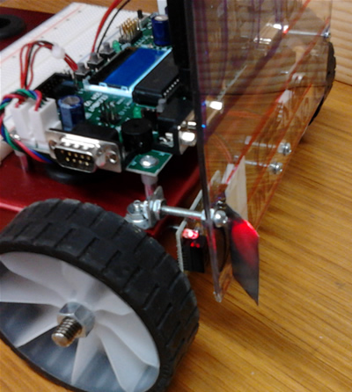
Wall Follower
Infrared waves are electromagnetic waves like the visible light we can see. Infrared waves behave like visible light in many ways including reflection. In this program you are to get the robot to follow a wall by taping a shiny piece of aluminum foil in front of the infrared sensor to reflect the infrared waves sideways. As the robot travels parallel to a wall it will sense the wall when it moves close to the wall. Program the robot to turn toward the wall when it does not sense the wall, and to turn away from the wall when it does sense the wall. In this way the robot will follow the wall.
Can you program the robot to follow a wall?

Robot Pachinko
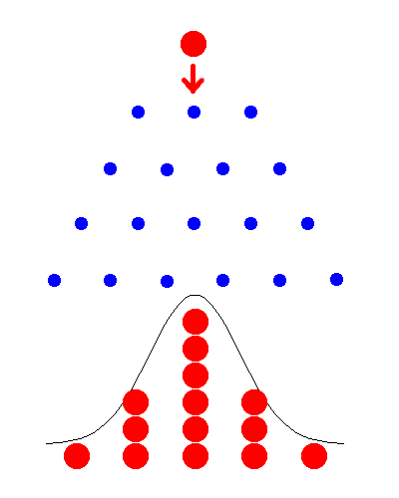
Pachinko is a Japanese game where balls dropping onto an alternating array of pegs are diverted to the left or right of each peg. For a large number of balls, if you count how the balls exit the array of pegs, the resulting counts will follow a normal distribution. Using a loop, a random number, and a conditional statement, the robot can be programmed to follow the path of a ball though a pachinko machine. Inside the loop, get a random number that is either 1 or 2, check the random number with a conditional and when it equals 1 go to the right, otherwise go to the left.
Can you program robot pachinko?

Random Walk
The random walk is an important mathematical model for processes such as the path of a molecule through a liquid or gas, the search path of a foraging animal, or the fluctuating price of a commodity. There are many different random walks that could be used for the robot. You might try having the robot move randomly in any one of four directions: ahead, back, left, or right.
Can you program a four directional random walk?

Robot Cruise Control
Some automobile cruise controls use sensors to monitor the cars in front and behind and to adjust the speed to keep a safe distance. A maximum speed limit can be set like any cruise control, but in heavy traffic the sensors can moderate the speed to match the surrounding cars. Using the front sensors, speed up the robot to a maximum when there is nothing in front of the robot, and slow down the robot when there is something sensed.
Can you program the robot cruise control?

