SPIRIT 2.0 Lesson:
The Power Steering Is Out?!

=============================== Lesson Header==============================
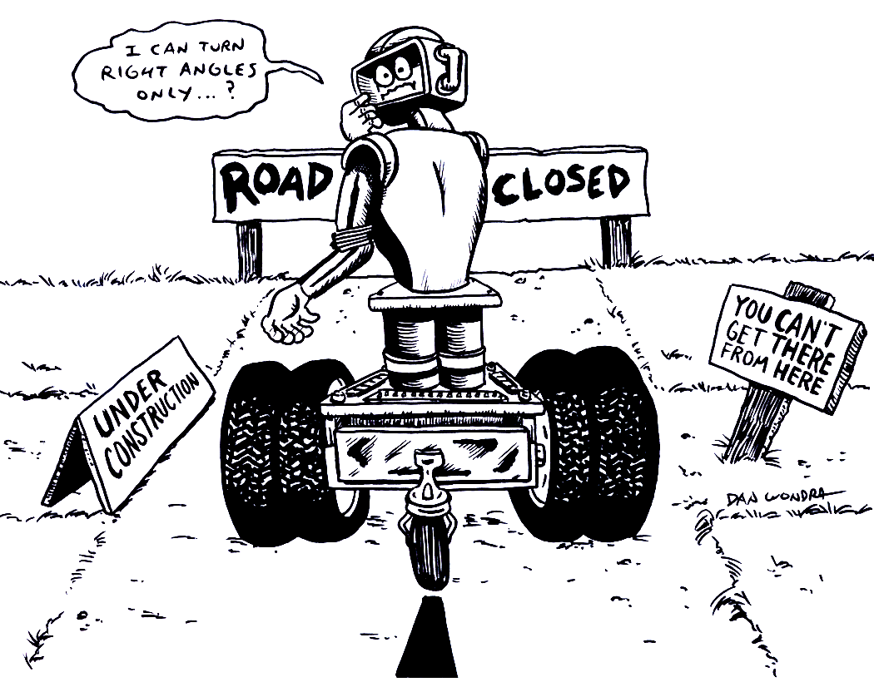
Lesson Title: The Power Steering Is Out?!
Draft Date: July 17, 2008, 2008
Author (Writer): Derrick A. Nero
Instructional Topic: Mathematics, Slope
m = rise / run and m = (y₂ – y₁) / (x₂ – x₁)
Grade Level: Middle

Content (what is taught):
- Use of coordinate planes and points
- Application of the mathematical formula
m = (y₂ – y₁) / (x₂ – x₁) or m = rise / run
- Measurement
Context (how it is taught):
- Coordinate points are identified and recorded
- The CEENBoT is driven from one coordinate point to another using the driving criteria,
Driving Citeria: Travel only horizontally or vertically and make only one 90º turn.

Activity Description:
In this lesson, students investigate how the slope of a line connecting two coordinate points is calculated. Students will select “locations” on a coordinate plane marked on the floor. Each student will record his/her “location” as a coordinate point. Pairs of students will be randomly selected to “travel” to one another’s “location” using the CEENBoT and the driving criteria. All students will record the horizontal and vertical distances traveled by the CEENBoT. The student pair will then travel in a straight path from one “location” to the other and will measure the path using a meter stick. Finally, students will calculate the slope of each pairing using the formula m = rise / run or m = (y₂ – y₁) / (x₂ – x₁).

Standards:

Science Technology
A1, A2 A3

Engineering Mathematics
A1, B1 A1, A3, D1, D2, E1, E3

Materials List:
CEENBoT Masking tape
Student Data Sheet Meter sticks
Notebook
ASKING Questions (The Power Steering Is Out?!)

Summary:
Students determine the best route to travel from one location to another.

Outline:
- Demonstrate the CEENBoT traveling on the coordinate plane that is marked on the floor.
- Drive the CEENBoT from one location to the other using many 90º turns.
- Driving Criteria: Drive the CEENBoT from one location to the other using only one 90º turn.

Activity:
The teacher will demonstrate driving the CEENBoT on the coordinate plane from one location to another. As students become interested, ask these questions:

Questions | Answers
How many routes can be used to travel to either location? | Numerous routes (with no constraints) can be used to travel to either location.
How many routes can be used to travel to either location, using the driving criteria? | Two routes (with the second being the opposite of the first) can be used to travel to either location using the driving criteria.
What is the quickest route from one location to the other? | A straight path is the quickest route from one location to the other.

EXPLORING Concepts (The Power Steering Is Out?!)

Summary:
Students investigate the relationship between the horizontal, vertical, and diagonal distances traveled from one point to another, and describe the slope between points using rise and run.

Outline:
- Students will drive the CEENBoT on a coordinate plane that is marked on the floor.
- Student pairs will drive the CEENBoT from one location to another using only 90º turns.
- Driving Criteria: Drive the CEENBoT from one location to the other using only one 90º turn.
- Student pairs will drive the CEENBoT from one location to another using the driving criteria..
- Students will predict the number of units from the starting location to the 90-degree turn (Run).
- Students will predict the number of units from the 90-degree turn to the ending location (Rise).
- Students will predict the straight path distance from one location to the other (Distance).

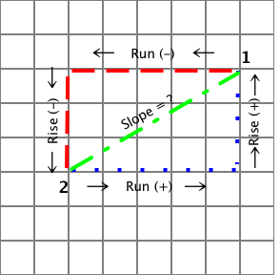
Location 1
Location 2

Activity:
In this lesson, students investigate how the slope of a line connecting two coordinate points is visualized. Students will select “locations” on a coordinate plane marked on the floor. Each student will name their “location” as a coordinate point. Pairs of students will be randomly selected to “travel” to one another’s “location” using the CEENBoT and the driving criteria. Students will name the horizontal and vertical distances traveled by the CEENBoT including the positive and negative sign on the value. The student pair will then travel in a straight path from one “location” to the other, and will describe the distance and features of the path and compare it to the path when using the driving criteria.

To provide formative assessments of the exploration, ask yourself or your students these questions:
- Did students consider the direction, therefore the negative or positive sign of the value?
- Did students predict the distances traveled to be identical between locations? both directions?
- How did students predict the straight path distance from one location to the other (i.e., math computation or estimate)?
INSTRUCTING Concepts (The Power Steering Is Out?!)

Putting Slope in recognizable terms: Other words for slope are: steepness, pitch, grade, angle of elevation, angle of inclination/declination, and rise over run.
Putting Slope in Conceptual terms: Slope is a relationship between two rates (related rates) or a comparison of two distances (remember that rate is just a distance divided by a measure of time, r = d/t): the distance the bot travels in the y direction varies (or changes) as a factor (m) of the distance the bot travels in the x direction. So, some number (m) times x gives us y. Therefore, m (dist. Of x) = (dist. Of y). If we solve for the variable m by dividing both sides of the equation by (dist. Of x), we get a related rate (slope). This is also called rise over run.
Putting Slope in Mathematical terms: We could also call the distance traveled in the y direction the change in distance of y or the difference in the y-coordinate values of two points. We could call the distance traveled in the x direction the change in distance of x or the difference in the x-coordinate values of the same two points. This gives us a formula: $M=\frac{Δy}{Δx}$ (difference in y values over the difference in x values or, delta y divided by delta x). When we get to calculus, we simplify by saying, $m=\frac{\text{dy}}{\text{dx}}$ .
Putting Slope in Process terms: Algebraic computation of slope: $m=\frac{y_{2}−y_{1}}{x_{2}−x_{1}}$. Provide examples of calculating slope between points. Be sure to include examples and explanation of negative value slopes.
Putting Slope in Applicable terms: Randomly angle the bot, drive it for three seconds from a given point, measure the vertical and horizontal components, and define the slope.
ORGANIZING Learning (The Power Steering Is Out?!)

Summary:
Students investigate the relationship between the horizontal, vertical, and diagonal distances traveled from one point to another, and calculate the slope between points using the slope formula or rise and run.

Outline:
- Student pairs will drive the CEENBoT from one location to another using the driving criteria.
- Driving Criteria: Drive the CEENBoT from one location to the other using only one 90º turn.
- Collect data as student pairs travel to one another’s locations
- Data includes the coordinate points, and horizontal (run), vertical (rise), and diagonal distances.
- Fractions should be expressed in reduced form.

Activity:
In this lesson, students calculate the slope of a line connecting two coordinate points. Students will select “locations” on a coordinate plane marked on the floor. Each student will record his/her “location” as a coordinate point. Pairs of students will be randomly selected to “travel” to one another’s “location” using the CEENBoT and driving criteria. All students will record the horizontal and vertical distances traveled by the CEENBoT. The student pair will then travel in a straight path from one “location” to the other and will measure the distance of the path using a meter stick. Finally, students will calculate the slope of each pairing using the formula m = rise / run or m = (y₂ – y₁) / (x₂ – x₁).

Student Worksheet
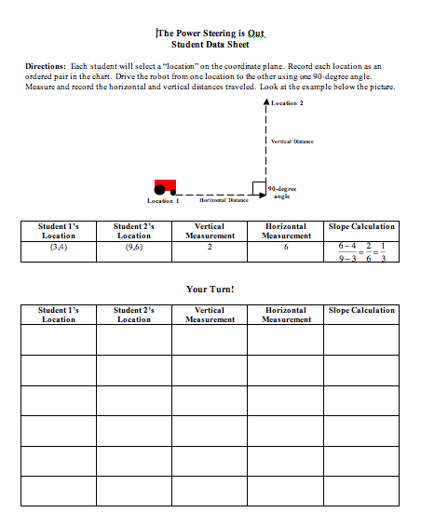

UNDERSTANDING Learning (The Power Steering Is Out?!)

Summary:
Students write essays about the application of m = rise / run or m = (y₂ – y₁) / (x₂ – x₁).

Outline:
- Formative assessment questions asked during the learning activity about slope and its meaning.
- Summative assessment essay questions about slope and its application.

Activity:
Formative Assessment
As students are engaged in learning activities ask yourself or your students these types of questions:
1. Were the students able to apply either formula for slope?
2. Can students explain the meaning of slope?

Summative Assessment
Students will complete the following essay questions about the distance-rate-time formula:
- Calculate the slope of the line formed by the student’s home and the local shopping mall.
- Write a story involving the path of a rogue robot determined to find its creator and how detectives found it based on its known locations.
- Describe how you can tell the positive or negative value of slope by looking at the location of two points on a coordinate plane.

Student Worksheet

The Power Steering is Out?!
Student Data Sheet

Directions: Each student will select a “location” on the coordinate plane. Record each location as an ordered pair in the chart. Drive the robot from one location to the other using one 90-degree angle. Measure and record the horizontal and vertical distances traveled. Look at the example below the picture.

90-degree angle
Location 1
Location 2
Horizontal Distance
Vertical Distance

Student 1’s Location | Student 2’s Location | Vertical  Measurement | Horizontal  Measurement | Diagonal  Measurement | Slope Calculation
(1, 2) | (4, 6) | 4 | 3 | 5 | $$\frac{6−2}{4−1}=\frac{4}{3}=1\text{.}\text{33}$$

Your Turn!

Student 1’s Location | Student 2’s Location | Vertical  Measurement | Horizontal  Measurement | Diagonal  Measurement | Slope  Calculation

The Power Steering Is Out
Essay Rubric
 | 5 Points | 4 Points | 3 Points
Essay 1  Calculation of Slope | The calculation of slope is correct with all work shown. The work shown is detailed and written out step-by-step. | The calculation of slope is correct. Some or all of the work is shown but is not as detailed. | The calculation of slope is incorrect. Some (or no) work is shown.
Essay 2  Rogue Robot Story | The story is detailed and includes mathematical vocabulary (slope, rise, run, etc.) throughout. The calculations are correct with all work shown. | The story is somewhat detailed and includes some mathematical vocabulary The calculations are correct but the work is not as detailed. | The story lacks detail and includes little (or no) mathematical vocabulary. The calculations may or may not be correct and the work is incorrect or not shown.
Essay 3  Positive and  Negative Slope | The explanation is clear and uses mathematical vocabulary (slope, rise, run, etc.) Examples (drawings) are shown with a clear explanation of each. | The explanation is somewhat clear and includes some mathematical vocabulary. Examples are included, but may not be as clearly explained. | The explanation is not clear and includes little (or no) mathematical vocabulary. Examples may be included but are incorrect and/or not explained.

