Comparison of CEENBoT and TekBot attributes

TekBot™ | CEENBoT™
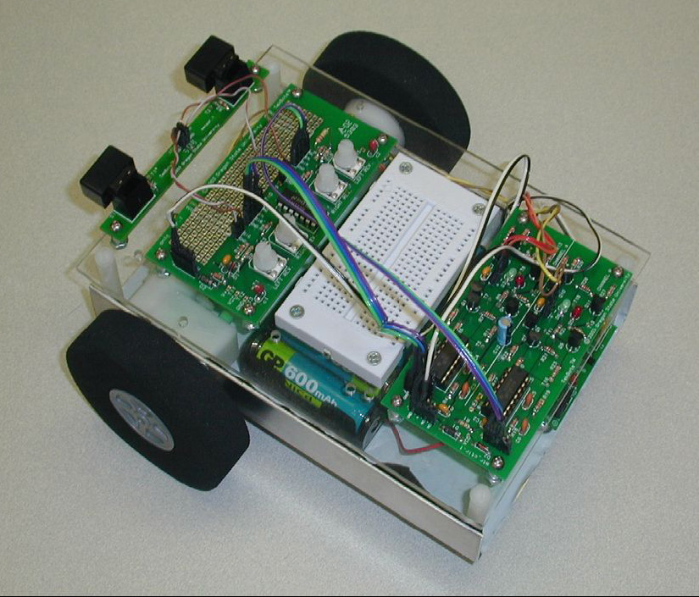 | 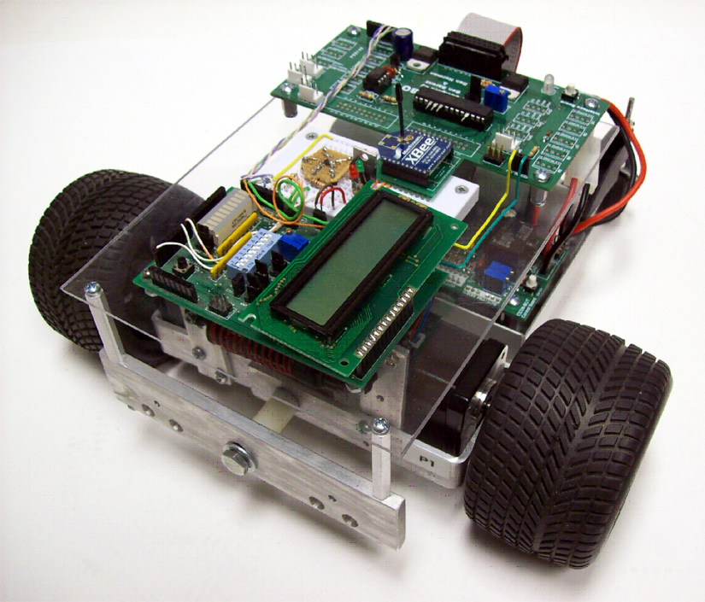
Attributes of the TekBot developed by Oregon State University: 5” by 7” footprint
- DC motors with plastic gear train and foam wheels
- Compact design
- Prototype board for use by college students at both Oregon State University and University of Nebraska (to 2007)

Attributes of the CEENBoT developed by the University of Nebraska (CEEN): 6” by 8” footprint
- High-quality stepper motors for precision control
- Full suspension for traversing uneven terrain
- Larger capacity, quick-change power supply
- Interchangeable rubber drive tires
- Remotely controllable using the popular Sony PlayStation® controller
- Large prototype board for projects and more reliable connectors
- Serial-to-peripheral interface (SPI) to allow communication between multiple multiprocessors
- Amenable to K-16 educational space to meet needs at multiple levels

Features Under Development
- GPI and C++ interfaces
- Platform can accommodate GPS, laser diode, alternate wireless controls, different microprocessor systems, on-board video camera, and a robotic arm
- Compatible with Microsoft Robotics Studio
- Available in a number of configurations from kits to completed modules

