Juice the Bot Exploration Sheet (CALCULATIONS)
CEENBoT Controller Buttons
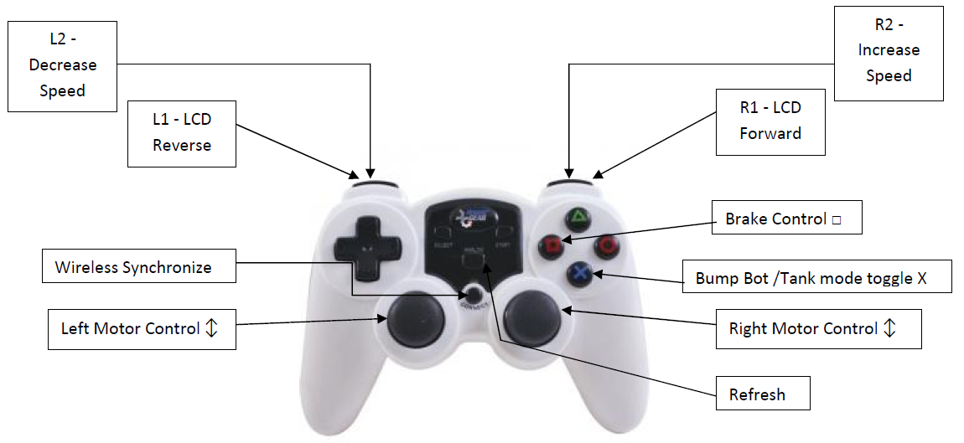
In this exercise, you explore the capabilities of the CEENBoT, the focus will be on calculations that can be done using the CEENBoT as a reference including using SI prefixes. While you work with your CEENBoT consider these questions. Record your thoughts, ideas, and answers in an engineering notebook.

- What numbers are given on the battery? (Size in mAh, Voltage, Charging Current)
- What numbers are given on the CEENBoT display? (Current in Amps, Analog speed)
- How do we convert between the mAh of the battery and Amps on the display?
- Using the CEENBoT display of current, convert how many mA are being used.
- Using the size of the battery in mAh divide by the number of mA being used to project how long the charge will last.
- What is the speed on the CEENBoT in miles per hour?

Here is some information that will help answer the questions above.
- The unit prefix milli represents 1/1000 th
- Numbers given with milli are 1/1000th of the unit, such as 10 mg is 10/1000 g.
- To convert milliamps to amps divide by 1000, for example 3800 mA = 3.8 A
- To find the amount of battery energy used multiply mA times hours to get mAh

It is also possible to do conversions concerning speed. For instance:
- Convert the speed of the CEENBoT into miles per hour, km per hour, etc.
- Measure the size of the CEENBoT and a car. Using the scale factor find how fast the CEENBoT would travel if it were full sized.

