Juice the Bot Exploration Sheet (CONTROLS)
CEENBoT Controller Buttons
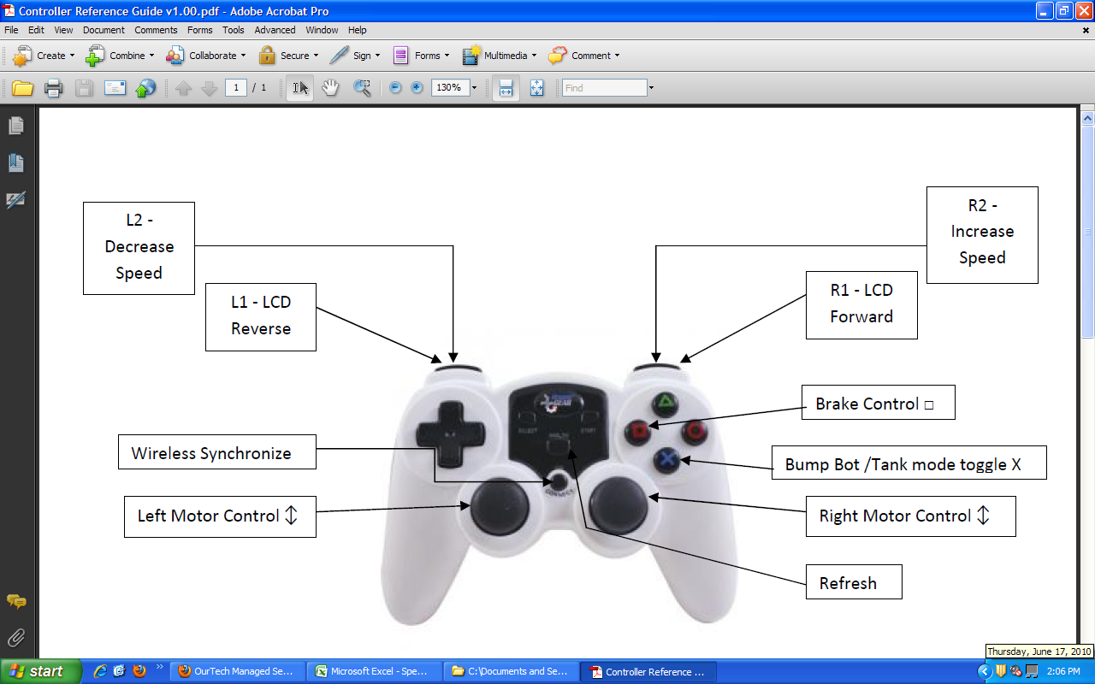
In this exercise, you explore the capabilities of the CEENBoT; the focus will be on learning the controls. As you work with your CEENBoT consider these questions. Record your thoughts, ideas, and answers in an engineering notebook.

First, place the CEENBoT on a block or stand to allow all wheels to spin freely and complete the tasks below.

- Using the controller for the CEENBoT, push buttons and become familiar with what they cause the CEENBoT to do. Be especially attentive to the buttons L1, R1, L2, and R2. What do they do? How do they respond? Are there any things that a new user should know?

- Be able to switch between the Analog Speed and the Battery Current LCD displays.

Next, place the CEENBoT on the ground.

- Try to drive the CEENBoT (at a constant speed) in a straight line, a circle, a figure eight or other pattern. Was this task difficult? What do you need to be aware of while “driving”? What should new users know?
- Try to drive the CEENBoT at varying speeds in a straight line, a circle, a figure eight or other pattern using the L2 and R2 buttons. Was this task easier or harder than at a constant speed? Why?
- Drive the CEENBoT at a wall or other solid object, using the brake control try to get as close to the wall as possible. The goal here is to not have “jerky” movement but rather constant movement with a gradual stop. Be careful to start slow and practice so that you do not damage the CEENBoT. Was this task difficult? What did you learn? What should new users know about how the CEENBoT responds?
- Try doing other driving tasks to practice using the controls. Record your experiences in your engineering notebook.

