Juice the Bot Exploration Sheet (DATA COLLECTION)
CEENBoT Controller Buttons
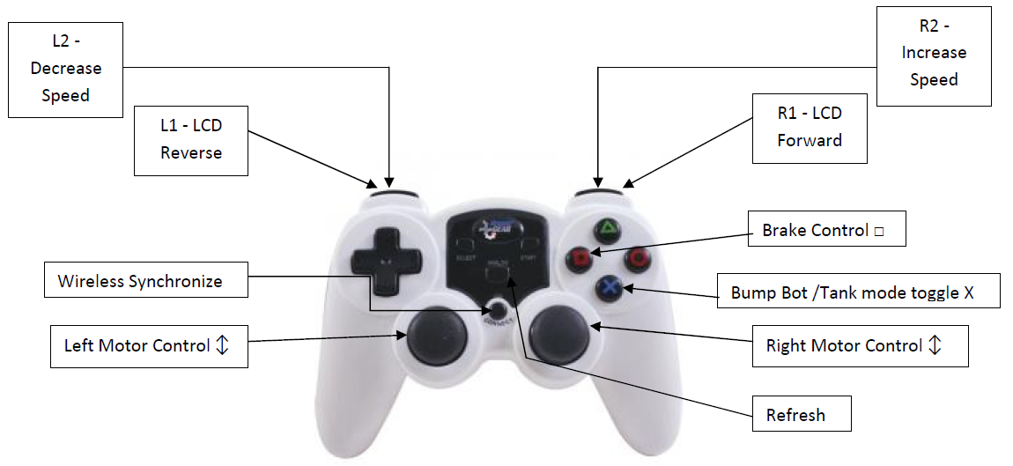
In this exercise, you explore the capabilities of the CEENBoT; the focus will be on data collection. As you work with your CEENBoT consider these questions. Note there are two different data collection opportunities that are very different. Record your thoughts, ideas, and answers in an engineering notebook.

Set the CEENBoT on a block or stand so that it will not move to collect the required data while performing the steps below.

- Select different Analog Speed settings.
- Run the motor(s) in a consistent manner, and record the current in amps.
- Create a properly labeled data table and graph.
- Calculate a third column showing the runtime for a fully charged battery.
- What relationships are illustrated in the data? (Linear, quadratic, direct, indirect, etc.)

Place the CEENBoT on the ground for this data collection experiment.
- What is a revolution of a wheel?
- Have you ever heard of revolutions per minute (RPM)? Where?
- How far will the robot move in one revolution of the wheel?
- What is the distance around the edge of a circle called?
- What is the formula for calculating the distance round the edge of a circle?

1. What is the fewest number of revolutions to drive 2 m?
2. If you double the distance, how does the number of revolutions change?
3. Line up all the robots and set the speeds: 20, 40, 60, 80, 100, 120, 140, 160, 180
Drive the robots in a straight line for 10 seconds. Are the robots still in a line?

