Juice the Bot Exploration Sheet (ENERGY)
CEENBoT Controller Buttons
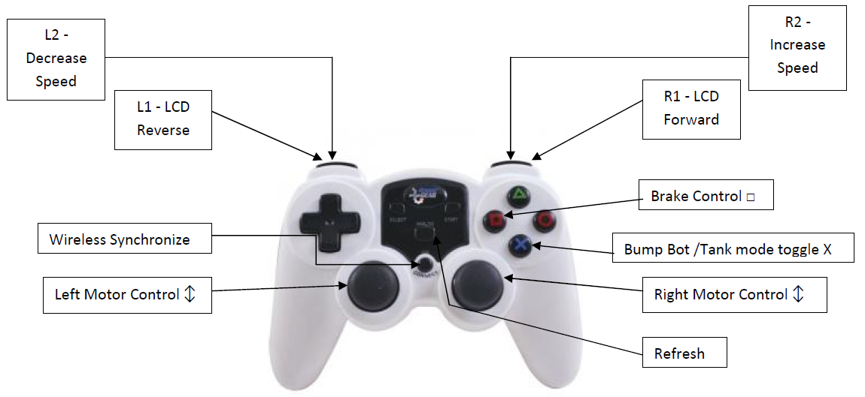
In this exercise, you explore the capabilities of the CEENBoT; the focus will be on energy. As you work with your CEENBoT consider these questions. Record your thoughts, ideas, and answers in an engineering notebook.

- What is energy?
- Where does the robot get its energy?
- How do you measure the amount of energy?
- How long will the CEENBoT run on a fully charged battery? (Maybe 2-3 hours)
- What do we need to know to answer this question? (Battery ratings, electricity terms)
- What numbers are given on the battery? (Size in mAh, Voltage, Charging Current)
- What numbers are given on the CEENBoT display? (Current in Amps, Analog speed)

Using the controller, you should complete the following tasks regarding the CEENBoT. Be sure to record the answers in your engineering notebook.

1. Put the robot on a block. What is the current usage at each speed setting:

30, 60, 90, 120, 150, 180

2. How much energy (Power) is used when driving 2 m at the different speed settings:

30, 60, 90, 120, 150, 180

3. Which speed setting uses the least amount of energy (Power)?

4. What speed setting uses the least current?

5. Using the information you have learned about energy consumption of the CEENBoT, how long should a fully charged robot battery last?

