Juice the Bot Exploration Sheet (PUTTING IT TOGETHER)
CEENBoT Controller Buttons
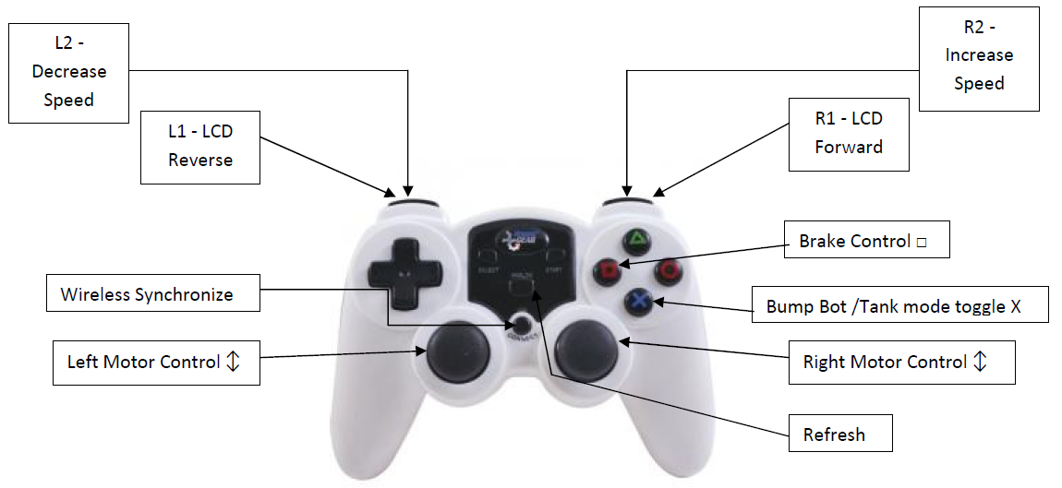
In this exercise, you explore the capabilities of the CEENBoT; the focus will be on putting your CEENBoT experiences together into one final task. As you work with your CEENBoT consider these questions. Record your thoughts, ideas, and answers in an engineering notebook.

Short Distance Run Around
You will be given a starting location, direction to begin your “run around” and an ending box where your CEENBoT must stop. On the playing field, there will be 12 objects that must be knocked down. Your task is to knock down all 12 objects by taking the shortest possible path while using the least amount of energy. The shortest path will be determined by the CEENBoT with the fewest number or tire revolutions. The energy consumption can be found by seeing the battery charge before and after the “run around”. First, a speed to run the course that your team deems to be optimal must be selected. Time will be provided to plan the speed and path that the CEENBoT will use. Your thoughts, choices, and reasons should be recorded in your engineering notebook for discussion after the “race”. When your group has made its choices show your engineering notebook to the judges and get in line to do your Official Shortest Distance Run Around. If time permits, try to better your score by completing another run.

Rules
- On the playing field will be a number of penalty objects that you are not to hit.
- Your CEENBoT is started in Tank mode at the starting location and direction.
- You are to drive the CEENBoT with your selected speed from start to end.
- You must knock down all objects using the least revolutions and energy.
- Each person on the team must knock down an equal number of objects.
Scoring
- Points: Your score will be the integer value of revolutions times energy.
- Penalties: You will receive penalty points for hitting penalty objects as indicated.
- Discounts: You will receive a 10% point discount for completed engineering notebooks.

