SPIRIT 2.0 Lesson:
Wow! That’s High Tech
===========================Lesson Header ========================
Lesson Title: Wow! That’s High Tech!
Draft Date: November 17, 2008
1st Author (Writer): Lisa Tingelhoff (adapted lesson)
2nd Author (Editor/Resource Finder): Derrick Nero
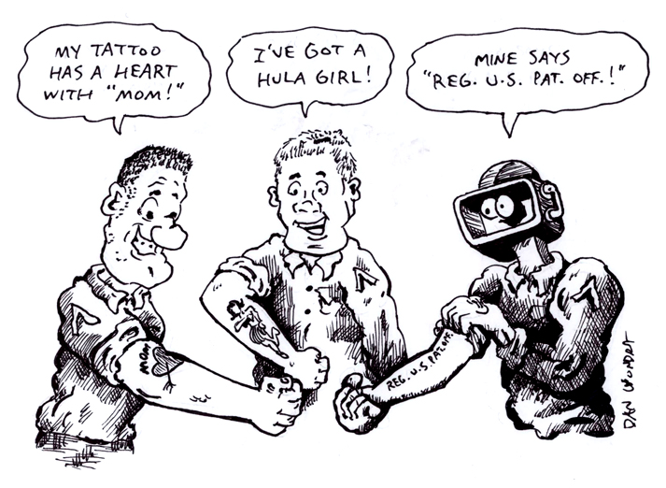
Grade Level: 5-8
Source: This is a modified lesson from “Invention and Innovation: A Standards-Based Middle School Model Course Guide” by the International Technology Education Association.

Content (what is taught):
- Definition of patent, copyright, infringement, and intellectual property
- Examination and explanation of the patent process
Context (how it is taught):
- Classroom instruction on patent vocabulary and the patent process
- Student exploration of “high tech toys” via the Internet.
- Student design of a multimedia presentation that showcases their chosen “high tech toy.”

Activity Description:
In this lesson, students will learn about patents and the patent process. Students will demonstrate understanding of patents as they choose a high tech toy to conduct research and then develop a multimedia presentation showcasing their chosen toys.

Standards: (At least one standard each for Math, Science, and Technology - use standards provided)
- Science—E2
- Technology—B2, E2

Materials List:
- Poster paper
- Stephen Caney’s Inventions Book by Steven Caney
- Computers
- LCD project

ASKING Questions (Wow! That’s High Tech!)

Summary:
Students are asked to discuss what motivates invention and innovation. Students are asked to discuss the system that is put in place to protect inventors and their inventions.

Outline:
- Facilitate class discussion of what motivates invention and innovation.
- Give examples of human needs or wants that have been satisfied by invention and/or innovation or give examples of inventions and innovations and discuss what need or want may have been met with the product.

Activity:
Begin this activity with a classroom discussion of what motivates invention and innovation. Students should arrive at the conclusion that it is society’s wants and needs that is the motivating factor. Give students a want or need and ask them to identify the invention or innovation that has helped satisfy that need. Then give students an invention and ask them to identify the want or needs that are satisfied by the invention.

Questions | Answers
What motivates invention and innovation? | The needs and wants of society motivate invention and innovation.
What is the invention/innovation associated with the following need or want________________? | Answers to this question may vary depending on the need/want.
What do you think motivated the invention of the CEENBot? | Answers will vary
What needs or wants could the CEENBot satisfy? For what purpose could the CEENBot be used? | Answers will vary

EXPLORING Concepts (Wow! That’s High Tech!)

Summary:
Students will explore their creativity as they develop inventions or innovations to meet a need or want of society.

Outline:
- Large group carousel activity
- Steven Caney’s Invention Book by Steven Caney

Activity:
During this activity, large poster paper will be placed around the room. Students will travel from one poster paper to the next adding inventions or innovations to accommodate a want or need of society. Students will make additions using pictorial representations and/or words.

Next, students/groups will write a want or need of their own on large poster paper and the activity described above will continue again as students will aim to accommodate the need or want through the design of an invention or innovation.

Finally, share with the students Steven Caney’s Invention Book by Steven Caney. Look particularly at the fantasy inventions that he describes at the end of each invention. Discuss the inventions and the wants and needs these inventions address.

INSTRUCTING Concepts (Wow! That’s High Tech!)

Intellectual Property (Legal definitions)
When an inventor or engineer creates something new (either an idea or invention) there are many legal implications about ownership and use of the idea or invention. Was the idea created while working for someone else or for yourself? Is the idea an adaptation or something new?
Patent
A patent is the exclusive legal right granted by a government to exclude others from producing or using an inventor’s discovery or invention for a limited period of time. Typically a patent must include a claim that the invention is new, different, and useful. The patent does not give the inventor the right to produce or use the invention. Rather it excludes others from doing so. The inventors can only apply for patents; but if the invention was created as a result of being under contract to an organization, the patent may be required to be assigned to that organization. Patents can be sold, transferred, mortgaged or abandoned like any other property.
Copyright
Copyright gives the creator of an original work the exclusive right to that work for a defined period of time. The exclusive right includes publication, distribution, and adaptation. After the copyright expires the work enters the public domain and is free for everyone to use. Copyright is similar to a patent but applies to ideas or information that has been authored, has substance, is distinct, and is fixed in a medium like print, film, music, etc.
Trademark
A distinctive design, picture, logo or wording that indicates that an individual, business or other legal entity uses to identify that a product or service is provided from a unique source. The trademark also distinguishes that this product or service is different from a similar product provided by another entity. Trademarks can be registered or unregistered. Registered trademarks are recognized by a particular government as unique and belonging only to one entity, therefore it is only usable by that entity.
Trade Secret
A trade secret is unique information that is not publicly known or easily learned about a product that the maker may legally protect form being released to others. This information can be used by a business to gain an economic advantage over competitors.
Intellectual Property
Intellectual property grants exclusive rights to the creator of such things as literary and artistic works, ideas, inventions, word phrases, symbols and designs. Intellectual property includes such things as patents, copyrights, trademarks, and trade secrets.
Royalty
A royalty is the fee that may be charged by the holder of a copyright or patent to allow someone else to use it.
Infringement
Infringement is the improper use of a patent or copyright by unauthorized persons. If infringement is discovered the owner of the intellectual property has the right to recover damages.
Plagiarism
Plagiarism is taking the words or work of another and presenting them as your own. Plagiarism is not copyright infringement. Rather it is concerned with the improving of one’s reputation by claiming false authorship.
ORGANIZING Learning (Wow! That’s High Tech!)

Summary:
First students will define patent related vocabulary. Then students will create a multimedia presentation to showcase high tech inventions.
Outline:
- Students will define patent related vocabulary and define them in their own words.
- Choose a high tech invention.
- Research the invention (name, manufacturer, purpose, cost, units produced, patent number, current status and history of the invention).
- Develop a multimedia presentation.
Activity:
First students will define patent related vocabulary. The students will create a vocabulary grid, which will list the vocabulary term, a teacher definition of the term, and a definition given by the student in his/her own words. The students will also describe the importance or impact of the term. Second, students will choose a high tech invention that fulfills a want or need of society. The students will use a variety of Internet resources and contacts with the manufacturer to research the invention. Upon gathering the required information (name, manufacturer, purpose, cost, units produced, patent number, status, and history of the invention), students will put together a multimedia presentation showcasing the invention. The presentation should include the following:
- Title page or slide
- Slide or two detailing the product and its history
- Slide or two detailing the current status of the product
- Slide or two “selling” the product; depicting the need or want fulfilled
- Product media: pictures, photos and video (e.g. commercials)
- Sounds

Students will share their presentations with the class at the end of this activity.

Robotics Connection:
This activity may be modified to limit the choices for high tech inventions to robots only. In this case, students would define robot and identify attributes of robots. Following the protocol described above, students would then use online resources to find an innovative robot to study further.

Patent Vocabulary Grid and Design Brief

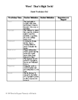
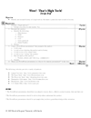

UNDERSTANDING Learning (Wow! That’s High Tech!)

Summary:
Students will write essays addressing the forces that drive engineering, invention, and the importance of patents in the design process.

Outline:
- Formative assessment of forces that drive engineering and invention
- Summative assessment of patent vocabulary

Activity:
Formative Assessment
As students progress through the series of activities, class discussion should answer the following questions:
1. What drives invention and innovation?
2. What system is put into place to protect the creativity of inventors?

Summative Assessment
Students will complete the following essay questions:
1. Write an essay that describes the forces that drive engineering, invention, and innovation. Be sure to include examples that were discussed throughout the unit as well as your high tech invention.
2. Write an essay that describes the importance of the patent process. Be sure to include patent vocabulary in your essay (patent, copyright, trademark, trade secret, infringement, intellectual property, plagiarism, and royalty).

