Popsicle Stick Truss Bridge Instructions and Photos

Step 1: Place 3 popsicle sticks along a straight edge. Cut one stick in half using a large scissors. Glue the halves to each end of the 3 sticks placed end to end and glue two popsicle sticks in the middle. Glue three more full sticks on top to create three layers with overlapping joints. Repeat this 3 more times to create four 3-popsicle stick beams. Create two 2-popsicle stick beams. (Glue halves to each end of 2 popsicle sticks laid end to end and glue one stick in the middle.)
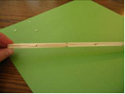
Step 2: Using one of the large 3 stick beams and one of the smaller two stick beams create a truss wall. With the flat side of the beams down on the table, arrange 6 popsicle sticks in a triangular pattern, cut off extra popsicle stick on both top and bottom to create flat surfaces and glue in place. Turn the truss wall over and repeat the process.
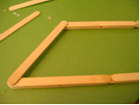

Step 3: This is an example of a completed truss wall. The last two 3 stick beams will be used to create the road. Lay them on the side and glue 33-35 sticks onto them.
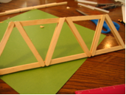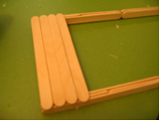

Step 4: Glue the two truss walls to the road. Add extra glue to the joints between the road and the truss wall.
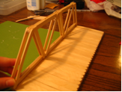

Step 5: Using 9 sticks, glue crossbeams to the top of the bridge. Note the pattern in the picture below. You can add paint and signs to complete your bridge!
