SPIRIT 2.0 Lesson:
Bridge Building

===============================Lesson Header ==============================
Lesson Title: Bridge Building
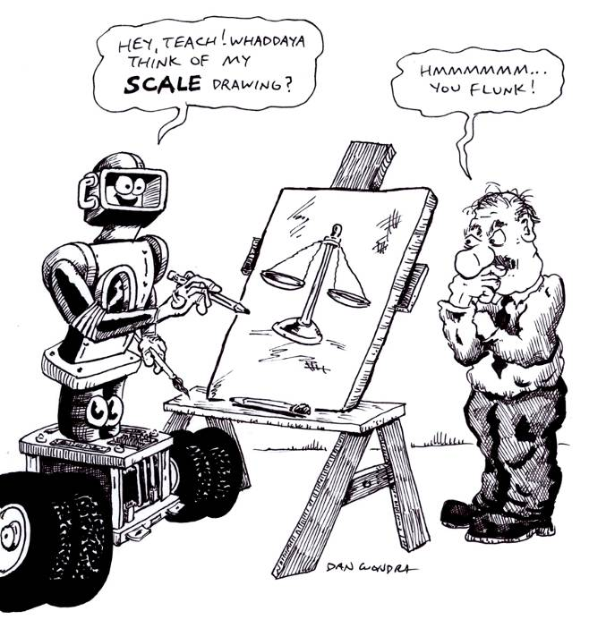
Draft Date: November 23, 2008
1st Author (Writer): Lisa Tingelhoff
2nd Author (Editor): Derrick Nero
Algebra Topic: Grade Level: Primary Elementary Middle Secondary
Cartoon Illustration Idea: a truss bridge

Content (what is taught):
- Bridge terminology
- Scale drawing techniques
Context (how it is taught):
- Teacher will provide an introduction to bridge terminology.
- Students will build a popsicle stick bridge.
- Students will draw a scaled version of their popsicle stick bridge.
- Students will draw a scaled version of a CEENBot and CEENBot components.
Activity Description:
In this activity, students will be introduced to bridge terminology through direct instruction. Students will then build a popsicle stick bridge according to specific instructions. Upon completion of the bridge building, the bridges will be tested at a critical load. Students will then be introduced to scale and scale drawings. Students will draw several scaled views of their popsicle stick bridge. Finally, students will practice drawing scale drawings of certain components of the CEENBot and of the CEENBot itself.

Standards:
- Math—C1, D1
- Science—B1
- Technology—D2

Materials List:

- Computers/Internet
- Popsicle sticks
- Glue
- Newspaper
- Drill
- 5-gallon bucket
- Sand
- Rulers
- Engineering notebook
- Digital camera
- Rubber bands
- Sand paper

ASKING Questions (Bridge Building)

Summary:
Students will use a resource from the IEEE to identify various types of bridges and their purposes as well as their advantages and disadvantages.

Outline:
- Identify at least six types of bridges and their purposes.
- Identify advantages and disadvantages for each type of bridge.
- Identify famous examples of each type of bridge.

Activity:
In this activity, students will identify, compare and contrast various types of bridges as well as the advantages and disadvantages of each type and will provide famous examples of each. A graphic organizer will be provided for students to guide them through the activity.

Questions | Answers
What types of bridges are there? | Types of bridges include arch, beam, cable-stayed, cantilever, suspension, and truss.
What are the advantages of a __________bridge? | Answers will vary depending on bridge type.
What are the disadvantages of a ________bridge? | Answers will vary depending on bridge type.
Give a famous example of a ___________bridge? | Answers will vary depending on bridge type.

Resource: Popsicle Bridge, Student Resource: Types of Bridges (page 7 of 11).
Developed by the IEEE found at http://www.tryengineering.org/lessons/popsiclebridge.pdf

Worksheet file: E-003-Scale_Drawing-Bridge_Building-A-Wrksht.doc

Bridge Types
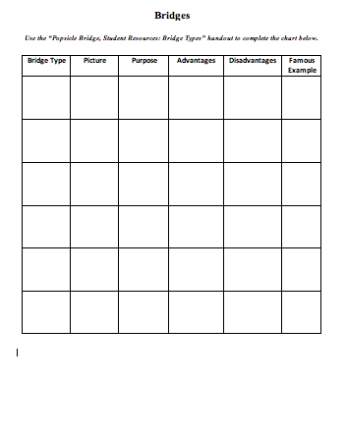

EXPLORING Concepts (Bridge Building)

Summary:
Students will build a popsicle stick bridge identifying specific bridge components.

Outline:
- Build a popsicle stick bridge following specific directions.
- Learn and identify basic bridge components on a popsicle stick bridge.
- Test bridge’s critical load.

Activity:
- Students will work in a group of two students to construct a popsicle stick bridge by following a specific set of directions (see pages 8-9.) As the students work through the directions, they will identify basic bridge components on the bridge such as beam, truss, etc.
- When students finish construction of the bridge, they will subject their bridge to a test of critical load. First, students will drill a hole through the bottom of each bridge and from the hole will hang a hooked bolt. Next, the students will hang a bucket from the hook. Finally, students will add sand to the bucket until the bridge collapses or until the maximum amount of sand has been added.

Robotics Connection:
Students will discuss how the bridge will need to be modified to accommodate travel by a CEENBot.

Bridge Instructions

INSTRUCTING Concepts (Bridge Building)
Scale Drawings

Putting Scale drawings in recognizable terms: Scale drawings are a way to represent things in the world that would not otherwise be possible. They are typically smaller representations of the real thing. For instance it would be impossible to create a real sized representation of the United States.
Putting Scale drawings in Conceptual terms: A scale drawing is a proportional reproduction of an object. On the drawing you will find the scale which will look something like this: 1 cm = 100 miles. This means that if you measure 1 cm on the drawing it will compare to 100 miles of actual distance in the real world. Everything that is noted on the map must be in the same relative position to the actual objects.
Putting Scale drawings in Mathematical terms: To produce a scale drawing you must use a series of proportions. Engineers and architects make blueprints by deciding how big the actual measurements of a building are going to be and then assign a scale; 1 mm = 10 ft for instance. To create a drawing using this scale, you would solve the proportion: $\frac{\text{1 mm}}{\text{10 ft}}=\frac{\text{Measurement on blueprint}}{\text{Actual measurement}}$. If you know the scale of the drawing to the actual world object, solving this proportion will allow to you measure the blueprint and find the actual measurement or vice versa.
Putting Scale drawings in Applicable terms: Scale drawings are used in many common applications. Maps are scale drawings. Engineers and architects use blue prints for constructions projects that are scale drawings. Even a copy machine can create a scale drawing if you use the enlarge or reduction settings. Any application that is a replica of a different sized object is a scale drawing.

ORGANIZING Learning (Bridge Building)
Summary:
Students will learn about the scale on scale drawings and find examples of scale drawings. Then they will draw a scale model of their popsicle stick bridge. Prior to drawing the scale model, students will construct a data table to record actual measurements and converted scale measurements.

Outline:
- Introduce concept of scale and scale drawings and show examples.
- Draw scale models of simple shapes.
- Take actual measurements of all components of a truss bridge.
- Convert actual measurements to scale measurements.
- Draw a model using scaled measurements.

Activity: First, students will work with scales and scale drawings with which they are familiar like maps. Second, after working with the ratios and proportions that map scales create, students will draw a scale model of simple shapes. Finally, students will measure and draw scale drawings of their bridge.

1. Introduce the concept of scale. Brainstorm examples of where scales are found and what they measure; for example, scales are used to measure the weight of an object, the temperature of air, the length of an object, and so on.
2. Show students a map of the United States and point out the scale in the map key. Tell students that scales can be used in two ways: to represent an object that is too large to fit on paper or to represent an object that is too small to visualize. Ask the students for examples of each of the two ways that scales can be used.
3. Discuss ratios and discuss how a scale is an example of a ratio.
4. Illustrate how to draw an object to scale. Use a ruler to draw a square on the board with sides that equal 10 inches in length. Ask students how they might use the square to draw another square that is half its size. Explain that an object is not simply cut in half when it is scaled down. The whole object is shrunk proportionally, meaning that the object does not change shape but that the object is reduced to a smaller size.
5. Measure and draw a second square with 5-inch sides. Explain that when an object is scaled down, the length of its sides must be reduced by the same amount. Compare the corresponding sides of the two squares. The ratio of the small square to the larger is 5:10. Explain that a ratio can be expressed in three ways: 5:10, 5 to 10, or 5/10, which is a fraction that reduces to 1/2.
6. Students will label all components of their truss bridge with a corresponding number.
7. Students will use a table to record actual measurements of all numbered components of their truss bridge.
8. Students will convert all of the actual measurements to scale measurements and draw a scale drawing of their bridge. (Using a 2:1 ratio).

Note: The use of grid paper will make the drawing easier for students.

UNDERSTANDING Learning (Bridge Building)

Summary:
Students will create scale drawings of several CEENBot components as well as the CEENBot itself.

Outline:
- Select and draw scaled drawings of several CEENBot components (2:1 and 1:2).
- Complete a scaled drawing of the CEENBot.

Activity:
Formative Assessment
As students work on their scaled drawings of the popsicle stick bridges, the teacher should visit with each student and review each student’s data table of actual and converted measurements. Reviewing the data tables will give the teacher an understanding of the students’ ability to use actual measurements and to convert those measurements to a specified scale.

Summative Assessment
In this activity, students will become more familiar with CEENBot components and a constructed CEENBot by completing several scaled drawings. Begin by having students select several CEENBot components from a CEENBot kit that has not yet been assembled. Students should draw two scaled drawings of each component: one that is scaled at least 2:1 and another that is scaled at least 1:2. This exercise will give students experience with drawing to both a larger as well as a smaller scale. After completing drawings of several of the CEENBot components, students should complete a scaled drawing of one view of an assembled CEENBot.

