SPIRIT 2.0 Lesson:
CEENBot Needs a New Job

==============================Lesson Header ==============================
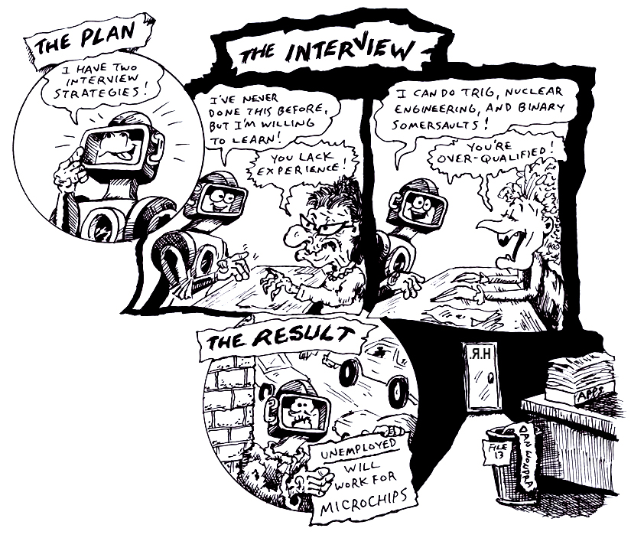
Lesson Title: CEENBot Needs a New Job
Draft Date: November 22, 2008
1st Author (Writer): Lisa Tingelhoff
2nd Author (Editor/Resource Finder): Derrick Nero
Grade Level: 5-8

Content (what is taught):
- Engineering design process
- Documentation using an engineering notebook
Context (how it is taught):
- Students will brainstorm possible uses for a CEENBot.
- Students will use the engineering design process to develop a use for the CEENBot.
- Students will use an engineering notebook to record their use of the engineering design process.
- Students will document the engineering design process using digital media.
Activity Description:
In this lesson, students will begin by exploring items that have various uses and then brainstorm possible alternative uses for common items. Students will then explore possible uses for a CEENBot and will use the engineering design process as a means to develop their ideas. The outcome for the lesson will be digital documentation of the engineering design process and a prototype of a possible use for the CEENBot.

Standards:
- Math—D1, D2
- Science—E1
- Technology—A1, B4

Materials List:
- Pictures of various machines, tools, and objects
- Multiple CEENBots
- Engineering notebooks
- Large poster paper and poster materials
- Digital cameras
- Computer access and printing capabilities
- Various construction/building materials
ASKING Questions (CEENBot Needs a New Job)

Summary:
Students will discuss machines/tools/objects that have multiple purposes. Students will brainstorm ideas for the possible uses of different machines/tools/objects.

Outline:
- Students will identify existing machines/tools/objects that have multiple purposes.
- Students will be given a machine/tool/object and be asked to give multiple purposes for it.

Activity:
Begin this activity with a discussion of machines/tools/objects that have multiple purposes and record the discussion on the board. Next, give students a picture of a machine/tool/object. Ask students to brainstorm alternative purposes for their machine/tool/object. Have students (or groups of 2-3) present their alternatives to the class for discussion.
.
Questions | Answers
What is an example of a machine/tool/object that has multiple purposes? | Machine/tool/objects with multiple purposes include hammers, screwdrivers, pick-up trucks, etc
What are alternative uses for machine/tool/objects such as rubber bands, cups, chairs, pulleys, cranes? | Answers will vary depending on objects given.

Chair

Cup
Pulley
Rubber bands
EXPLORING Concepts (CEENBot Needs a New Job)

Summary:
Students will brainstorm and design alternative purposes for the CEENBot. Students will use an engineering notebook to document their exploration.

Outline:
- Students will get hands-on experience working with the CEENBot.
- Students will work individually to brainstorm several alternative purposes for the CEENBot and will document their brainstorming using their engineering notebook.
- Students will then be placed in groups of 2-3 as a means of sharing their individual brainstorming session.
- Groups will then choose one of the alternative purposes to develop further.

Activity:
This activity begins by allowing students to look at and play with the CEENBot to determine the CEENBot’s potential. Then students will work individually to brainstorm several alternative purposes for the CEENBot and will document this brainstorming session in their engineering notebook. Students should provide basic development of each alternative purpose. The focus should be on quantity of alternative purposes as opposed to fully developing each purpose.

After 15-25 minutes, students will be placed in groups of 2-3 students. Students will share their individual brainstorming session. Once all students have shared within the group, the group should work to choose one of the alternative purposes to develop further. Once the group has chosen an idea to develop further, they will use their engineering notebook to expand on the design using the engineering design process. Students should use scale models in their engineering notebooks to provide final documentation of their designs.
INSTRUCTING Concepts (CEENBot Needs a New Job)
Engineering design process
The engineering design process has many forms. Some conceptual models have as many as ten steps others as few as five. The process is as individual as the engineer who is using it. It is cyclical meaning that you can start at any step in the process and it is dynamic meaning that it is always changing and adapting. For this instructional module we have chosen a simplified five-step approach to the engineering design process. The five steps are: 1) Ask, 2) Imagine, 3) Design, 4) Create, and 5) Improve.
Ask
In this step you ask what is the problem that needs addressed and do a lot of research to see what other ideas are out there and what other solutions have been attempted. This research is critical because it means you won’t duplicate something that others have tried and were unsuccessful. It allows you to frame the problem and limit (constrain) it so that you have a better understanding of what is required.
Imagine
Here you brainstorm ideas that might possibly be a solution to the problem you explored in the Ask step. Don’t be afraid to think big and out of the box. Sometimes if the answer to a problem is obvious or simple it would have been solved already. Get creative! After brainstorming possible ideas and solutions, you should analyze each possibility for potential merit. Finally select the best alternative for further exploration.
Design
This step involves the creation of a plan to carry out the idea that you selected in the Imagine step. You can make a diagram, create lists of things that you will need, and gather together the necessary skills that you will need to carry out your plan.
Create
This is the fun step. You get to actually build/create the idea that you selected and planned out. This is the hands on step where you see the intellectual idea actually come to live. It is important to follow your plan that you created. Be sure to note what went well and what didn’t work for future use in refining the idea. Finally test your product and see if it does what it is supposed to do. Does it solve the problem? It is possible that you will have to go back to any of the previous steps after you test your creation. If it doesn’t work, do you need a better plan, a better idea, or do you need to rethink your initial problem?
Improve
Here is the refinement stage. You have something that works but you want it to be the best it can be. You want the most speed, efficiency, the best appearance, etc. Here you think about and talk about what works, what doesn’t work and what could be improved on. After this discussion occurs, modify your design to see if you can improve it. Finally test out to see if you actually improved your solution or not. Remember at this stage it is possible that you might have to go back to any of the other stages.

The powerful thing about this process is that it is fluid and creates a nice organizational flow for the process to follow. At the end of each step always ask if you accomplished what you set out to do. If you did not repeat that step or go back further in the process to try to arrive at a better solution. Remember you can start at any step but once the process is begun you need to go from one step to another in order for the process to be effective.

Note Sheet Attachment: Engineering Design Process

ORGANIZING Learning (CEENBot Needs a New Job)

Summary:
In this activity, students will demonstrate the engineering design process by creating a poster that shows the steps of the process. Then, they will take digital pictures that demonstrate each of step of the engineering design process as it relates to the “CEENBot Needs a New Job” project. Students will carry out the design process in its entirety.

Outline:
- Groups of 2-3 students will work through the engineering design process as they develop an alternative purpose for the CEENBot.
- Students will work in groups of 2-3 to construct a poster that shows the steps of the engineering design process as it relates to the “CEENBot Needs a New Job” project.
- Groups will use a digital camera to document their work through the engineering design process.
- Groups will place the pictures they take of the design process on the Engineering Design Process poster created in the INSTRUCTING Learning portion of this activity.

Activity:
Groups will brainstorm alternative uses of the CEENBot. Students will then work in a group to construct a visual aid (poster) that shows the engineering design process in action as it relates to the “CEENBot Needs a New Job” project. The poster should show the flow of the design process as well as its various steps. Next, students will work through the design process documenting each step with digital photos and captions of how the picture demonstrates each step. Groups should use the “Documenting the Engineering Design Process” handout to record picture choices and captions as they organize their work. The outcome of the project will be a poster complete with definitions, pictures, and captions for each step of the engineering design process. Each group will also produce a prototype of their alternative use of for the CEENBot.

Documenting the Engineering Design Process

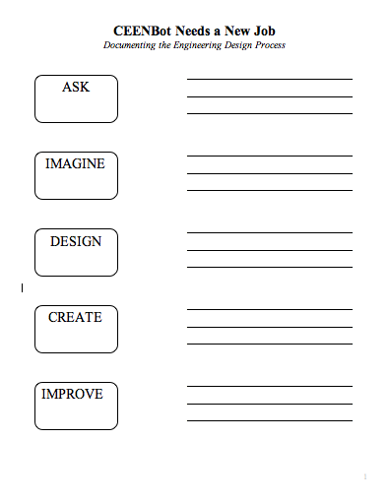

UNDERSTANDING Learning (CEENBot Needs a New Job)

Summary:
Students will identify steps of the engineering design process and will use the design process to address a given task.

Outline:
- Formative assessment of the engineering design process
- Summative assessment of the engineering design process

Activity:
Formative Assessment
As students complete their visual aid complete with pictures of each step, they will identify how events fall into the design process.

Summative Assessment
Students will be given the following design task and be asked to document the engineering design process as they address the task.
- Using the CEENBot and an egg, design a vehicle that can be used to transport the egg safely through a variety of obstacles (bumps, turns, sudden stops, uphill and downhill ramps, etc.)

Students will use their engineering notebook to use and document the engineering design process as a means of addressing the task.
STOP

