Medieval Weaponry
Medieval Arms Race
Use the following website to learn more about offensive and defensive medieval weaponry and war tactics.
http://www.pbs.org/wgbh/nova/lostempires/trebuchet/race.html

An image similar to the one at the right is provided on the website listed above. The image at the right is provided courtesy of http://www.fromoldbooks.org and is in the public domain and is on the web at:  http://www.fromoldbooks.org/Grose-Antiquities/pages/00-machines-of-war/719x1002.html war/719x1002.html | 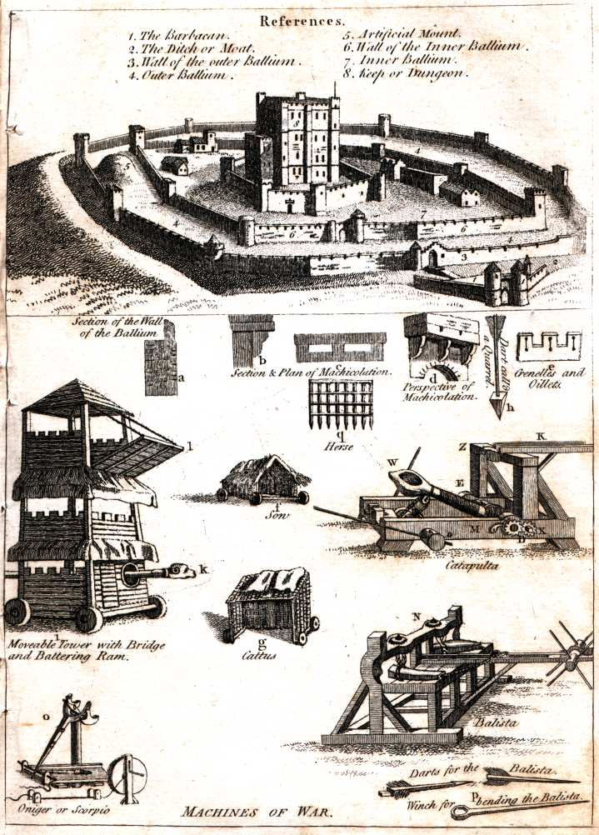

number | weapon/tactic | offense or defense | description
 | archers
 | battering ram
 | siege tower
 | moat
 | gatehouse
 | trebuchet
 | direct assault
 | walls
 | tunnels

