Medieval Weaponry
The Battering Ram: Applying Physics Terms and Concepts
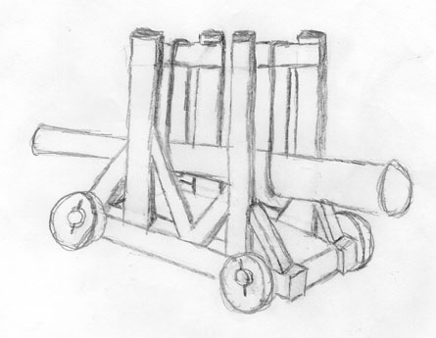
Label and explain the following physics terms and concepts on the diagram above.
Acceleration | Inertia | Trajectory | Newton’s 2nd Law
Force | Propel | Newton’s 1st Law | Newton’s 3rd Law

