SPIRIT 2.0 Lesson:
Medieval Weaponry

===============================Lesson Header==============================
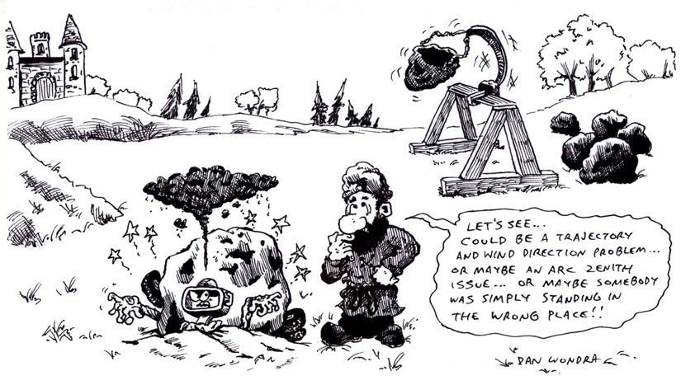
Lesson Title: Medieval Weaponry
Draft Date: December 3, 2008
1st Author (Writer): Lisa Tingelhoff
2nd Author (Editor/Resource Finder): Derrick Nero
Grade Level: 5-8

Content (what is taught):
- Engineering design process
- Historical weaponry
- Physics terms: acceleration, force, inertia, mass, propel, reference point, trajectory
Context (how it is taught):
- Students will research historical weaponry via an Internet activity.
- Students will use the engineering design process to construct and test a catapult.
- Students will learn about projectile motion using their designed catapults.
Activity Description:
The activity will begin as students conduct a WebQuest exposing them to medieval weaponry used both offensively and defensively. Students will then build a model trebuchet either by their own design or by utilizing a trebuchet kit (supplied by a host of different vendors). Next, the teacher will introduce common physics terms that students will apply to a picture of a trebuchet as well as to their model. Students will then conduct several launches of their model trebuchet utilizing a data chart to collect information regarding the launches. Finally, students will apply common physics terminology to another medieval weapon.

Standards: (At least one standard each for Math, Science, and Technology - use standards provided)
- Math—B2, D1, D2
- Science—A1, B1
- Technology—A3

Materials List:

- Various building supplies (for trebuchets)
- Trebuchet kits
- Clay
- Rulers
- Computers/Internet access

c

ASKING Questions (Medieval Weaponry)

Summary:
Students will learn about medieval weaponry by conducting an online WebQuest.

Outline:
- Students will learn about weaponry and siege tactics used in the middle ages by using an online resource.
- Students will complete a graphic organizer of weaponry and siege tactics.

Activity:
Students will use http://www.pbs.org/wgbh/nova/lostempires/trebuchet/race.html to learn more about medieval siege tactics and medieval weaponry. Also, students will use the website to gather information and to complete a graphic organizer.

Questions | Answers
What tactics and weaponry were used in the offensive for medieval armies? | Tactics and weaponry used in the offensive included direct assault, siege towers, battering rams, and tunnels.
What tactics and weaponry were used in the defensive for medieval armies? | Tactics and weaponry used in the defensive included walls, archers, gatehouses and moats.
How could robotics be used to enhance weaponry and siege tactics? | Answers will vary.

Medieval Arms Race

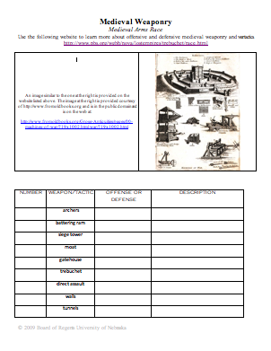
EXPLORING Concepts (Medieval Weaponry)

Summary:
Students will design and build a model trebuchet using the engineering design process.

Outline:
- Students will brainstorm the design and construction of a trebuchet that works within given constraints OR students will construct a model trebuchet using a kit provided by the teacher.
- Students will build a trebuchet that works within given constraints.

Activity:
After students have studied medieval arms, they will design and/or build a trebuchet. Students will work in groups of 2-3 students to complete this task. To build the trebuchet, the students may be given materials to construct the model, provided with a trebuchet kit, or asked to bring the materials from home. Students will be given the criteria that the trebuchet should be able to launch a 5 gram ball of clay.

Robotics Connection:
Groups will then be asked to design a trebuchet that functions as part of the CEENBot. Groups will use their engineering notebooks to document the design and then create a prototype of their design to share with the class.

INSTRUCTING Concepts (Medieval Weaponry)
Applied Physics
Engineering has sometimes been described as applied physics. Engineers use physics all the time in their professions whether it is the civil engineer building a bridge or an aerospace engineer designing an airplane. These engineers must have an intuitive understanding of physics. All these concepts can be stand alone instructional lessons but they are all interconnected. So here we will give basic definitions of some applied physics terms that engineers use everyday. For more detailed explanations you can look at the science instructional components at the website: http://www.ceen.unl.edu/TekBots/SPIRIT2/Science/
Acceleration
Acceleration is the rate of change in the velocity of an object. In physics and engineering things that are moving are often accelerating. It is measured in a linear distance per time squared (for example m/sec²). Acceleration is force applied / Mass this means that to increase acceleration you either have to increase the force or decrease the mass. This is why it takes big cars more energy (force) to accelerate than a smaller car.
Force
Force is a push or pull on an object with mass that causes its velocity to change (i.e. accelerate). There are forces at work all the time. When we walk we exert a force on the floor and the floor exerts a force on us. Forces are paired where one produces and action and the other produces a reaction.
Inertia
Inertia is the resistance of an object to a change in its state of motion or velocity. The inertia is larger if an object has more mass (i.e.. more resistant change in motion). Inertia is present in all cases but is sometimes hidden by friction and gravity.
Propel
To propel means to drive or throw an object forward by applying a force to cause motion. If you propel an object it causes the object to accelerate by use of a force. Remember that when propelling an object you will have to overcome the object’s inertia.
Trajectory
Trajectory is the path of a moving object through space. Objects in orbit or projectile motion have a trajectory.
Torque
Torque is the tendency of a force to cause rotation about an axis or pivot. It can be thought of a twist. Torques can be found in rotational motion.
Newton’s First Law of Motion
Newton’s First Law of Motion states that an object in motion will stay in motion and an object at rest will stay at rest unless a force is applied. This law is often called the law of inertia.
Newton’s Second Law of Motion
Newton’s Second Law of Motion states that force is mass times acceleration. This law relates two major physics concepts.
Newton’s Third Law of Motion
Newton’s Third Law of Motion basically states that for every action there is an equal and opposite reaction. This law basically says that forces always come in opposite pairs. This is important for engineers to understand when trying to understand the forces at work in a situation.

ORGANIZING Learning (Medieval Weaponry)

Summary:
Students will apply physics terms to a trebuchet diagram. Then they will use their model trebuchets to conduct several launches. Students will construct a table to organize their data as well as the data for other students.

Outline:
- Students will apply physics terms to a trebuchet.
- Students will conduct several trials of the launching of their trebuchet.
- Students will record their results in a data table.
- Students will compute the mean for each trebuchet that is launched.

Activity:
To begin this activity, students will use their engineering notebooks to record definitions for the physics terms. Once students have completed the definitions, they will be given a simple diagram of a trebuchet. Students will then apply the terms to the diagram, labeling and providing an explanation for each term placement.

Next, each student built trebuchet will be launched a total of five times. Students will measure and record the distance the clay object traveled on a data chart. All students will record data from all launchings. Once the data for each trebuchet has been recorded, students will use the data to calculate the mean for the launchings.

Trebuchet Data Table The Trebuchet

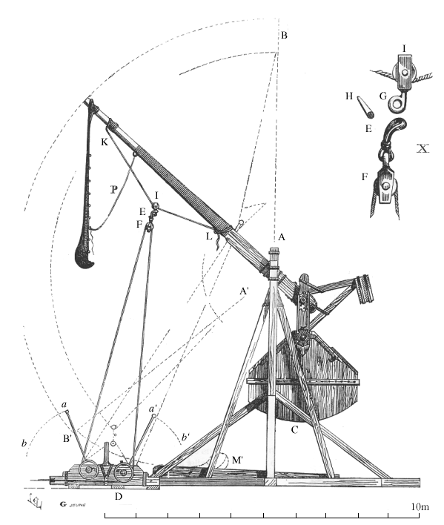

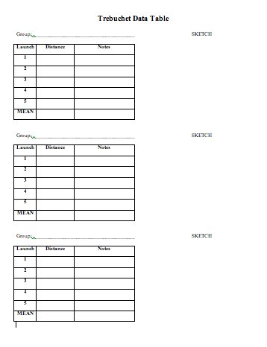

UNDERSTANDING Learning (Medieval Weaponry)

Summary:
In this activity, students will apply common physics terms to medieval weapons.

Outline:
- Students will review how common physics terms are demonstrated by a trebuchet.
- Students will then apply common physics terms to another medieval weapon.

Activity:
Students will review physics terms and concepts using the diagram from the INSTRUCTING Learning component. Students will then be presented with another medieval weapon, the battering ram. Discuss with the students how the weapon is used. Students will then use a diagram to represent how common physics terms apply to this weapon.

Formative Assessment
After students have completed The Trebuchet Worksheet, review the handout together as a class. Ask for variety in application of each term or concept to identify level of understanding of students.

Summative Assessment
The teacher will introduce the students to another medieval weapon, the battering ram. The class will discuss how the battering ram is used in combat. Each student will then apply physics terms and concepts to the function of the battering ram using a graphic organizer that will be provided.

The Battering Ram
