SPIRIT 2.0 Lesson:
Minority and Women Inventors Wax Museum

===============================Lesson Header==============================
Lesson Title: Minority and Women Inventors Wax Museum
Draft Date: December 30, 2008
1st Author (Writer): Lisa Tingelhoff
2nd Author (Editor/Resource Finder): Derrick Nero
Algebra Topic: Grade Level: Primary Elementary Middle Secondary

Content (what is taught):
- Impact and contributions of minority and women inventors
Context (how it is taught):
- Students will match famous inventors and engineers with contributions.
- Students will chose and research a minority or woman inventor.
- Students will write and present a monologue for a minority or woman inventor.
Activity Description:
Students will begin by matching famous inventors and engineers with their contributions. After, students will choose one inventor or engineer and will conduct biographical research on this person. Through their research, students will develop a monologue that they will use to present their findings of their research. The culmination of this activity will be a wax museum during which each student will portray their chosen inventor.

Standards:
- Science—E2, F5, G1
- Technology—D2

Materials List:
- Minority and women inventor cards
- Computer and Internet access
ASKING Questions (Minority & Women Inventors Wax Museum)

Summary:
In this activity, students will play a matching game of minority and women inventors and their contributions.

Outline:
- Present all students with all inventors and all contributions, but in mixed order.
- Allow students to play a game matching inventors and contributions.

Activity:
In this activity, students will match minority and women inventors with their contributions. This exercise will allow students to become familiar with a variety of inventors and give them ideas for potential wax museum characters.

Questions | Possible Answers
Who invented ____________ ? | Answers will vary depending on the invention.
What did ______________ invent? | Answers will vary depending on the inventor.
Is a robot, like the CEENBot, an invention? Why or why not? | Answers will vary.
If you had to invent something to be sold with the CEENBot, what would it be? | Answers will vary.
Did the boys and girls in the class have different inventions for items to be sold with the CEENBot? | Answers will vary.

Inventor Cards
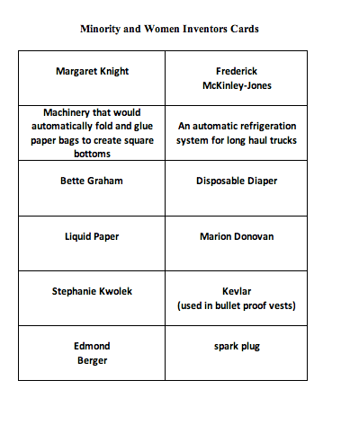

EXPLORING Concepts (Minority & Women Inventors Wax Museum)

Summary:
Students will choose one minority or woman inventor and will conduct biographical research on their inventor. Students could choose an inventor from the previous class discussion or use http://inventors.about.com/ and the links for African American and Women Inventors.
Students will identify 20 (more or less depending on number of students in class) famous minority and woman inventors and their contributions.

Outline:
- Each student will chose one minority or woman inventor.
- Students will conduct biographical research on their inventor of choice. Each student will complete and submit a biographical research page for their inventor.
- As students present their biographical research for their chosen inventors, each student will complete a data chart that organizes the name, date and contribution of each inventor.
- As an alternative, students will conduct an online search to find 20 minority or woman inventors and will complete a data chart that organizes the name, date and contribution of each inventor.

Activity:
After completing the matching of minority and women inventors with their contributions, students will select one inventor to focus on for a biographical research project. Students will complete a biographical research page for their inventor and submit it to the teacher.

For this activity, students will present their biographical research for the inventor of their choice to a student audience. The students in the audience will record the name, date and contribution(s) of the inventors that their classmates present.

Biographical Research Page and Inventor Data Chart
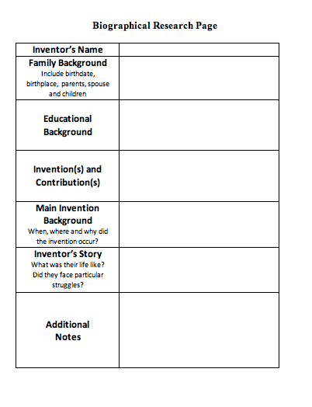
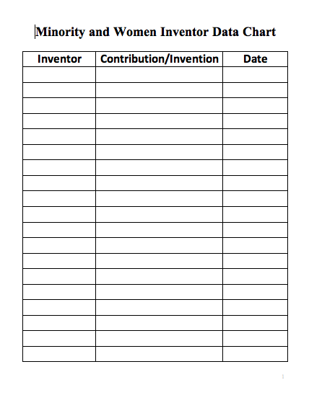

Inventor Data Chart

INSTRUCTING Concepts (Minority & Women Inventors Wax Museum)
Invention vs. Innovation
When considering the human condition there have advancements through invention and innovation. These are similar concepts and yet are subtly different. The processes of invention and innovation is carried out to improve a situation or to solve a problem that has been encountered.

Invention
Invention is the creation of a NEW product, system or process that has never existed before. It is created through study and experimentation. It is important that invention is

Innovation
Innovation is an improvement of an existing technological product, system or process. Some definitions of innovation state that there needs to be a significant improvement in the product, system, or process. Innovation differs from invention because it is an improvement of something that has been previously created (invented).

Other vocabulary
The process of invention and innovation is accomplished through similar techniques. You might encounter the terms: technology, science, engineering, and robot when discussing the creation and improvement of products, systems, and processes. Invention and innovation are critical to the learning of new things but they don’t stand-alone. Any of the terms above can be used as part of the inventive and innovative process.
Technology
Technology is defined as the generation of knowledge and processes to develop systems that solve problems and extend human capabilities. As you can see the invention or innovation can create technology. Technology is a result of invention or innovation.
Science
Science is defined as the study of the natural world through observation, identification, description, experimental investigation and theoretical explanations. Science allows us to understand the world and how it works. Through the knowledge gained from science we can analyze our needs and start the process of invention and innovation.
Engineering
Engineering is defined as the knowledge of mathematical and natural sciences applied with judgment and creativity to develop products, processes and systems to benefit humankind. If science provides us with knowledge about the world, engineering provides us with tools to use in the process of invention and innovation
Robot
A robot is a device that automatically performs complicated, often repetitive tasks; a mechanism guided by automatic controls. A robot is a tool that can be used to do science or engineering. As science and technology advance, robots will become integral components of invention and innovation.

ORGANIZING Learning (Minority & Women Inventors Wax Museum)
Summary:
Students will construct a data chart to compile examples and definitions of the following terms: invention, innovation, technology, science, and engineering. Then they will use the biographical research page to gather information about their inventor. In addition, students will use this research page to present information to their classmates, develop a monologue, and participate in the class wax museum. Students will also use a data chart to record information about the inventors that their fellow classmates present.

Outline:
- Students define terms related to invention and innovation.
- Students will use a research page to guide their biographical study of a minority or woman inventor.
- Students will use a data chart to record biographical information of other inventors presented by the class.

Activity:
Students will construct a data chart and use it to gather definitions and examples for the following terms: invention, innovation, technology, science, and engineering. The teacher will provide the definitions for each term. Students will work with a partner to provide examples for each term and will share those examples with the class. Next students select a minority or woman inventor, they will complete a biographical research page using online and book resources. Students will give a short presentation to the class using this research page. As each student presents their inventor, students in the audience will record the name, date and contribution of each inventor on the Minority and Women Inventor Data Chart.

Robotics Connection:
Students will then describe how robots could be used to mass produce their inventor’s invention.

Biographical Research Page and Inventor Data Chart

UNDERSTANDING Learning (Minority & Women Inventors Wax Museum)

Summary:
Students will use their biographical research to write and present a monologue for their chosen inventor.

Outline:
- Students will write a 1-2 minute monologue about their chosen inventor.
- Students will dress as their chosen inventor.
- Students will present their monologue as if they are the inventor.

Activity:
Formative Assessment
Prior to the wax museum, each student will present, in a form other than monologue, her/his biographical research. Each student will address name, background, date and major contributions of the inventor of their choice.

Summative Assessment
Students will write a 1-2 minute monologue (first person) presenting their inventor. Students will also develop an activation activity for their wax museum character (i.e., a student portraying Babe Ruth might have the audience say “Batter Up!”). Students will dress as their inventor and have appropriate models or visual aids for their contributions. Students will freeze in position and deliver their monologue to a moving audience that performs the activation activity. Once the monologue is completed, the student will return to the frozen position until the next audience performs the activation activity.

