SPIRIT 2.0 Lesson:
My Robot Can Do That!
==========================Lesson Header ==========================
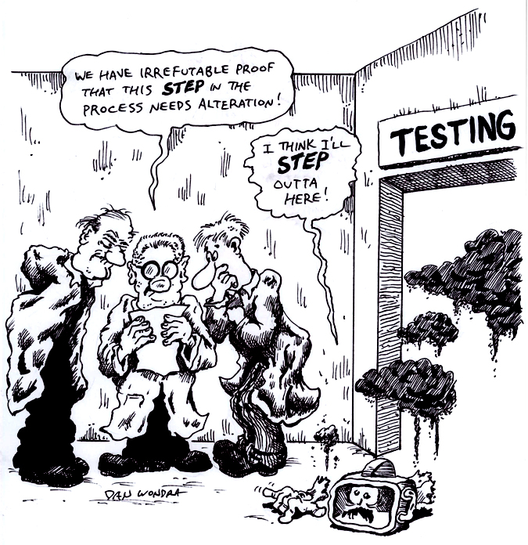
Lesson Title: My Robot Can Do That!
Draft Date: 12/20/09
1st Author (Writer): Lynn Spady
2nd Author (Editor/Resource Finder):
Instructional Component Used: Engineering Design Process
Grade Level: Upper Elementary and Middle School

Content (what is taught):
- Types of robots
- Students will answer the questions for the Ask, Imagine, and Design steps in the engineering design process.

Context (how it is taught):
- Students will explore different types of robots and the tasks they can complete
- Students will design their own robot
Activity Description:
Students will travel around to stations in groups of two or three. Ideally, 4-5 different robots will be available for students to explore (i.e. CEENBoT, humanoid robot, etc.). During the 10 minutes in each station, students will fill out information in a chart (sketch of the robot, what the robot can do, questions about the robot, etc.). While exploring the different robots, students will begin to think about their own robot and how it would be designed. Students will go through the first 3 steps of the engineering design process (Ask, Imagine, Design) by answering the questions/statements for each step in their engineering notebook.

Standards:

Science Technology Engineering
SE1, SF5 TA2 EA2, EB6, EC1

Materials List:
Different types of robots (CEENBoT, humanoid robot, graphing calculator robot, etc.)
Engineering notebooks
Pencils and colored pencils
Access to Internet for various resources

Asking Questions (My Robot Can Do That!)

Summary: Students will learn about different types of robots and robots that are currently in use today.

Outline:
- Find out student’s prior knowledge of robots
- Discuss types of robots and robots that are currently in use today
- Have students write down questions they have about robots

Activity:
Depending on student’s prior knowledge of robots, ask the questions below or have them research types of robots online. By typing in ‘Types of Robots’ at http://www.google.com, students can find several websites with information. Have students list questions they have about robots in their engineering notebook.

Questions | Answers
Where have you seen robots before? You may suggest pop culture movies if students are having a hard time thinking of examples. | Rosie the robot maid in The Jetsons, the droids of Star Wars (R2-D2 and C-3PO), I Robot, WALL-E.
What types of robots are currently in use? Again, you may need to prompt students and have them identify which category the robot falls into. | Industrial Robots (packaging goods, lab applications, robots that place electronic components on circuit boards, etc.)  Mobile Robots (Automated Guided Vehicles or AGV’s, robots that transport materials over large sized places, etc.)  Agricultural Robots (robots that can pick apples, prune grapevines, and transport seedlings, etc.)  Telerobots (robots that are used in places that are hazardous to humans, robots used to do surgeries, etc.)  Service Robots (personal use robots such as pet robots, robots for house cleaning, etc.)
What would you like to know about robots? | Questions should be written down and/or collected. After studying robots, return to the questions to see if students can answer them.

Resources:
Type in ‘Types of Robots’ at http://www.google.com to find websites with information on types of robots already in use.
  - http://www.buzzle.com/articles/types-of-robots.html
  - http://prime.jsc.nasa.gov/ROV/types.html
  - http://sci-fi.lovetoknow.com/wiki/Types_of_Robots
Exploring Concepts (My Robot Can Do That!)

Summary: Students will explore different robots and their capabilities. Students will fill out a chart in their engineering notebook.

Outline:
- Students will travel to different stations and work with a variety of robots.
- During the 10 minutes in each station, students will explore the capabilities of each robot and fill out an information chart in their engineering notebook.
- Students will begin to think about designing their own robot

Activity:
Students will start by copying down the table (shown below) in their engineering notebook. Ideally, 4-5 different robots will be available for students to explore. In groups of 2-3, students will travel around to different stations exploring the robots available. If different robots are not available, a station might include a magazine or newspaper article about robots, a website with information about robots, or a short video clip about robots. As students are traveling through the stations, encourage them to think about designing their own robot and what it would be able to do.

Robot | Type  of  Robot | Sketch | What can the robot do? | What questions do you have about the robot?
CEENBoT | The CEENBoT is mobile and could be a service robot.

Resources:
- Featured Robot Stories can be found at http://www.livescience.com/robots/ or by typing ‘Robot Articles’ at http://www.google.com
- Robot videos can be found at http://www.robotclips.com/ or by typing ‘Robot Videos’ at http://www.google.com
- Additional videos can be found at http://www.pbs.org/wgbh/nova/robots/clips/
Instructing Concepts (My Robot Can Do That!)

Engineering Design Process

The engineering design process has many forms. Some conceptual models have as many as ten steps others as few as five. The process is as individual as the engineer who is using it. It is cyclical meaning that you can start at any step in the process and it is dynamic meaning that it is always changing and adapting. For this instructional module we have chosen a simplified five-step approach to the engineering design process. The five steps are: 1) Ask, 2) Imagine, 3) Design, 4) Create, and 5) Improve.

Ask

In this step you ask what is the problem that needs addressed and do a lot of research to see what other ideas are out there and what other solutions have been attempted. This research is critical because it means you won’t duplicate something that others have tried and were unsuccessful. It allows you to frame the problem and limit (constrain) it so that you have a better understanding of what is required.

Imagine

Here you brainstorm ideas that might possibly be a solution to the problem you explored in the Ask step. Don’t be afraid to think big and out of the box. Sometimes if the answer to a problem is obvious or simple it would have been solved already. Get creative! After brainstorming possible ideas and solutions, you should analyze each possibility for potential merit. Finally select the best alternative for further exploration.

Design

This step involves the creation of a plan to carry out the idea that you selected in the Imagine step. You can make a diagram, create lists of things that you will need, and gather together the necessary skills that you will need to carry out your plan.

Create

This is the fun step. You get to actually build/create the idea that you selected and planned out. This is the hands-on step where you see the intellectual idea actually come to life. It is important to follow your plan that you created. Be sure to note what went well and what didn’t work for future use in refining the idea. Finally test your product and see if it does what it is supposed to do. Does it solve the problem? It is possible that you will have to go back to any of the previous steps after you test your creation. If it doesn’t work, do you need a better plan, a better idea, or do you need to rethink your initial problem?

Improve

Here is the refinement stage. You have something that works but you want it to be the best it can be. You want the most speed, efficiency, the best appearance, etc. Here you think about and talk about what works, what doesn’t work and what could be improved on. After this discussion occurs, modify your design to see if you can improve it. Finally test out to see if you actually improved your solution or not. Remember at this stage it is possible that you might have to go back to any of the other stages.

The powerful thing about this process is that it is fluid and creates a nice organizational flow for the process to follow. At the end of each step always ask if you accomplished what you set out to do. If you did not repeat that step or go back further in the process to try to arrive at a better solution. Remember you can start at any step but once the process is begun you need to go from one step to another in order for the process to be effective.
Organizing Learning (My Robot Can Do That!)

Summary: Students will design a robot following the first 3 steps of the Engineering Design Process.

Outline:
- Students will design a robot following the first 3 steps of the Engineering Design Process (Ask, Imagine, and Design) in their engineering notebook.
- Students will share their robot ideas with the rest of the class and talk about possible improvements to the designs.

Activity:
Students will write out the first 3 steps (Ask, Imagine, and Design) of the Engineering Design Process in their engineering notebook. Students will design their own robot incorporating features they like about other robots, or coming up with a completely original idea. See MyRobotCanDoThatWS.doc for an example.

Resources:
Engineering is Elementary: http://www.mos.org/eie/engineering_design.php

Worksheet: E-011-Engineering_Design-MyRobotCanDoThat_O_WS.doc
Understanding Learning (My Robot Can Do That!)

Summary: Students will design a robot following the first 3 steps of the Engineering Design Process.

Outline:
- Read Hans Moravec interview at http://www.pbs.org/wgbh/nova/robots/moravec.html
- Design a robot following the first 3 steps of the engineering design process.

Activity:
Have students read the interview with Hans Moravec at http://www.pbs.org/wgbh/nova/robots/moravec.html. Students can also review types of robots at the following websites:
http://www.buzzle.com/articles/types-of-robots.html
http://prime.jsc.nasa.gov/ROV/types.html
http://sci-fi.lovetoknow.com/wiki/Types_of_Robots

Formative Assessment
As students are engaged in the lesson ask these or similar questions:
- Are students able to classify robots into different types (mobile, industrial, service, entertainment, etc.)?
- Do students understand the steps of the engineering design process?
- Can students define robot? According to the interview with Hans Moravec, “Robots are machines that are able to do things that previously had been associated only with human beings or animals—such as the ability to understand their surroundings and plan their actions.”

Summative Assessment
- Students will write out the first 3 steps (Ask, Imagine, and Design) of the Engineering Design Process designing a robot to complete task(s). The teacher may choose to assign a certain ‘type’ of robot for students to create. For example:
- A vacuum robot
- A bomb squad robot
- A space robot
- Hazardous duty robot
- A surgical robot
2) Explain the generations of robots according to Hans Moravec.

Worksheet: E-011-Engineering_Design-MyRobotCanDoThat_U_Rubric.doc

