SPIRIT 2.0 Lesson:
Design Teams
==========================Lesson Header ==========================
Lesson Title: Design Teams
Draft Date: 2/2/10
1st Author (Writer): David Porter
Instructional Component Used: Technology: Collaboration
Grade Level: 6th-8th grades—Middle School

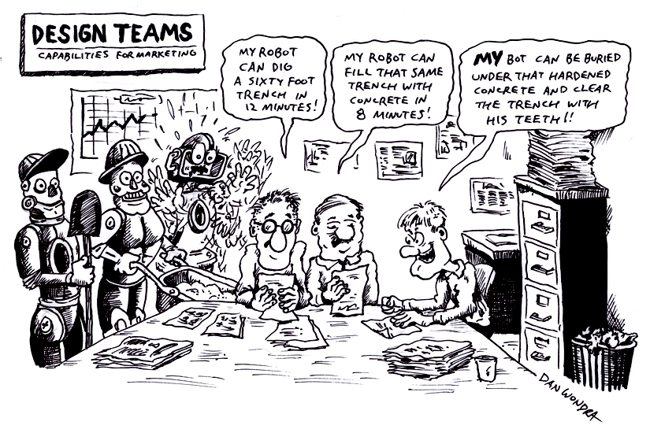
Content (what is taught):
- Design team process

Context (how it is taught):
- Information is gathered re: classroom robots and their market
- Students work together to synthesize robot capabilities and form with demands of the market.
- Designs for alterations to a CEENBoT or a compatible product are drafted and evaluated.
Activity Description:
Students are led through a design team process. Students research capabilities of classroom robots and potential enhancements to a CEENBoT or similar classroom robot while considering the potential market. Designs are evaluated while considering realistic production criteria.

Standards:

Science Technology
SE1, SG1 TB1-4, TA1-4, TD1-4, TC1-4

Engineering Math
ED1-6, EA1-6, EC1, EB1-6 MD1-2, ME 1

Materials List:
- CEENBoT or similar classroom robot (it is important for this lesson that the classroom robot not have an engineered factory-created covering).
- Model-building materials as required by the design teams if prototypes are constructed.

Asking Questions (Design Teams)

Summary: The students will be introduced to the engineering/product design process by being provided information which highlights the process such as the video produced by ABC news which describes the IDEO Deep Dive process or searching the web.

Outline:
- Groups will be instructed in the design team process.
- After the instruction students will be lead through a series of questions that further the understanding of the design process.

Activity: The engineering design process sometimes has a different number of steps or different names for the steps but the overreaching goal is to improve a situation or product through a systematic method. Students can be given information that highlights the design process such as: the video “The Deep Dive” from ABC new which highlights the IDEO’s unique approach to engineering design or students can search the web for information about the engineering/product design process. One good website about product design is listed below but a web search will reveal numerous others.
http://www.ider.herts.ac.uk/school/courseware/design/overview/overview.html

After looking at the process ask the following questions relating to the CEENBoT as a possible product to improve through the design process.

Questions | Answers
Who would be the most likely users of the product? | To be determined by the students. Expected answers might be teachers, school districts, and/or students.
What qualities would be important to the purchasers: Appearance?—if so, what sort of appearance? Protection of the CEENBoT and/or durability? Price?—what is the upper limit of what the purchasers would be willing to spend? Utility?—are there qualities which could be built into the shell which would increase the functionality of the CEENBoT? | To be determined by the students in focus group meetings with potential consumers.
What will be the most accurate way to determine the answers to the above questions? | Focus group meetings with potential consumers.
What preparation will be necessary in order to make the gathering of the above data most effective? | Descriptions/images of potential shells including the advantages/disadvantages associated with them. Images of the original CEENBoT should be included-to make certain that it is not already the most desirable configuration to consumers.
Exploring Concepts (Design Teams)

Summary: Students will explore current and potential capabilities of the CEENBoT in varied settings in order to brainstorm ideas for a potential CEENBoT product to make it more efficient or better in some way. This product might be a shell, attachment, utility vehicle (like a trailer), etc. The purpose is to see what is out there and what might be needed by users of the CEENBoT.

Outline:
- Students will explore the utility of a CEENBoT as well as other wheeled robots.
- Students will brainstorm and research adaptations/revisions which could be made to a CEENBoT and considered desirable by potential users of CEENBoTs.

Activity: Students will be divided into design teams. Each team will explore a CEENBoT’s capabilities through hands-on use and research into ways in which both CEENBoTs and other wheeled robots have been used in situations where a remote controlled vehicle is safer, cheaper, or more practical than hands-on contact. Students will also use and/or research other commercially produced wheeled classroom-style robots in order to see how their exteriors, attachments, add-ons, etc. are designed. Notes can be taken in a chart similar to the one shown below. An example is given.

Once potential CEENBoT uses have been determined and the research completed on competing robots, the design teams will create a design plan to improve the CEENBoT.

Robot | Capability | Adaptations/Revisions
CEENBoT | Can push a ball from one location to another. | Design a shovel or scoop that will secure the ball from one location to another without having it roll all over the place.

Instructing Concepts (Design Teams)

Engineering Design Process

The engineering design process has many forms. Some conceptual models have as many as ten steps others as few as five. The process is as individual as the engineer who is using it. It is cyclical meaning that you can start at any step in the process and it is dynamic meaning that it is always changing and adapting. For this instructional module we have chosen a simplified five-step approach to the engineering design process. The five steps are: 1) Ask, 2) Imagine, 3) Design, 4) Create, and 5) Improve.
Ask: In this step you ask what is the problem that needs addressed and do a lot of research to see what other ideas are out there, what other solutions have been attempted, and what might be required for the potential market. This research is critical because it means you won’t duplicate something that others have tried and were unsuccessful. It allows you to frame the problem and limit (constrain) it so that you have a better understanding of what is required
Imagine: Here you brainstorm ideas that might possibly be a solution to the problem you explored in the Ask step. Don’t be afraid to think big and out of the box. Sometimes if the answer to a problem is obvious or simple it would have been solved already. Get creative! After brainstorming possible ideas and solutions, you should analyze each possibility for potential merit. Finally select the best alternative for further exploration.
Design: This step involves the creation of a plan to carry out the idea that you selected in the Imagine step. You can make a diagram, create lists of things that you will need, and gather together the necessary skills that you will need to carry out your plan.
Create: This is the fun step. You get to actually build/create the idea that you selected and planned out. This is the hands-on step where you see the intellectual idea actually come to life. It is important to follow the plan that you created. Be sure to note what went well and what didn’t work for future use in refining the idea. Finally test your product and see if it does what it is supposed to do. Does it solve the problem? It is possible that you will have to go back to any of the previous steps after you test your creation. If it doesn’t work, do you need a better plan, a better idea, or do you need to rethink your initial problem?
Improve: Here is the refinement stage. You have something that works but you want it to be the best it can be. You want the most speed, efficiency, the best appearance, etc. Here you think about and talk about what works, what doesn’t work and what could be improved upon. After this discussion occurs, modify your design to see if you can improve it. Finally test out to see if you actually improved your solution or not. Remember at this stage it is possible that you might have to go back to any of the other stages.

The powerful thing about this process is that it is fluid and creates a nice organizational flow for the process to follow. At the end of each step always ask if you accomplished what you set out to do. If you did not, repeat that step or go back further in the process to try to arrive at a better solution. Remember you can start at any step but once the process is begun you need to go from one step to another in order for the process to be effective.
Organizing Learning (Design Teams)

Summary: Students will be given a design concept. This can be made to be a stand-alone component by the teacher providing the concept to the students or the concepts can come from an earlier step in the lesson. After students analyze the concept design, they will complete the Create step of the process and do an evaluation to simulate the Improve step.

Outline:
- Students will analyze the product concept.
- Students will create the product design.
- Students will generate a list of factors to be considered during the evaluation/testing step.
- Students will use a framework to evaluate several of the detailed designs.

Activity: Students in each team will view a demonstration of a CEENBoT and be given a design concept. They will be told that they are a design team that has been tasked to make the CEENBoT as marketable as possible by actually creating the design concept that they were presented. This can be accomplished in many ways depending on your students. Some possibilities are: 1) CAD software on the computer, 2) draw scale models from different view of the design, 3) actually make in 3D using clay, paper mache, etc., 4) any other means that the teacher finds useful.

While students are creating the final design they should think about a list of factors that will help evaluate the final designs of all the teams and how they will evaluate the designs. A way to help them come up with important criteria and help them evaluate would be to give them this scenario:

You are to brainstorm what they will be doing this weekend and create a list of factors that could be used to make a decision about what they will actually do. The factors can include: cost, practicality/possibility, fun, adventure, stimulation, etc. Provide students with the evaluation framework (see attached file) on which they will list 5-6 of these factors across the top and each of their top ideas of things to do along the side. They will then work in a team to rank the list: giving each weekend idea a rating according to each factor (i.e. if there are 6 weekend ideas, each will get a ranking between 1 and 6 according to each factor—flying to Paris gets a ranking of 6 (the highest) in both the fun and adventure factors, but a 1 in cost and practicality). Once all ideas have been rated by each factor, total points for each idea will be computed. A discussion as to the accuracy of the process will be held, stressing the importance of choosing the most important evaluative factors.

Finally they will brainstorm a list of factors that are important to the CEENBoT and use these with the attached evaluation framework to evaluate the designs that were created. The teacher will help them to consider appropriate evaluative factors such as appeal to the intended market.

Attachments: T011_Design_Teams_0_Evaluation_Framework.doc

Understanding Learning (Design Teams)

Summary: Students will demonstrate understanding of the engineering design process by presenting the design process to the class or by completing a particular step in the design process.

Outline:
- Formative assessment of the engineering design process.
- Summative assessment of the engineering design process.

Formative Assessment
As students are engaged in the lesson ask these or similar questions:
- How are all team members involved in the creation of the prototype?
- Does the design of the prototype need to be changed due to real-world/practicality issues discovered in the construction process?
- Do the redesigns keep faith with the original design concept?
- Are working designs/drawings clear with accurate measurements/scale?

Summative Assessment
Students will create a multi-media presentation outlining the engineering design process. The presentation should include all the steps of the process and what happens in each step. Examples from their experiences should be included.

Students can answer the following writing prompt:
Describe the engineering design process and explain why it is so effective for the creation of new products.

Project Option 1: Students will work through part of the engineering design process by being asked to find a new use for the CEENBoT. This should include the steps of Ask, Imagine and Design stages.

Project Option 2: The teacher can present teams a design concept for the CEENBoT and the team will actually bring the concept to reality and then evaluate it. A sample rubric to grade the real world concept creation is attached. See attached file: E012-Design_Team-U-rubric.doc

Attachments: E012_Design_Team_U_rubric.doc

