Project SHINE / SPIRIT2.0 Lesson:
This Teacher was mentored by:

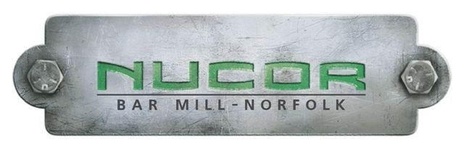
www.nucorbar.com

In partnership with Project SHINE grant funded through the

National Science Foundation

Bridge Building
==========================Lesson Header ==========================
Lesson Title: Bridge Building
Draft Date: July 19, 2010
1st Author (Writer): Jane Brockman
Associated Business: Nucor Steel
Instructional Component Used: Force
Grade Level: 7th

Content (what is taught):
- Motion and Forces

Context (how it is taught):
- Students will be able to identify different types of bridges.
- Students will build a model of a bridge and test the amount of weight it will support.
- Students will learn how to maneuver different materials to make structures stronger.
Activity Description:
In this lesson, students will listen to a presentation by the teacher explaining basic background information about bridges. An engineer from Nucor Steel will come to the class to give a presentation about their manufacturing facility and how it relates to bridge building. Students will complete a scavenger hunt via the Internet using the information the teacher presented, the information from the presentation by Nucor Steel and the Internet as resources. Students will build bridges both individually and as groups using materials such as straws, newspapers and balsa wood.

Standards:

Science: A1, A2, B1, B2 Technology: B4, C1, F1

Engineering: A1, B2, C1, D3 Math: B1, D2, E1

Materials List:
- Plastic cup
- Pennies
- Newspaper
- Masking tape
- Dish pan
- Plastic bottle
- Poster board

- Projector
- Whiteboard
- Nucor Steel video
- Scavenger hunt worksheet
- Internet
- Straws
- Straight pins
Asking Questions: (Bridge Building)

Summary: The teacher will present some basic information about bridges via the classroom projector to give students some introductory information.

Outline:
- Teacher presents some basic information about bridges
- As a class, students "brainstorm" to come up with a definition for a bridge
- Have a class discussion of what the early bridges were made from. Discuss how bridges have progressed over time.
- On whiteboard, list as many different types of bridges as students can come up with.

Activity: The teacher will present some basic information about bridges via the classroom projector. This information will include how a bridge takes people across either man-made or natural obstacles, what early bridges were made of, what bridges are made of today, and the different types of bridges. After the teacher has presented the basic information, students will come up with a definition for bridge. The class will discuss how bridges have progressed over time. Students will compare and contrast what the early bridges were made of to what bridges are made of now. Then students will brainstorm as many different kinds of bridges they can.

Questions | Answers
What does a bridge do? | A bridge needs to be strong enough to support its own weight plus the load of passengers and whatever they are carrying against the force of gravity.
What are the different types of bridges? | Beam, cantilever, arch, suspension, cable-stayed, truss, movable, double-deck.
What can a bridge be made of? | Steel, wood, concrete, etc.

Exploring Concepts: (Bridge Building)

Summary: An engineer from Nucor Steel will give a presentation on how bridges are built from the raw material stage to the final product. In this presentation, the engineer will also talk about different careers involved in bridge construction including metallurgic arts, engineering and other technical fields.

Outline:
- An introductory video, created by Nucor Steel in Norfolk, Nebraska, will show students the different facets of Nucor Steel including bridge building.
- An engineer from Nucor Steel will be coming to the class to give a presentation on construction of bridges.
- After the Nucor Steel presentation, students will complete a web quest about bridges using the Internet.

Activity: Due to the dangerous environment at Nucor Steel, tours are not allowed for students. Therefore, they have created a video of what goes on at Nucor Steel in Norfolk, Nebraska. This introductory video will be shown to students so they can see the different facets of this manufacturing plant. An engineer will then come to the class to give a presentation on the construction of bridges from raw materials to final product. After the presentation, the students will explore bridge construction by completing a scavenger hunt about the history of bridge construction, types of bridges, and the science behind bridge construction (Attached file:
E016-SHINE-Bridge_Building-E-Scavenger_Hunt.doc).

Attachments:
Scavenger Hunt: E016-SHINE-Bridge_Building-E-Scavenger_Hunt.doc
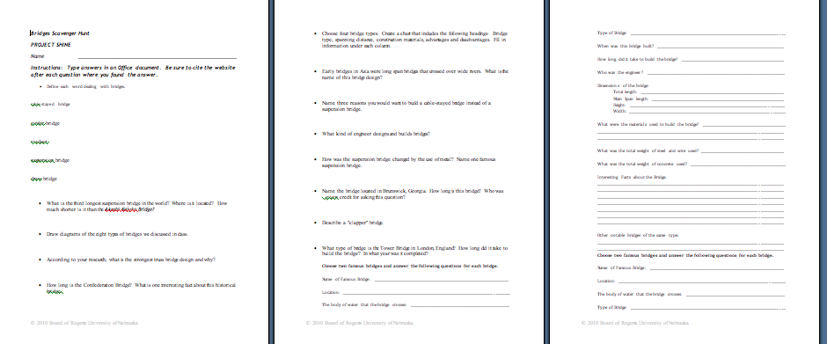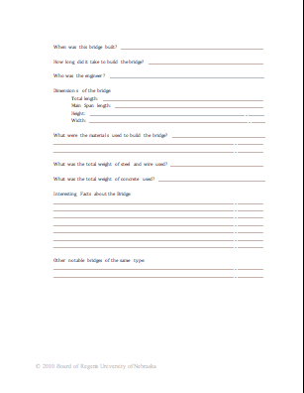

Resources:
- Nucor Steel video
- Engineers at Nucor Steel
Instructing Concepts: (Bridge Building)

Engineering Design Process: The engineering design process has many forms. Some conceptual models have as many as ten steps others as few as five. The process is as individual as the engineer who is using it. It is cyclical meaning that you can start at any step in the process and it is dynamic meaning that it is always changing and adapting. For this instructional module we have chosen a simplified five-step approach to the engineering design process. The five steps are: 1) Ask, 2) Imagine, 3) Design, 4) Create, and 5) Improve.

Ask: In this step you ask what is the problem that needs addressed and do a lot of research to see what other ideas are out there and what other solutions have been attempted. This research is critical because it means you won’t duplicate something that others have tried and were unsuccessful. It allows you to frame the problem and limit (constrain) it so that you have a better understanding of what is required.

Imagine: Here you brainstorm ideas that might possibly be a solution to the problem you explored in the Ask step. Don’t be afraid to think big and out of the box. Sometimes if the answer to a problem is obvious or simple it would have been solved already. Get creative! After brainstorming possible ideas and solutions, you should analyze each possibility for potential merit. Finally select the best alternative for further exploration.

Design: This step involves the creation of a plan to carry out the idea that you selected in the Imagine step. You can make a diagram, create lists of things that you will need, and gather together the necessary skills that you will need to carry out your plan.

Create: This is the fun step. You get to actually build/create the idea that you selected and planned out. This is the hands-on step where you see the intellectual idea actually come to life. It is important to follow your plan that you created. Be sure to note what went well and what didn’t work for future use in refining the idea. Finally test your product and see if it does what it is supposed to do. Does it solve the problem? It is possible that you will have to go back to any of the previous steps after you test your creation. If it doesn’t work, do you need a better plan, a better idea, or do you need to rethink your initial problem?

Improve: Here is the refinement stage. You have something that works but you want it to be the best it can be. You want the most speed, efficiency, the best appearance, etc. Here you think about and talk about what works, what doesn’t work and what could be improved on. After this discussion occurs, modify your design to see if you can improve it. Finally test out to see if you actually improved your solution or not. Remember at this stage it is possible that you might have to go back to any of the other stages.

The powerful thing about this process is that it is fluid and creates a nice organizational flow for the process to follow. At the end of each step always ask if you accomplished what you set out to do. If you did not repeat that step or go back further in the process to try to arrive at a better solution. Remember you can start at any step but once the process is begun you need to go from one step to another in order for the process to be effective.
Organizing Learning: (Bridge Building)

Summary: First, students will individually experiment with building a bridge with straws. Next, students will use creative problem solving, communication and teamwork to build a bridge out of newspaper and masking tape. Lastly, students will collect pictures of different types of bridges over different periods of time and use these pictures to create a poster.

Outline:
- Individually, students will build a bridge applying the engineering design process using only the materials the teacher provides.
- In teams, students will use the skills they have learned through their team building lessons to build a bridge using the engineering design process out of newspaper and masking tape. This process will be timed.
- Students will collect pictures of different bridges from different sources over different periods of time and create a poster.

Activity: The students will build a bridge out of straws and pins that will support a cup of 100 pennies. After supporting the cup of pennies, students will use the scientific method to find out which parts of the bridge are needed and which parts are not needed. The students will then modify their bridge. The next part of the lesson involves teamwork. Students will use newspaper and masking tape to build a bridge that will hold a bottle. In addition, the bridge must be tall enough for a pan to pass under. The bridge has to be free standing. They will have eleven minutes to plan and twelve minutes to build the bridge. Finally, students will collect pictures of bridges over different periods of time and they will create a poster. On the poster, they will have the eight types of bridges that we have talked about in class listed and place their pictures under the correct headings.

Understanding Learning: (Bridge Building)

Summary: Students will design, build and test a bridge using balsa wood and other materials.

Outline:
- Formative assessment of engineering design
- Summative assessment of engineering design

Activity:
The student will do a formative assessment by answering the discussion questions below. For the summative assessment, there will be a performance assessment with a writing component.

Formative Assessment
As students are engaged in the lesson ask these or similar questions:
- Were students able to explain how the engineering of bridges uses scientific knowledge to solve problems?
- What are the phases of the bridge building process?

Summative Assessment
- The student will build a bridge that spans at least 30 centimeters, a roadbed at least 5 centimeters, and a clearance of at least 10 centimeters in height. The distance between the bridge supports should be at least 10 centimeters.
- Draw the side, top and end view of the bridge according to specifications. This will serve as a blueprint for your structure. Once this has been approved, you may begin constructing.

Writing Assessment
- Students will record observations about their bridges during the designing, building and testing process in their STEM journals.
- Using engineering technology, list and describe three different types of bridges and their uses.
- The Madison County Commissioners have asked you to build a bridge connecting Krenzien Drive to Pasewalk Avenue. They would like it to accommodate light vehicle traffic and pedestrians. What kind of bridge would you choose? Draw a draft of your bridge. Type a paragraph with your justifications for this type of bridge.

