Project SHINE Lesson:
If You Can Dream It, You Can Do It!
==========================Lesson Header ==========================
Lesson Title: If You Can Dream It, You Can Do It!
This Teacher was mentored by:


http://www.tri-vtool.com/

and


http://www.dreamit-doit.com/Nebraska/

In partnership with Project SHINE grant funded through the

National Science Foundation
Draft Date: November 15, 2011
1st Author (Writer): Tracy Rumbaugh
Associated Business: Dream It Do It
Instructional Component Used: Invention vs. Innovation
Grade Level: 6-8 Middle

Content (what is taught):
- How value can be created and the role of innovation in manufacturers’ competitiveness
- Quality of a product depends on how well it is made and how well it meets its intended purpose

Context (how it is taught):
- Students explore manufacturing (U.S. and Local) through news articles and videos
- Current Event News Reporting – Student news teams create news video report on local manufacturing/manufacturers to share with class
Activity Description:
In this lesson, students will investigate the role of innovation in manufacturing. Students will research recent trends in U.S. manufacturing through a series of news articles and videos. Students will work in cooperative groups to explore the website of a local Dream It Do It Business/Manufacturer and present to their class. A select student news team will lead the class in brainstorming questions they would like to ask local manufacturers about their business. The news team will refine and edit the questions, set up interviews with local manufacturers, and create a news video/report to share with the class.

Standards:

Math: ME1 Science: SF5, SG1

Technology: TA2, TB1, TB2, TB4 Engineering: EC4, EE2

Materials List:
- Student Presentation Materials (student choice of poster, Power Point, Prezi, etc.)
- Video Camera
- Video Editing Software
- Optional Equipment (tripod, mic)
Asking Questions: (If You Can Dream It, You Can Do It!)

Summary: Students will understand that innovation is an idea turned into a working solution that meets a real need.

Outline:
- Students are asked to name some of the things that are popular and valuable to people their age, and then are asked if they know, “Where their gadgets come from?”
- Teacher leads a discussion on manufactured products and manufacturing as a “value added” process

Activity: Ask students to name some of the things that are popular and valuable to people their age, such as gadgets and games (if students have any of these items in their pockets or bags ask them to place them on their table). Ask students if they know where their gadgets come from. Who makes them? What is involved? Remind students that these materials don’t just appear readily made on the shelves of their favorite store.

Teacher should point out that we are surrounded by manufactured products. Teacher may say “When I sit at my desk, I have at least 20 manufactured items around me. This includes my keyboard, coffee mug, books, stapler, pens, and computer speakers. While some of these products—the coffee mug, for example—come from a single material and process, others, such as my computer, rely on several parts assembled in a variety of processes.”

Guide students to recognize that the quality of a product depends on how well it is made and how well it meets its intended purpose. Quality in turn adds to the value of the product and the competitiveness of the manufacturer who makes that product.

As students become interested throughout the discussion ask these questions:
Questions | Answers
What gadgets and games are popular and valuable to people your age? | Cell phones, I-pods, game systems, computers, flip cameras, clothes, and accessories, etc.
Where do your gadgets come from? | Stores, factories, China, etc.
Who makes them? | Workers, engineers, etc.
Why is this important to you? | Entertainment, fun, friends, etc.
Is this important to your future? | Some students may have an interest in manufacturing and/or engineering as a job. Students may also realize as they get older manufactured items and technology will become an even bigger part of their lives. As they continue in school and jobs, drive, travel, buy or build homes, etc.
What do you know about local manufacturers? | Students may have family who works for a local manufacturer or may have noticed buildings or signs for local manufacturing companies.
Exploring Concepts: (If You Can Dream It, You Can Do It!)

Summary: Students will investigate the role of innovation in manufacturing.

Outline:
- Students explore manufacturing (U.S. and Local) through news articles and videos

Activity: In this lesson, students will research recent trends in U.S. manufacturing through a series of news articles and videos. Students watch the “Did You Know 3.0…Shift Happens” video (see resources below). Then the teacher will ask students to reflect on what they saw by answering two questions. “How does it make you feel?” “What does it make you want to do?”

Students will divide into cooperative groups. Each group will be given an article relating a recent trend in U.S. manufacturing (see resources for article suggestions). Groups will read and discuss their article. During reading, a group recorder will fill out a four square graphic organizer of the article’s main points. After reading each group will introduce the topic of their article to the class and summarize the main point or issue discussed in the article. Each group should include in their summary discussion how the article relates to the topic of innovation in manufacturing and any results, conclusions, or applications addressed in the article.

Teacher will introduce the “Dream It Do It” organization website to the class and the list of local manufacturing partners who have agreed to be available for interviews or classroom visits.

Resources:
- Did You Know 6.0…Shift Happens video: http://www.youtube.com/watch?v=XVQ1ULfQawk
- Suggested News Articles:
http://www.wired.com/magazine/2011/05/ff_jobsessay/
http://www.wired.com/magazine/2011/02/ff_madeinamerica/all/1
http://web.mit.edu/newsoffice/2010/future-manufacture-0331.html
http://www.washingtonpost.com/opinions/the-coming-renaissance-in-us-manufacturing/2011/05/10/AFRI53jG_story.html
- Dream It Do It Nebraska: http://www.dreamit-doit.com/nebraska/
- Four-Square Chart

Instructing Concepts: (If You Can Dream It, You Can Do It!)

Invention vs. Innovation

When considering the human condition there have been advancements through invention and innovation. These are similar concepts and yet are subtly different. The processes of invention and innovation is carried out to improve a situation or to solve a problem that has been encountered.

Invention: Invention is the creation of a NEW product, system or process that has never existed before. It is created through study and experimentation. It is important that invention creates an entirely new product.

Innovation: Innovation is an improvement of an existing technological product, system or process. Some definitions of innovation state that there needs to be a significant improvement in the product, system, or process. Innovation differs from invention because it is an improvement of something that has been previously created (invented).

Other Vocabulary
The process of invention and innovation is accomplished through similar techniques. You might encounter the terms: technology, science, engineering, and robot when discussing the creation and improvement of products, systems, and processes. Invention and innovation are critical to the learning of new things but they do not stand-alone. Any of the terms above can be used as part of the inventive and innovative process.

Technology: Technology is defined as the generation of knowledge and processes to develop systems that solve problems and extend human capabilities. As you can see the invention or innovation can create technology. Technology is a result of invention or innovation.

Science: Science is defined as the study of the natural world through observation, identification, description, experimental investigation and theoretical explanations. Science allows us to understand the world and how it works. Through the knowledge gained from science we can analyze our needs and start the process of invention and innovation.

Engineering: Engineering is defined as the knowledge of mathematical and natural sciences applied with judgment and creativity to develop products, processes and systems to benefit humankind. If science provides us with knowledge about the world, engineering provides us with tools to use in the process of invention and innovation.

Robot: A robot is a device that automatically performs complicated, often repetitive tasks; a mechanism guided by automatic controls. A robot is a tool that can be used to do science or engineering. As science and technology advance, robots will become integral components of invention and innovation.
Organizing Learning: (If You Can Dream It, You Can Do It!)

Summary: Students will investigate the role of innovation in local manufacturing.

Outline:
- Students will work in cooperative groups to explore the website of a local Dream It Do It Business/Manufacturer and present to their class
- Current Event News Reporting - A select student news team will create a news video/report on manufacturing/manufacturers in their local area

Activity: In this lesson, students will investigate the role of innovation in local manufacturing. Students will work in cooperative groups to learn about area Dream It Do It Businesses/Manufacturers through each company’s website. Students will complete a Who, What, When, Where, Why, and How graphic organizer on their assigned business. Each group will then create a poster, Prezi, or PowerPoint to present the gathered information on their assigned business to the class. Following presentations a select student news team will pole the class for questions they would like to ask the businesses. This group of students will refine/edit the class questions and set up interviews with the Dream It Do It Businesses/Manufacturers. The news team will create a news video/report on area manufacturing/manufacturers to share with the class.

Resources:
http://www.behlenmfg.com/
http://www.conductix.com/
http://www.conductix.us/
http://www.bd.com/
http://www.tri-vtool.com/

Attachments:
- Who, What, When, Where, Why, and How Graphic Organizer:
E028_SHINE_If_Can_Dream_It_You_Can_Do_It_O_5WHGraphicOrganizer.doc
- Interview Contact Sheet (for News Team):
E028_SHINE_If_Can_Dream_It_You_Can_Do_It_O_InterviewContactSheet.pdf
- Story Board Template (for News Team):
E028_SHINE_If_Can_Dream_It_You_Can_Do_It_O_StoryboardTemplate.doc
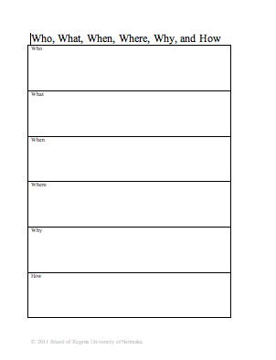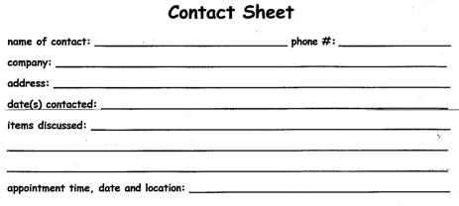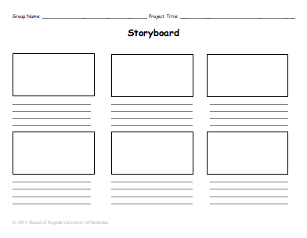
Understanding Learning: (If You Can Dream It, You Can Do It!)

Summary:
Students will investigate the role of innovation in manufacturing and understand that innovation in manufacturing turns ideas into working solutions that meet consumer needs.

Outline:
- Formative Assessment of Innovation in Manufacturing
- Summative Assessment of Innovation in Manufacturing

Activity: Students will complete written assessments about their understanding of innovation in manufacturing.

Formative Assessment: As students are engaged in the lesson ask these or similar questions:
- Do students understand what innovation is?
- Can students cite some of the events and ideas spurred people to come up with thousands of invention in the past 100 years?
- Do students know what drives innovation in organizations?

Summative Assessment: Students can answer the following writing prompt:
- Consider the impact of one innovation on you and your family and, using the internet, look briefly at the development history behind that innovation. Discuss the impact this innovation has had on you and your family. When did your family first get the product? How long were you aware of the product before buying it? Was it a new gadget or the latest version of a well established product? If you delayed buying what were your reasons (example: cost or reliability?) Have you since replaced it with an improved or updated version?

Students can answer the following questions after viewing the student news video/report:
- What drives innovation for these local businesses?
- What obstacles to innovation have these local businesses had to overcome?
- What jobs or types of jobs are available in your community through these local businesses? Are there any of particular interest to you and to your future?

