Diagrams of Possible Configurations for “A” Activity

Connecting a ornamental light to a battery | 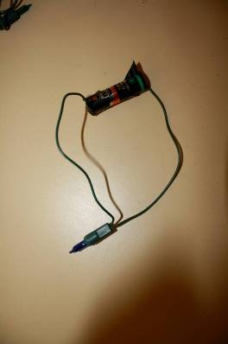
Three bulbs in series | 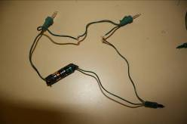
One 3 bulb configuration | 