SPIRIT 2.0 Lesson:
Traction Control
==========================Lesson Header ==========================
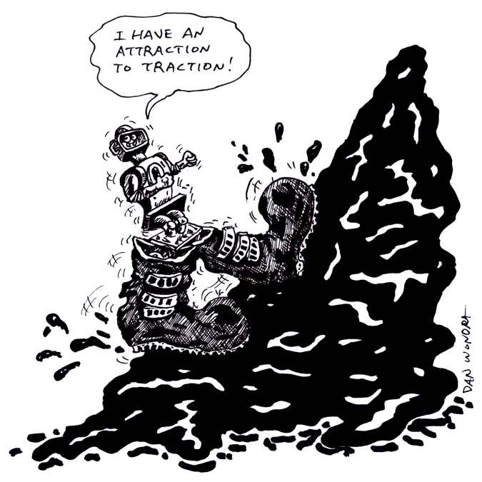
Lesson Title: Traction Control
Draft Date: 5/8/12
1st Author (Writer): Tony Reisdorff
Instructional Component Used: Engineering Design Process
Grade Level: 7th-8th Grade

Content (what is taught):
- Identify the steps of the Engineering Design Process
- Understanding motions and forces and how they affect traction
- Understanding how to evaluate potential solutions
- Cooperation through teams to create new and inventive ideas

Context (how it is taught):
- Solving problems in groups using the Engineering Design Process
- Evaluating materials to find their level of traction
- CEENBoT and the use of the Engineering Design Process to climb the steepest hill possible
Activity Description:
In this lesson, students will be working in groups to investigate the influence/necessity of traction and apply it to the CEENBoT and its ability to climb steep hills. Students will begin by learning to think and solve problems with the help of the Engineering Design Process. Next, students will investigate how varieties of materials have different amounts of traction on a ramp, recording and graphing their results. Finally, students will apply their knowledge of traction and the Engineering Design Process to help the CEENBoT to climb the steepest hill possible.

Standards:

Math: MA1 Science: SB1

Technology: TB4 Engineering: EB2, EC1, ED1

Materials List:

- CEENBoT
- Ramps
- 6-8” Dowels
- Variety of cloth like materials
- Rulers/Tape Measures
- Protractors
- Knife/Scissors
- Glue/Tape/Staples/etc.

Asking Questions: (Traction Control)

Summary: Students are asked to use the Engineering Design Process in helping to solve a hypothetical problem. They will mainly be working through the first three steps: Ask, Imagine, & Design. The final two steps Create and Improve will be done reviewing each groups’ idea presented to the class.

Outline:
- Students will start by defining the problem
- In groups of 2-4 students will imagine ideas to solve the problem
- Create a plan to implement the best idea created from Step 2. (diagrams, lists, designs, etc.)
- Students will present their idea to the class who will asses the create plan and suggest any improvements

Activity: You and your friends are the only people in your town who have not been infected with a life threatening illness. Plants that can heal everyone grow at the top of a mountain, but you live at the bottom. With everyone being sick, you and your friends are the only people who can get to it. The terrain of the mountain and weight of the equipment are obstacles in your way. You will need to create a device that can be used to carry the equipment you need to harvest the plant and safely return it to your town. The device can only be made with parts from the near by junk yard and be human powered (examples: pushing, pulling, pedal, rowing, etc.).

Questions | Answers
What is the problem? | How to create a device to get to the plants
How many ideas did your group come up with? | ???
How did your group choose the best idea? | ???
Is your design easy to understand/build? | ???
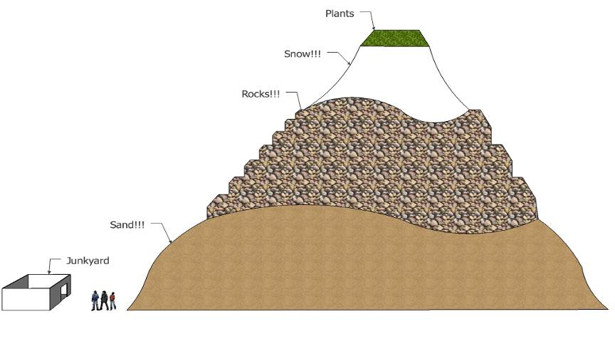
Attachment:
- E032_Traction_Control_A _O_Engineering_Design_Process.pdf
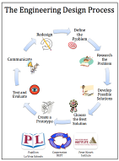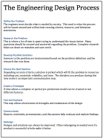
Exploring Concepts: (Traction Control)

Summary: Students are asked to make observations of how different materials roll down hill and to think of alternative materials that would work even better.

Outline:
- Demonstrate at what angle different materials start to roll down hill
- Ask students to pick the material that will not roll until the steepest angle
- Students will chart at what angles different materials start to roll down hill
- Students will create a list of alternative materials they think would work even better

Activity: The teacher should demonstrate different materials rolling down hill. Keep adjusting the ramp recording at what angle each material starts to roll down hill. Create a list of materials you think would work even better than the ones provided.

Questions | Answers
What is the highest angle recorded for each material? | ???
What material reached the highest angle? | ???
Why did some materials not work very well? | ???
What materials do you think would work even better? | ???
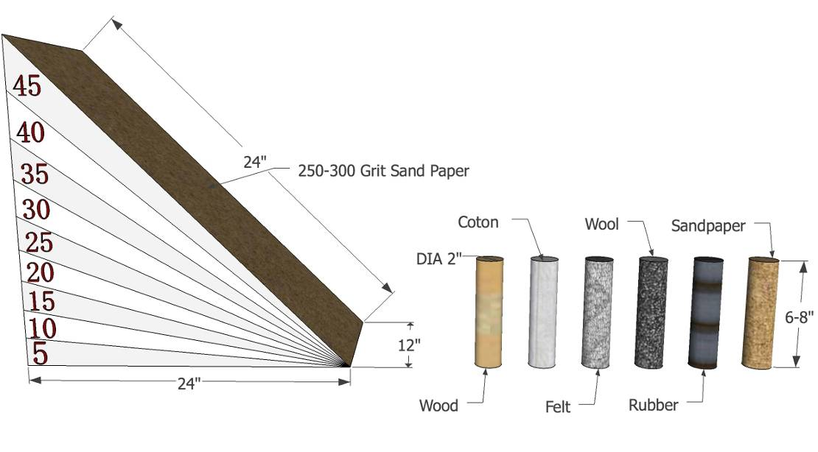
Attachment:
- E032_Traction_Control_E_Data_Table_and_Graph.xls
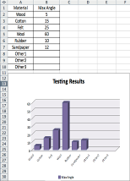
Instructing Concepts: (Traction Control)

Engineering Design Process

The Engineering Design Process has many forms. Some conceptual models have as many as ten steps others as few as five. The process is as individual as the engineer who is using it. It is cyclical meaning that you can start at any step in the process and it is dynamic meaning that it is always changing and adapting. For this instructional module we have chosen a simplified five-step approach to the engineering design process. The five steps are: 1) Ask, 2) Imagine, 3) Design, 4) Create, and 5) Improve.

Ask: In this step you ask what is the problem that needs addressed and do a lot of research to see what other ideas are out there and what other solutions have been attempted. This research is critical because it means you won’t duplicate something that others have tried and were unsuccessful. It allows you to frame the problem and limit (constrain) it so that you have a better understanding of what is required.

Imagine: Here you brainstorm ideas that might possibly be a solution to the problem you explored in the Ask step. Don’t be afraid to think big and out of the box. Sometimes if the answer to a problem is obvious or simple it would have been solved already. Get creative! After brainstorming possible ideas and solutions, you should analyze each possibility for potential merit. Finally select the best alternative for further exploration.

Design: This step involves the creation of a plan to carry out the idea that you selected in the Imagine step. You can make a diagram, create lists of things that you will need, and gather together the necessary skills that you will need to carry out your plan.

Create: This is the fun step. You get to actually build/create the idea that you selected and planned out. This is the hands on step where you see the intellectual idea actually come to life. It is important to follow your plan that you created. Be sure to note what went well and what didn’t work for future use in refining the idea. Finally test your product and see if it does what it is supposed to do. Does it solve the problem? It is possible that you will have to go back to any of the previous steps after you test your creation. If it doesn’t work, do you need a better plan, a better idea, or do you need to rethink your initial problem?

Improve: Here is the refinement stage. You have something that works but you want it to be the best it can be. You want the most speed, efficiency, the best appearance, etc. Here you think about and talk about what works, what doesn’t work and what could be improved on. After this discussion occurs, modify your design to see if you can improve it. Finally test out to see if you actually improved your solution or not. Remember at this stage it is possible that you might have to go back to any of the other stages.

The powerful thing about this process is that it is fluid and creates a nice organizational flow for the process to follow. At the end of each step always ask if you accomplished what you set out to do. If you did not repeat that step or go back further in the process to try to arrive at a better solution. Remember you can start at any step but once the process is begun you need to go from one step to another in order for the process to be effective.
Organizing Learning: (Traction Control)

Summary: Students will use the CEENBoT and supplemental materials to attempt to climb the steepest ramp possible.

Outline:
- The CEENBoT will travel up a ramp at ever increasing angles
- Students will assess the CEENBoT and its limitations in its ability to climb the ramp
- Students will use the Engineering Design Process to explore and create items to help the CEENBoT climb the steepest ramp angle
- Students will demonstrate their solution to the class/instructor upon completion

Activity: Working in groups of 2-4, students will work with the CEENBoT to climb the steepest angle possible. Students will use the steps of the Engineering Design Process to complete this activity. First, they will define the problem. Second, a list of ideas will be created. Third, students will design the best solution from the best idea chosen. Fourth, materials to create a working solution of their design will need to be located. Fifth, students will test and improve upon their design by repeating steps 1-4 as many times necessary. Finally, the data from the activity will be organized and the final solution presented along with the results to the class/instructor.
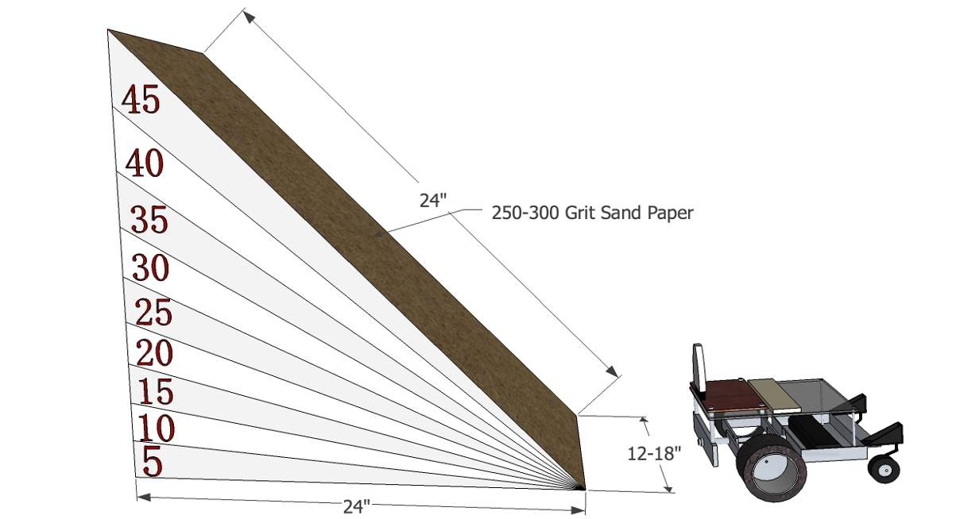

Attachment:
- E032_Traction_Control_A _O_Engineering_Design_Process
Understanding Learning: (Traction Control)

Summary: Students will use the Engineering Design Process to solve a hypothetical problem. Students will also explain their solution to test its merit and room for refinement/improvement.

Outline:
- Formative assessment of Engineering Design Process
- Summative assessment of Engineering Design Process

Activity: Students will complete written and performance assessments over the Engineering Design Process.

Formative Assessment: As students are engaged in the lesson ask these or similar questions:
- Ask: Were students able to identify the problem?
- Imagine: Can students show examples of brainstorming solutions and potential merit?
- Design: Do students have a clear diagram/list of materials needed to solve the problem?
- Create: Are students able to build a solution to the problem?
- Improve: Were students able to identify design problems and improve upon their solution?

Summative Assessment: Students can answer the following writing prompt:
Students will write an essay explaining each step of the Engineering Design Process as it applies to the activity. The essay should define the problem, include lists of ideas, diagrams of designs, detailed descriptions of their creations, and how they improved their creation through testing.

Students can complete the following performance assessment:
Students will present each step of the Engineering Design Process as it applies to a hypothetical problem to the class/instructor. This presentation should include the problem that they solved, lists of ideas, diagrams of designs, detailed descriptions of their solution and how they would improve their solution through testing.

