SPIRIT 2.0 Lesson:
Robotic Programming
==========================Lesson Header ==========================
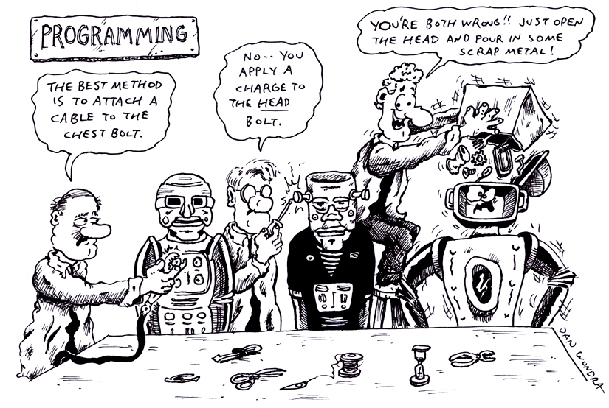
Lesson Title: Robot Programming
Draft Date: 5/14/12
1st Author (Writer): Tony Reisdorff
Instructional Component Used: Engineering Design Process
Grade Level: 7th-8th Grade

Content (what is taught):
- Identify the steps of the Engineering Design Process
- Understanding the different types of robotic programming/control
- Understanding how to create/evaluate autonomous robotic programs
- Cooperation through teams to create new and inventive programs
Context (how it is taught):
- Solving problems in groups using the Engineering Design Process
- Using supplemental articles to inform students about robotic control
- Using programming to autonomously complete a task
- CEENBoT/CEENBoT Commander and the use of the Engineering Design Process to teach the steps of programming

Activity Description:
In this lesson, students will be working in groups to learn about robotic programming and how to apply it to the CEENBoT and its ability to complete tasks. Students will begin by learning to think and solve problems with the help of the Engineering Design Process. Next, students will investigate the different approaches to robotic control. Finally, students will apply their knowledge of robotic control and the Engineering Design Process to help the CEENBoT navigate its way through the maze

Standards:

Math: MD1 Science: SG2

Technology: TB4 Engineering: EB2, EC1, ED1

Materials List:

- CEENBoT
- Computer with CEENBoT Commander
- Rulers/Tape measures
- Large playing area
- 3-5 blindfolds
- Index cards
- Stopwatch
- Obstacles NOTE: Do not use any materials that the blindfolded students will trip or fall over-paper works well

Asking Questions: (Robotic Programming)

Summary: Students will be using the first two parts of the Engineering Design Process as they are asked to read two articles about robot programming. They will use the Engineering Design Process to think about robotic programming and human interaction.

Outline:
- Students will start by reading articles relating to robotic programming
- Students will then answer question about the articles
- As a class, discuss/imagine/design how to program robots

Activity: Students will apply the Engineering Design Process while they learn about different types and approaches to robotics programming. They will accomplish this by reading two articles from NASA (see links below) about robotic programming. As students read, they will be answering the following questions:

Questions | Answers
Describe different types of control and which you think is best and why? | Deliberative and Reactive
What is Fuzzy Logic? What are Neural Networks? Is one better than the other? | Fuzzy logic expresses actions as a human would while Neural is learning through experience.
What roles will robots have in society? | Cooperative
What are the types of human-robot communication? | Collaborative (Speak), Reasoning and Partner to Partner (Physical Contact)

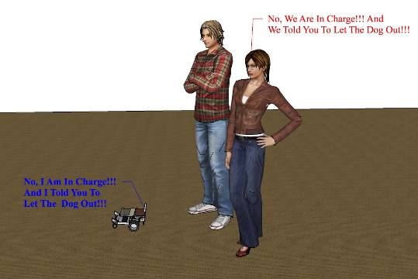
Resources:
- http://www.nasa.gov/vision/universe/roboticexplorers/robots_like_people.html
- http://www.nasa.gov/centers/ames/research/exploringtheuniverse/robots_human_coop.html

Attachments:
- E034_Robotic_Programming_A_Article_Questions.doc
- E034_Robotic_Programming_AEO_Engineering_Design_Process.pdf
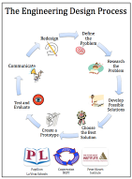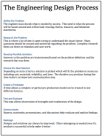
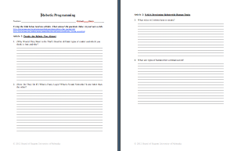
Exploring Concepts: (Robotic Programming)

Summary: Students are asked to use the Engineering Design Process to create/write a robotic program to control a human rover. They will be working through all the steps: Ask, Imagine, Design, Create & Improve.

Outline:
- Students will first define the problem
- In groups of 4-5 students will imagine ideas to solve the problem
- Groups will create a program to implement (diagrams, lists, designs, etc.)
- Students will present their program to the class who will help assess the program and suggest any areas for improvement

Activity: Your team will use the Engineering Design Process to help learn the challenges of operating a robot and writing robotic programming. Groups will create a human rover (blindfolded) with an independent driver who will execute a pre-set series of commands that will guide a human rover through a pre surveyed surface. Groups will learn the challenges of creating robotic programming.

Questions | Answers
Did students work together on programming? | ???
How were driver/rover positions selected? | ???
Did the robotic program work? | ???
What were some of the challenges & solutions? | ???
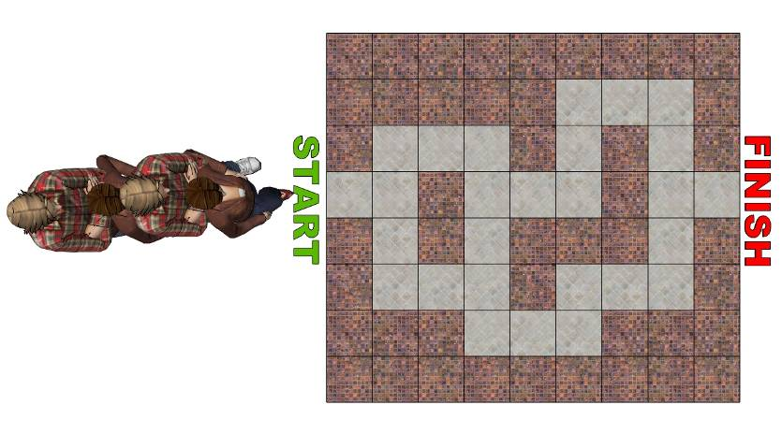
Attachments:
- E034_Robotic_Programing_E_Design_Brief.doc
- E034_Robotic_Programming_AEO_Engineering_Design_Process.pdf
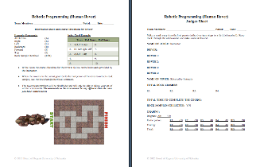
Instructing Concepts: (Robotic Programming)

Engineering Design Process

The Engineering Design Process has many forms. Some conceptual models have as many as ten steps others as few as five. The process is as individual as the engineer who is using it. It is cyclical meaning that you can start at any step in the process and it is dynamic meaning that it is always changing and adapting. For this instructional module we have chosen a simplified five-step approach to the engineering design process. The five steps are: 1) Ask, 2) Imagine, 3) Design, 4) Create, and 5) Improve.

Ask: In this step you ask what is the problem that needs addressed and do a lot of research to see what other ideas are out there and what other solutions have been attempted. This research is critical because it means you won’t duplicate something that others have tried and were unsuccessful. It allows you to frame the problem and limit (constrain) it so that you have a better understanding of what is required.

Imagine: Here you brainstorm ideas that might possibly be a solution to the problem you explored in the Ask step. Don’t be afraid to think big and out of the box. Sometimes if the answer to a problem is obvious or simple it would have been solved already. Get creative! After brainstorming possible ideas and solutions, you should analyze each possibility for potential merit. Finally select the best alternative for further exploration.

Design: This step involves the creation of a plan to carry out the idea that you selected in the Imagine step. You can make a diagram, create lists of things that you will need, and gather together the necessary skills that you will need to carry out your plan.

Create: This is the fun step. You get to actually build/create the idea that you selected and planned out. This is the hands-on step where you see the intellectual idea actually come to life. It is important to follow your plan that you created. Be sure to note what went well and what didn’t work for future use in refining the idea. Finally test your product and see if it does what it is supposed to do. Does it solve the problem? It is possible that you will have to go back to any of the previous steps after you test your creation. If it doesn’t work, do you need a better plan, a better idea, or do you need to rethink your initial problem?

Improve: Here is the refinement stage. You have something that works but you want it to be the best it can be. You want the most speed, efficiency, the best appearance, etc. Here you think about and talk about what works, what doesn’t work and what could be improved on. After this discussion occurs, modify your design to see if you can improve it. Finally test out to see if you actually improved your solution or not. Remember at this stage it is possible that you might have to go back to any of the other stages.

The powerful thing about this process is that it is fluid and creates a nice organizational flow for the process to follow. At the end of each step always ask if you accomplished what you set out to do. If you did not repeat that step or go back further in the process to try to arrive at a better solution. Remember you can start at any step but once the process is begun you need to go from one step to another in order for the process to be effective.
Organizing Learning: (Robotic Programming)

Summary: Students will be using the CEENBoT and CEENBoT Commander to program the robot.

Outline:
- The CEENBoT will travel through the maze
- Students will use CEENBoT Commander to program their CEENBoT
- Students will use the Engineering Design Process to explore and create a program to help the CEENBoT successfully complete the maze.
- Students will demonstrate their solution to the class/instructor upon completion.

Activity: Working in groups of 2-4, students will work with the CEENBoT and CEENBoT Commander to solve the maze. Students will use the steps of the engineering design process to complete this activity. First, they will define the problem. Second, imagine and design a program. Third, create a program with CEENBoT Commander. Fourth download test and improve upon their design by repeating steps 1-4 as many times necessary. Finally, the robot solving the maze will be presented along with the program to the class/instructor.
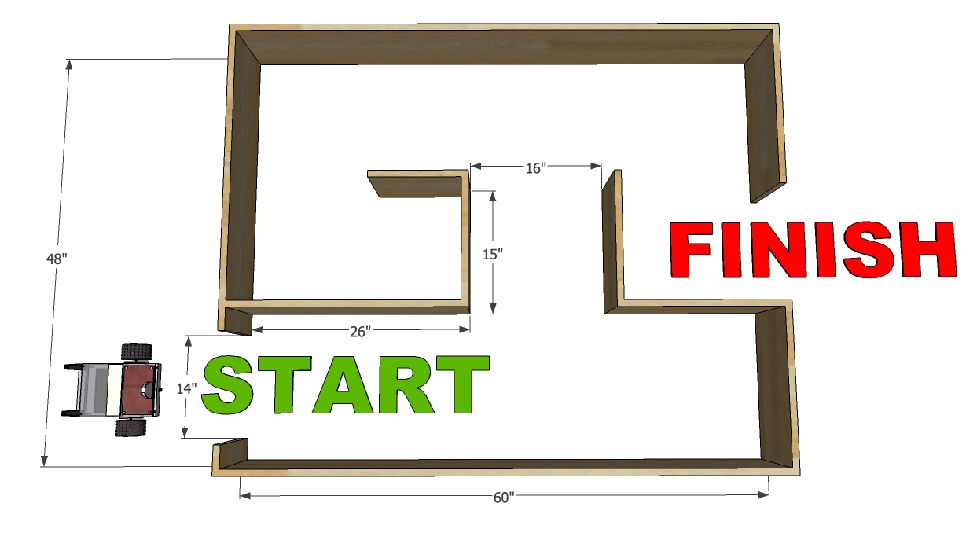
Attachment:
- E034_Robotic_Programming_AEO_Engineering_Design_Process.pdf
Understanding Learning: (Robotic Programming)

Summary: Students will use the Engineering Design Process to solve a hypothetical problem. Students will also explain their solution to test its merit and room for refinement/improvement.

Outline:
- Formative Assessment of Engineering Design Process
- Summative Assessment of Engineering Design Process

Activity: Students will complete written and performance assessments over the Engineering Design Process.

Formative Assessment: As students are engaged in the lesson ask these or similar questions:
- Ask: Were students able to identify the problem?
- Imagine: Can students show examples of brainstorming solutions and potential merit?
- Design: Do students have a clear diagram/list of materials needed to solve the problem?
- Create: Are students able to build a solution to the problem?
- Improve: Were students able to identify design problems and improve upon their solution?

Summative Assessment: Students can answer the following writing prompt:
Students will write an essay explaining each step of the Engineering Design Process. The essay should include each step in order and an explanation of why the engineering design process is an important tool.

Students can complete the following performance assessment: Students will present each step of the Engineering Design Process as it applies to a hypothetical problem to the class/instructor. This presentation should include the problem that they solved, lists of ideas, diagrams of designs, detailed descriptions of their solution and how they would improve their solution through testing.

