Robotic Programming (Human Rover)

Team Members: ______________________________________ Period: ____ Date: ________

Information Sheet and Course Directions for Driver

Example Commands: Index Card Example
All Rovers (A)
Right (R)
Left (L)
Backward (B)
Forward (F)
Stop (S)
Rock Sample Retrieval (RSR)
Team: Red Rover, Red Rover
1. A,R,F 3 steps | 6.
2. R1 turn right 90º | 7.
3. A,R,F 1 step | 8.
4. | 9.
5. | 10.

- Write down the course directions for the rover to follow on the index cards provided by the instructor.

- When the rover is in the correct position for the last person of the rover to collect a rock sample, use the Rock Sample Retrieval command.

- The rover team members will be blindfolded and will only be able to follow your set of written commands. The commands to the rover cannot be any different than the ones you have written down.

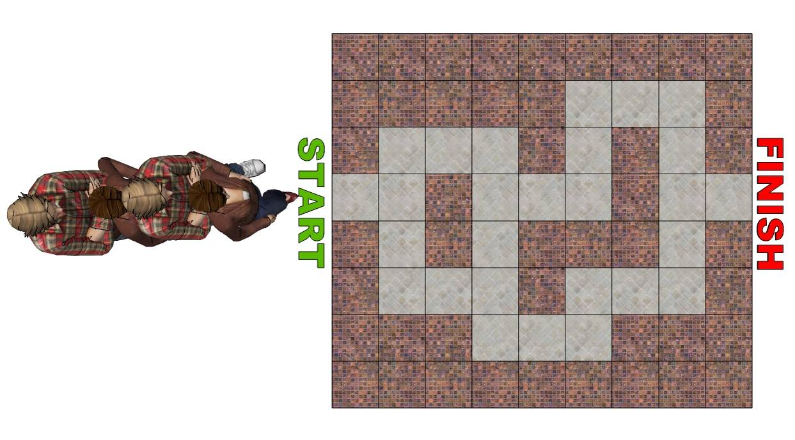
Robotic Programming (Human Rover)
Judges Sheet

Team Members: ______________________________________ Period: ____ Date: ________

Make a mark every time the first person on the rover team steps on a tile (rock crashes!). Keep track through the whole course and make a total at the end.

NAME OF JUDGE: Instructor

DRIVER:

ROVER 1:

ROVER 2:

ROVER 3:

ROVER 4:

NAME OF TIMER: Selected by Instructor

TOTAL ROCK CRASHES:

R1: R2: R3: R4:

TOTAL TIME TO COMPLETE THE COURSE:

ROCK SAMPLES COLLECTED: Y/N

GRADING:
Program: AR: / 30
Participation: R1: /10 R2: /10 R3: /10 R4: /10 RD: /10
Testing: R1: /10 R2: /10 R3: /10 R4: /10 RD: /10
Total: R1: /50 R2: /50 R3: /50 R4: /50 RD: /50

