SPIRIT 2.0 Lesson:
Structural Design
==========================Lesson Header ==========================
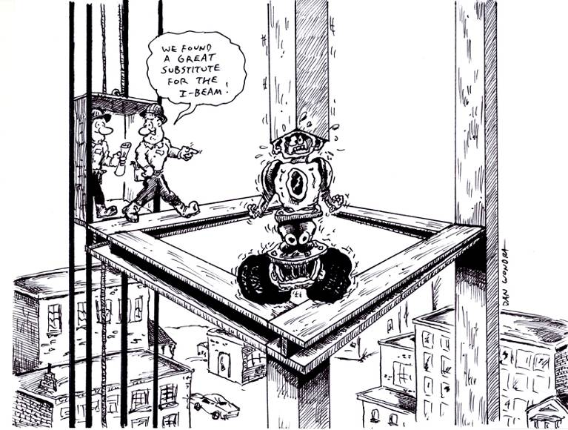
Lesson Title: Structural Design
Draft Date: 5/14/12
1st Author (Writer): Tony Reisdorff
Instructional Component Used: Engineering Design
Grade Level: 7th-8th Grade

Content (what is taught):
- Identify the steps of the Engineering Design Process
- Understanding Structural Design: Forces and Forces in Action
- Cooperation through teams to create new and inventive ideas

Context (how it is taught):
- Solving problems in groups using the Engineering Design Process
- Using supplemental articles to inform students about Structural Design and Forces.
- CEENBoT and the use of the Engineering Design Process to teach Structural Design and Forces

Activity Description:
In this lesson, students will be working in groups to learn about Structural Design: Forces and Forces in Action. Students will begin by learning to think and solve problems with the help of the Engineering Design Process. Next, students will investigate Structural Design: Forces and Forces in Action. Finally, students will apply their knowledge and the Engineering Design Process to the CEENBoT to work with the other CEENBoTs to construct a Skyscraper Tower.

Standards:

Math: MD1 Science: SG2

Technology: TA1, TB4 Engineering: EB2, EC1, ED1

Materials List:

- CEENBoT
- Computer
- Rulers/Tape measures
- Golf Balls
- Paper
- Index cards
- Scissors
- Foam
- Cardboard
- Paperclips
- Paper
- Tape
- White & Hot Glue

Asking Questions: (Structural Design)

Summary: Students will be using the Engineering Design Process as they work in groups of two to learn about structural design and forces that act upon structures.

Outline:
- Students will use Internet resources to learn about forces and forces in action
- Students will complete 2 worksheets pertaining to forces and forces in action

Activity: Students will apply the engineering design process while they learn about forces and forces in action. They will accomplish this by doing research from an Internet resource. As students do online research they will be answering the following questions.

Questions | Answers
What are types of Forces? | Static, Dynamic, Internal, Tension, Compression, Shear & Torsion
What is a STRUT? | Beam in Compression
What is a TIE? | Beam in Tension
Are students able to show/draw their own examples of all Forces and Forces in Action? | ?

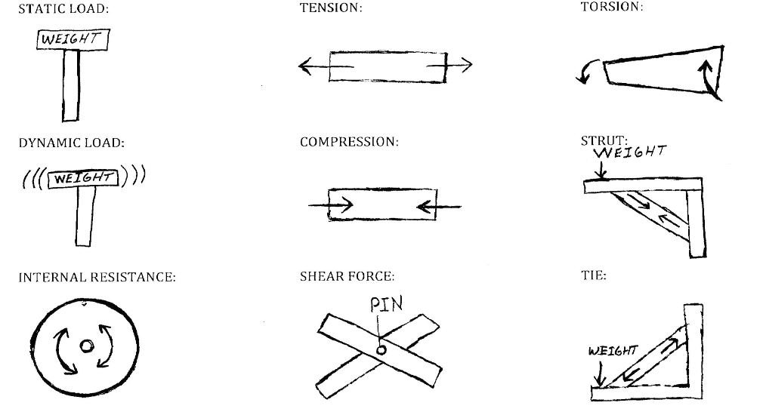
Resources:
- http://www.technologystudent.com/forcmom/force1.htm
- http://www.technologystudent.com/forcmom/dkforce1.htm

Attachment:
- E035_Structural_Design_A _E_O_Engineering_Design_Process.pdf
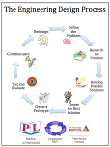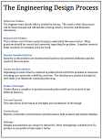
Exploring Concepts: (Structural Design)

Summary: Students are asked to use the engineering design process to imagine/design and create a paper tower, learning about forces and forces in action. They will be working through all the steps: Ask, Imagine, Design, Create & Improve.

Outline:
- Students will first define the problem
- In groups of 2-4 students will imagine ideas to solve the problem
- Groups will create a design to implement. (Diagrams, lists, designs, etc.)
- Students will build and test their tower with a static load
- Students will then document/present possible ways to improve their tower

Activity: Your team will use the Engineering Design Process to help learn about forces and forces in action. Teams will be attempting to build the tallest paper tower possible in the given time frame. The Tower will then be required to hold a static load (golf ball, Book, etc.) on top for 10 seconds.

Questions | Answers
Did students work together on their design? | ???
Did their tower stand up and how tall? | ???
Were they able to hold a static load on top? | ???
During construction and testing were they able to improve their design/ideas? | ???

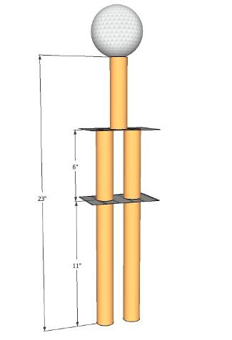
Attachments:
- E035_Structural_Design_A_Tower_of_Power.doc
- E035_Structural_Design_A_E_O_Engineering_Design_Process.pdf
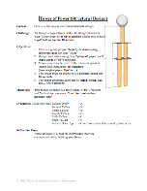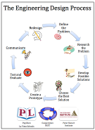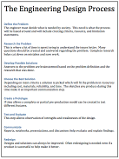
Instructing Concepts: (Structural Design)

Engineering Design Process

The Engineering Design Process has many forms. Some conceptual models have as many as ten steps others as few as five. The process is as individual as the engineer who is using it. It is cyclical meaning that you can start at any step in the process and it is dynamic meaning that it is always changing and adapting. For this instructional module we have chosen a simplified five-step approach to the engineering design process. The five steps are: 1) Ask, 2) Imagine, 3) Design, 4) Create, and 5) Improve.

Ask: In this step you ask what is the problem that needs addressed and do a lot of research to see what other ideas are out there and what other solutions have been attempted. This research is critical because it means you won’t duplicate something that others have tried and were unsuccessful. It allows you to frame the problem and limit (constrain) it so that you have a better understanding of what is required.

Imagine: Here you brainstorm ideas that might possibly be a solution to the problem you explored in the Ask step. Don’t be afraid to think big and out of the box. Sometimes if the answer to a problem is obvious or simple it would have been solved already. Get creative! After brainstorming possible ideas and solutions, you should analyze each possibility for potential merit. Finally select the best alternative for further exploration.

Design: This step involves the creation of a plan to carry out the idea that you selected in the Imagine step. You can make a diagram, create lists of things that you will need, and gather together the necessary skills that you will need to carry out your plan.

Create: This is the fun step. You get to actually build/create the idea that you selected and planned out. This is the hands on step where you see the intellectual idea actually come to life. It is important to follow your plan that you created. Be sure to note what went well and what didn’t work for future use in refining the idea. Finally test your product and see if it does what it is supposed to do. Does it solve the problem? It is possible that you will have to go back to any of the previous steps after you test your creation. If it doesn’t work, do you need a better plan, a better idea, or do you need to rethink your initial problem?

Improve: Here is the refinement stage. You have something that works but you want it to be the best it can be. You want the most speed, efficiency, the best appearance, etc. Here you think about and talk about what works, what doesn’t work and what could be improved on. After this discussion occurs, modify your design to see if you can improve it. Finally test out to see if you actually improved your solution or not. Remember at this stage it is possible that you might have to go back to any of the other stages.

The powerful thing about this process is that it is fluid and creates a nice organizational flow for the process to follow. At the end of each step always ask if you accomplished what you set out to do. If you did not repeat that step or go back further in the process to try to arrive at a better solution. Remember you can start at any step but once the process is begun you need to go from one step to another in order for the process to be effective.
Organizing Learning: (Structural Design)

Summary: Students will be working in groups of 2-4 using the Engineering Design Process and CEENBoTs to construct a skyscraper tower.

Outline:
- In Teams of 2-4 students will use the CEENBoT to construct a skyscraper
- Students will use the engineering design process to explore and create attachments to help the CEENBoT construct a skyscraper
- Students will use their attachment to work with the other teams to construct a skyscraper
- Students will demonstrate their solution with the rest of the class to the instructor upon completion.

Activity: Students will use the steps of the Engineering Design Process to complete this activity. First, they will define the problem. Second, a list of ideas will be created. Third, students will design the best solution from the best idea chosen. Fourth, materials to create a working solution of their design will need to be located. Fifth, students will test and improve upon their design by repeating steps 1-4 as many times necessary. Finally, the team and CEENBoT will work with the other teams to construct a Skyscraper Tower.
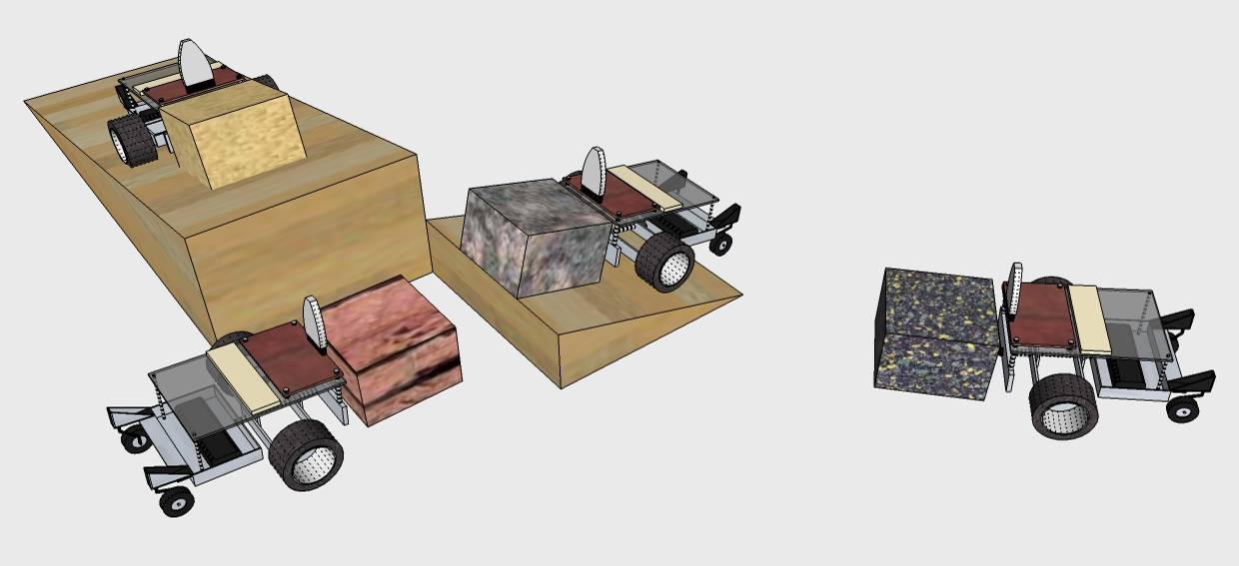

Attachments:
- E035_Structural_Design_O_CEENBoT_Skyscraper_Design_Brief.doc
- E035_Structural_Design_A _E_O_Engineering_Design_Process.pdf
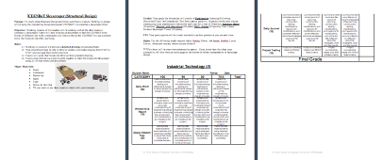
Understanding Learning: (Structural Design)

Summary: Students will use the Engineering Design Process to solve a hypothetical problem. Students will also explain their solution to test its merit and room for refinement/improvement.

Outline:
- Formative Assessment of Engineering Design Process
- Summative Assessment of Engineering Design Process

Activity: Students will complete written and performance assessments over the engineering design process.

Formative Assessment: As students are engaged in the lesson ask these or similar questions:
- Ask: Were students able to identify the problem?
- Imagine: Can students show examples of brainstorming solutions and potential merit?
- Design: Do students have a clear diagram/list of materials needed to solve the problem?
- Create: Are students able to build a solution to the problem?
- Improve: Were students able to identify design problems and improve upon their solution?

Summative Assessment: Students can answer the following writing prompt:
Students will write an essay explaining each step of the engineering design process as it applies to the activity. This essay should define the problem; include lists of ideas, diagrams of designs, detailed descriptions of their creations and how they improved their creation through testing.

Students can complete the following performance assessment: Students will present each step of the engineering design process as it applies to a hypothetical problem to the class/instructor. This presentation should include the problem that they solved, lists of ideas, diagrams of designs, detailed descriptions of their solution and how they would improve their solution through testing.

