CEENBoT Skyscraper (Structural Design)

Purpose: To learn about Structural Design and Forces and Forces in action. Working in groups of 2-4 using the engineering design process and CEENBoT’s to construct a skyscraper tower.

Objective: Working in teams of 2-4 students will be working with all the other teams to construct a skyscraper. Teams will need to create an attachment to help the CEENBoT move blocks of different size to the construction site. Once at the site the CEENBoT will use a ramp to move the block on top of the last block.

Rules:
- Working in teams of 2-4, provide a detailed drawing of your attachment.
- Your attachment must be able to retrieve variable size blocks ranging from 6”x6” to 2”x2” and navigate them to the tower site.
- Teams will select their blocks for retrieval from a random drawing.
- Teams must then devise a plan to work together to build the blocks into Skyscraper using all of their robots and attachments.
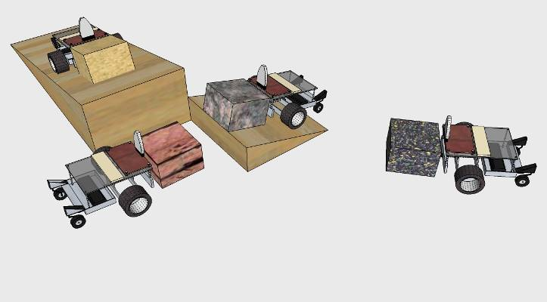
Major Materials:

  - Foam
  - Cardboard
  - Paperclips
  - Paper
  - Tape
  - White & Hot Glue
  - *If you want to use other materials check with your instructor

Grades: Your grade for this project will consist of Participation (Listening/Following Directions/Clean Up/Cooperation). This Participation grade will be graded on the days you are constructing your attachments (5 points for each class for a total of 50 points), Summary Report (10 points), Drawing with dimensions (20 points) Daily Journal (10 points), Your classes finished Skyscraper Tower (10 points),

FYI: Your participation will be closely watched to see how productive you are each class.

Sights: Try the following search engines online Google, Yahoo, Ask Jeeves, HotBot, Lycos, Excite, About.com and any others you can think of.

***This sheet will be your tower construction permit. If you do not have this sheet your alternative will be to write an entire page on the history of robotic transportation or skyscraper design.

Industrial Technology I/II
Student Name: Period: Date:
CATEGORY |  | 100 |  | 90 |  | 80 |  |  | 70-0 | Total
Daily Work  (50) |  | Clear evidence of troubleshooting, testing, and refinements based on the engineering design process. |  | Some clear evidence of troubleshooting, testing and refinements based on the engineering design process. |  | Some too little evidence of troubleshooting, testing and refinements based on the engineering design process. |  |  | Little to no evidence of troubleshooting, testing or refinement based on the engineering design process.
Written/Oral Report  (10) |  | Written/Oral explanations indicate a clear and accurate understanding of engineering design process underlying the construction and modifications as it relates to the project. |  | Written/Oral explanations indicate a relatively accurate understanding of engineering design process underlying the construction and modifications as it relates to the project. |  | Written/Oral explanations indicate some understanding of engineering design process underlying the construction and modifications as it relates to the project. |  |  | Written/Oral explanations do not illustrate much understanding of engineering design process underlying the construction and modifications as it relates to the project.
Design/Sketch/Plan  (20) |  | Appropriate materials/items were selected and creatively modified in ways that made it possible to complete the task. |  | Appropriate materials/items were selected and there was an attempt at creativity and modification to complete part but not the entire task. |  | Appropriate materials/items were selected. Some too little of the task was completed. |  |  | Inappropriate materials/items were selected and little too none of the task was completed.
Daily Journal (10) |  | Journal provides a complete record of planning, construction, testing, modifications, reasons for modifications, and complete reflection about the strategies used and the results. |  | Journal provides some record of planning, construction, testing, modifications, and reasons for modifications, and some reflection about the strategies used and the results. |  | Journal provides some too little record of planning, construction, testing, modifications, and reasons for modifications, and some too little reflection about the strategies used and the results. |  |  | Journal provides very little too no record of aspects of the planning, construction, testing, modifications, and reasons for modifications, and very little too no reflection about the strategies used and the results
Project Testing  (10) |  | Project successfully meets all of listed criteria. |  | Project successfully meets over 90% of listed criteria. |  | Project successfully meets over 80% of listed criteria. |  |  | Project successfully meets 0%-70% of listed criteria.
Final Grade

