SPIRIT 2.0 Lesson:
Pop Goes the CEENBoT
==========================Lesson Header ==========================
Lesson Title: Pop Goes the CEENBoT
Draft Date: 5-26-12
1st Author (Writer): Nancy L. Boyle
Instructional Component Used: Engineering Design Process
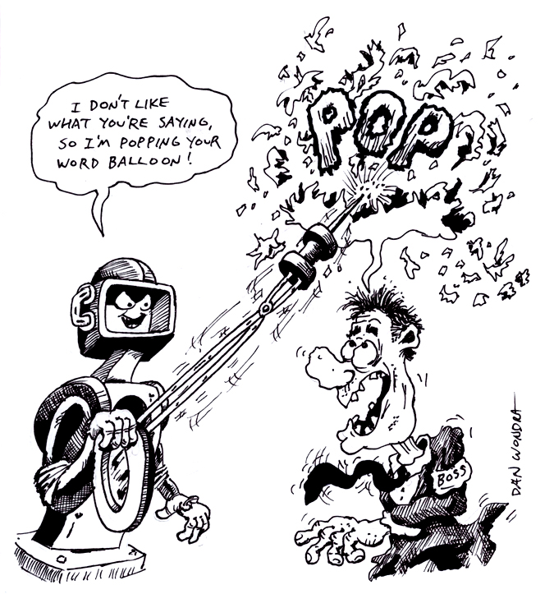
Grade Level: Middle School

Content (what is taught):
- Engineering Design Process
- Application of the Engineering Design Process

Context (how it is taught):
- Students will learn the Engineering Design Process
- Students will apply the Engineering Design Process to modify a CEENBoT
Activity Description:
Students will use the Engineering Design Process to modify CEENBoT with the addition of a balloon popping attachment.

Standards:

Technology: TA1, TA2

Engineering: EA2, EA4, EA5

Materials List:
- Cardboard of various length and width
- Duct Tape
- Nails
- Paperclips
- Scissors
- Balloons
Asking Questions: (Pop Goes the CEENBoT)

Summary: Students will brainstorm a new invention and how an inventor would go about creating that new invention.

Outline:
- Students will decide a new invention to create
- Students will think about how to create the new invention

Activity: The teacher will lead the class through a discussion about creating a new invention. It could be whatever the class decides to create. What is being created in not important, it is the “how” to create it that the activity needs to focus on. Students should be asked how do you design a product. What things do you have to consider? Is there a “method to an inventors madness?”

Questions | Answers
Have you ever built something and it hasn’t worked as you had envisioned? | Student answers will vary.
How did you go about fixing that problem? | Student examples will vary.
Would you like to invent the latest gizmo/gadget/toy? What steps would you need to follow? | Student responses may vary.
How do you think inventors improve/modify/alter items to get a newer version? | Student answers will vary.
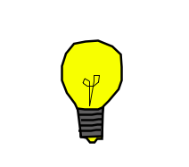
Exploring Concepts: (Pop Goes the CEENBoT)

Summary: The teacher will introduce the Engineering Design Process and it will be applied to an invention that the students want to create.

Outline:
- Students will be introduced to the Engineering Design Process
- Teams of students will decide how to apply the Engineering Design Process to a project the class chooses
- Discussion about how each group applied the Engineering Design Process

Activity: The teacher will introduce the Engineering Design Process (see attached file for a diagram of the Engineering Design Process). They may want to provide an example of the Engineering Design Process in application to help students understand the concept. Terminology will be introduced and discussed as necessary dependent upon student’s familiarity with the topic. After the introduction to the engineering process, the class will apply the steps of the process to the invention/improvement of a product. It could be anything that the class decides on as group. The class will be divided up into teams with each team being assigned to apply the Engineering Design Process to the class product. After the teams work together, a class discussion about how each team would apply the steps will conclude the activity.

Attachment:
- E036_Pop_Goes_the_CEENBoT_E_Engineering_Design_Process.pdf
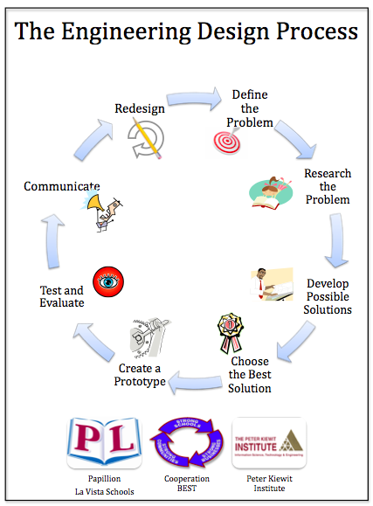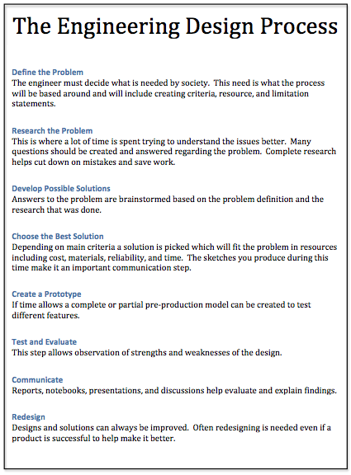
Instructing Concepts: (Pop Goes the CEENBoT)

Engineering Design Process

The Engineering Design Process has many forms. Some conceptual models have as many as ten steps others as few as five. The process is as individual as the engineer who is using it. It is cyclical meaning that you can start at any step in the process and it is dynamic meaning that it is always changing and adapting. For this instructional module we have chosen a simplified five-step approach to the engineering design process. The five steps are: 1) Ask, 2) Imagine, 3) Design, 4) Create, and 5) Improve.

Ask: In this step you ask what is the problem that needs addressed and do a lot of research to see what other ideas are out there and what other solutions have been attempted. This research is critical because it means you won’t duplicate something that others have tried and were unsuccessful. It allows you to frame the problem and limit (constrain) it so that you have a better understanding of what is required.

Imagine: Here you brainstorm ideas that might possibly be a solution to the problem you explored in the Ask step. Don’t be afraid to think big and out of the box. Sometimes if the answer to a problem is obvious or simple it would have been solved already. Get creative! After brainstorming possible ideas and solutions, you should analyze each possibility for potential merit. Finally select the best alternative for further exploration.

Design: This step involves the creation of a plan to carry out the idea that you selected in the Imagine step. You can make a diagram, create lists of things that you will need, and gather together the necessary skills that you will need to carry out your plan.

Create: This is the fun step. You get to actually build/create the idea that you selected and planned out. This is the hands on step where you see the intellectual idea actually come to life. It is important to follow your plan that you created. Be sure to note what went well and what didn’t work for future use in refining the idea. Finally test your product and see if it does what it is supposed to do. Does it solve the problem? It is possible that you will have to go back to any of the previous steps after you test your creation. If it doesn’t work, do you need a better plan, a better idea, or do you need to rethink your initial problem?

Improve: Here is the refinement stage. You have something that works but you want it to be the best it can be. You want the most speed, efficiency, the best appearance, etc. Here you think about and talk about what works, what doesn’t work and what could be improved on. After this discussion occurs, modify your design to see if you can improve it. Finally test out to see if you actually improved your solution or not. Remember at this stage it is possible that you might have to go back to any of the other stages.

The powerful thing about this process is that it is fluid and creates a nice organizational flow for the process to follow. At the end of each step always ask if you accomplished what you set out to do. If you did not repeat that step or go back further in the process to try to arrive at a better solution. Remember you can start at any step but once the process is begun you need to go from one step to another in order for the process to be effective.
Organizing Learning: (Pop Goes the CEENBoT)

Summary: Students will form teams to modify a CEENBoT to pop a stationary balloon. Each team will test and modify their CEENBoT to pop a balloon using the Engineering Design Process.

Outline:
- Students will brainstorm a design attachment to pop a stationary balloon
- Students will select best design and build it
- Teams will test their design
- Using the Engineering Design Process teams will modify their design for round two

Activity: The class will be assigned the task to use the Engineering Design Process to build an attachment for a CEENBoT that will pop a stationary balloon. Each group will go through the design process completely, build, and test their design. After the initial tests, each group will go through the engineering design process again to improve their initial design and retest it. The redesign should be completed even if they were successful at popping the balloon during the first trial. They could be given additional parameters that will force a redesign such as: limited weight, easily removable, limited cost. These types of parameters should help simulate the conditions that a real engineer must satisfy in a design. When the second trial is completed, each group will complete a write-up of the procedure highlight how and when the engineering design process was utilized.
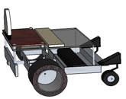
POP
Understanding Learning: (Pop Goes the CEENBoT)

Summary: Students will complete written and performance assessments of the Engineering Design Process. The performance assessment will include drawing and labeling a diagram of the modifications necessary to alter the CEENBoT to scoop balls into a hole or cup.

Outline:
- Formative Assessment of Engineering Design Process
- Summative Assessment of Engineering Design Process

Activity: Students will complete written and performance assessments of the Engineering Design Process.

Formative Assessment: As students are engaged in the lesson ask these or similar questions:
- Did students identify and correctly use the steps of the Engineering Design Process?
- Were students able to correctly apply the Engineering Design Process to the problem in class?
- Did student modifications show logic and use of the Engineering Design Process?

Summative Assessment: Student can complete the following writing prompt:
Explain how your group applied the Engineering Design Process to produce a solution to the problem in class. Why is the Engineering Design Process effective?

Student can complete the following performance assessment: Groups of student will be given the task to use a CEENBoT to scoop balls of various sizes into a hole. The engineering design process must be used with a clear description of what the group did in each step with each step correctly labeled and in the correct order.

