SPIRIT 2.0 Lesson :
That’s A Robot?
==========================Lesson Header ==========================
Lesson Title: That’s A Robot?
Draft Date: 6-3-12
1st Author (Writer): Nancy L. Boyle
Instructional Component Used: Robotics
Grade Level: 4th and 5th Grade

Content (what is taught):
- Robots are defined as a machine which may carry out two or more tasks without human intervention
- Most robots have five main parts
- Robots perform tasks that are dirty, dull, or dangerous to humans

Context (how it is taught):
- Students will draw a robot or use Google-Sketch up to draw a robot. Students will discuss robot traits
- Students will apply new knowledge gained about robots to re-draw their robot and create a commercial about it
Activity Description:
Through viewing the attached power point and discussion students will clarify their understanding about robots. This new information will be used to create a commercial for their robotic invention.

Standards:

Math: MB1, MC4, MB3 Science: SE1

Technology: TA1, TA2, TD2 Engineering: EC3, EC4

Materials List:

- Drawing Paper
- Google-Sketch Up
- Props needed for commercial
- Video Camera
- Crayons or Markers
- Rulers
- Pencils

Asking Questions: (That’s A Robot?)

Summary: Students will produce a KWL chart on what they think a robot is.

Outline:
- Students will draw a robot on the computer or paper
- Teacher creates a KWL chart
- Students brainstorm on what a robot is
- Students will brainstorm robots benefits to society

Activity: Students will draw a robot followed by a discussion of robotics and their benefits to society.

Questions | Answers
How many of you have used a computer today? | Everyone has used a computer today even if you haven’t logged-on. Electric toothbrushes, traffic lights, home heating /cooling systems and all automobiles today use computers.
How many of you have encountered a robot today? | Answers will vary.
What is a robot? | American Institute of Robotics defines a robot as: A reprogrammable, multifunctional manipulator designed to move material, parts, tools, or specialized devices through various programmed motions for the performance of a variety of tasks.
What is the difference between a robot and a machine? | Robots are able to perform a programmed task without human intervention. Machines are not able to do so.
How many robots do I come in contact with in a day? | Student’s answers will vary.
How do robots benefit society? | Student answers will vary.

Resource:
- The Robotics Institute: http://www.ri.cmu.edu/
Exploring Concepts: (That’s A Robot?)

Summary: Students will explore robots and refine their understanding of a robot is and how they are used.

Outline:
- Explore the purposes of a robot to perform dirty, dull, and dangerous jobs and view the attached Power Point
- Discuss things a robot may have in common with other robots. Student may view technical drawing of a robot.
- Discuss the possible benefits of robots to society and create a T-chart

Activity: Teacher may demonstrate real world examples of working robotic toys or robots for students to analyze or students may Google images of working actual robots. Next, students will view a PowerPoint (see attached file: E037_Thats_A_Robot_E_Presentation.ppt) and discuss/refine their concept of a robot. As a summary, a T–chart of pros and cons of robots benefits to society will be constructed and students will brainstorm a list of common characteristics found in robots we explored today in class.

Resource:
http://library.thinkquest.org/COO7O56/data/robotics/parts.html

Attachment:
- E037_Thats_A_Robot_E_Presentation.ppt
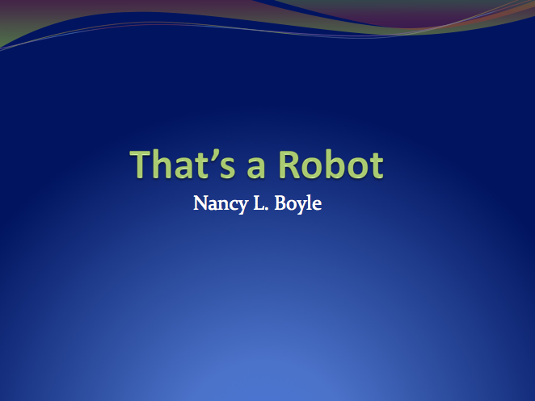
Instructing Concepts: (That’s A Robot?)

Robotics

Robotics is a branch of technology that is concerned with the design, construction, operation, structure, manufacture, and use of robots. The field of robotics encompasses many disciplines including: electronics, engineering, mechanics, mechatronics, and computers (hardware and software).

Main Parts of a Robot
Arm – This is a critical part of the robot. It allows the robot to manipulate its environment by controlling the end effector (hand). Robotic arms tend to resemble human arms and model human arms movements using seven degrees of freedom. The seven degrees of freedom are: shoulder pitch (up and down shoulder movement), arm yaw (side to side arm movement), shoulder roll (arm rotation from the shoulder), elbow pitch (bending of elbow), wrist pitch (bending wrist), and wrist roll (rotating the wrist). Simple robotic arms usually have three degrees of freedom with more complex robots having more or all of them.

Controller – The brain of the robot, which is usually some aspect of a computer. It networks (connects) the systems of the robot so that they can function together and allowing very complex tasks to be completed. Many modern controllers have strived to attain a level of artificial intelligence (AI). AI allows for a robot to think and react for itself without having to be prompted or programmed to do so.

Drive – The engine of the robot, which allows for mobility of the robot and the movements of the joints. The drive can be powered by pneumatic, electrical, mechanical, radioactive or fluidic means.

End Effector – The “hand” of the robot. It can be a like a human hand or it can be a blowtorch, pincher, saw or any other appropriate tool.

Sensor – These provide feedback to the robot so that it can make judgments about its surroundings. Common sensors include but are not limited to: cameras, range finders, and sonar devices.

History and Uses of Robots
Robotics and the idea of robots have fascinated man for thousands of years. As far back as the third century BCE, the idea of a robot (automaton) was conceived. Recently, the word robot was integrated into our culture by Isaac Asimov in his books. Norbert Wiener formulated the laws of cybernetics, which provide the practical basis for robotics, in 1948. Fully autonomous robots have only appeared in the last 50 years and have found widespread use in manufacturing and exploration of environments that are to harsh for human existence. Commercial and industrial robots perform jobs more cheaply, accurately and reliably than humans. Robots are also employed in jobs that are to dirty, dangerous or dull to be suitable for humans. Robots are widely used in manufacturing, assembly, packing and packaging, transport, earth and space exploration, surgery, weaponry, laboratory research, safety, and the mass production of consumer and industrial goods.
Organizing Learning: (That’s A Robot?)

Summary: Students will design a robot that has a specific purpose and contribution to society.

Outline:
- Students will be instructed to design a robot with a specific function and benefit
- Students present their project to the class including what they learned about robotics

Activity: Students will be divided into groups and assigned the task to design a robot that has a specific function and benefit to society. The design should include a detailed drawing of what the robot will look like (remember not all robots are humanoid looking). The purpose and benefit to society should be explained as well as parts that would need to be included in the robot to perform its function. After the groups have completed their design, they will present and explain the final results to the class. Part of the explanation should include new knowledge of “what a robot is” that they learned as part of the lesson.
Understanding Learning: (That’s A Robot?)

Summary: Using new information gained, students will create a commercial explaining what they learned in the robotics lesson.

Outline:
- Formative Assessment of Robotics
- Summative Assessment of Robotics

Activity: Students will complete written and performance assessments on robotics.

Formative Assessment: As students are engaged in the lesson ask these or similar questions:
- Did students gain a new understanding of robots and what robots are?
- Can students identify the function of a robot given a picture?
- Did students’ drawing depict a robot that was well thought out?
- Does student drawing reflect discussion points?

Summative Assessment: Students can complete the following writing prompt:
Pick a robot that you have interacted with in some way recently. Give a detailed description of the robot and explain the robot’s purpose. Your description should reflect evidence of learning including the five main parts of a robot.

Students can complete one of the following performance assessments:
- Students will create an advertisement about the robot they have interacted with or designed. The advertisement can be any form of media presentation and should include why/how you would use this robot and its benefit to society.
- Students will redesign a robot that they have seen in the past for a new purpose. The student should include the new purpose and detailed description or their robot and should reflect evidence of learning including the five main parts of a robot. The final product should be a student created poster which can be displayed to the class. For a sample poster rubric see attached file: E037_Thats_A_Robot_U_Rubric.xls

Attachment:
- E037_Thats_A_Robot_U_Rubric.xls
