SHINE Lesson:
Burning Down the House
==========================Lesson Header ==========================
Lesson Title: Burning Down the House
Draft Date: 6/10/12
1st Author (Writer): Jess Eckman
This Teacher was mentored by:
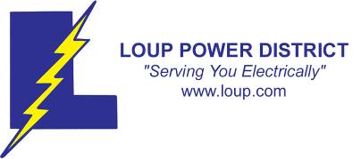
www.loup.com

In partnership with Project SHINE grant funded through the

National Science Foundation
2nd Author (Editor/Resource Finder): Loup Power
Instructional Component Used: Safety
Grade Level: 6-8

Content (what is taught):
- Laboratory Safety
- Laboratory Expectations

Context (how it is taught):
- Laboratory Record Sheet
- Laboratory Expectations Study Guide and Quiz
- Laboratory Self-Assessment
Activity Description:
In this lesson, students will observe unsafe behavior and define safety, create a skit about lab safety, complete a lab safety sheet while doing a cooking lab, and complete a self-assessment and lab expectation quiz.

Standards:

Math: ME1 Science: SF4

Technology: TB4 Engineering: ED3

Materials List:
- Laboratory Expectations Sheet
- Laboratory Self-Assessment
- Laboratory Safety Record Sheet
Asking Questions: (Burning Down the House)

Summary: Students will observe and discuss what safety means and when it is required.

Outline:
- Students will observe a safety demonstration dealing with scissors
- Students will discuss safety and situations that require extra caution

Activity: The instructor will give a demonstration on “what not to do” when using a pair of scissors. Examples: running, carrying blade up, waving them around, drop near open toed shoes, etc. A class discussion will follow where students will talk about safety and where it is required. While the instructor is giving the demonstration, students are encouraged to shout out safety problems that they observe.

Questions | Answers
What does it mean to be “safe”? | Answers will vary
What situations in daily life require extra attention to safety? | Answers will vary
What or where are potential dangers in the kitchen? | Answers will vary
Can you think of a time you were injured in the kitchen? | Answers will vary
How can we avoid kitchen accidents? | Answers will vary
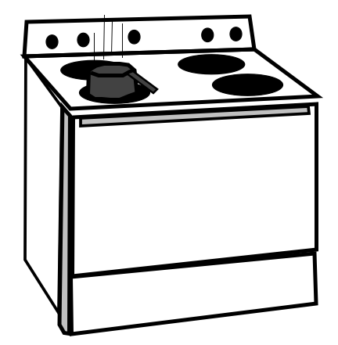
Exploring Concepts: (Burning Down the House)

Summary: Students will be given the lab expectations and create a skit with their lab groups to demonstrate the expectations.

Outline:
- Students will receive and discuss the lab expectations handout and parent contract
- Students will meet with their lab group and assigned a specific lab expectation. They will then be asked to create a skit of “what not to do” for their expectation
- Classmates will record things they see in each skit that do not meet the lab expectations

Activity: Students will be given the lab expectations handout, which is also the study guide for the lab expectations quiz. The lab expectations parent contract will also be distributed and needs to be returned by the next class. Students will break into assigned lab groups they will be working with for the quarter. Each group will be assigned a lab expectation and be asked to create a 2-3 minute skit demonstrating “what not to do” in lab settings based on their specific assigned expectation. While the skits are performed, students in the audience will identify and record the expectation is not being met.

Attachments:
- Lab Expectations: E041_SHINE_Burning_Down_the_House_E_Expectations.doc
- Parent Contract: E041_SHINE_Burning_Down_the_House_E_Parent.doc
Instructing Concepts: (Burning Down the House)

Laboratory Safety
There are several safety categories to consider when working in a classroom or in a business. The following are generalizations and not likely to be a complete list.

Biological Safety: A very broad safety area involving the proper procedures for handling living organisms or material from living organisms such as human body fluids or bacteria.

Eye Protection: Safety goggles are a must if handling chemicals, heating materials, or projectile hazards. Also, it is best if contact lenses are not worn as chemicals or particles can get between the lens and the eye causing damage.

Chemical Safety: There are many facets to chemical safety. Ultimately, handling the chemicals properly according to the Material Data Safety Sheets (MSDS) will cover any topic. (e.g. storage, usage, disposal, flammables, corrosives, pressurized gas, carcinogens, toxins, irritants)

Clothing Requirements: For personal protection, lab aprons, lab coats, closed-toed shoes, long skirts/ pants, or long sleeves can be worn. Avoid wearing nylon and polyester fabrics as they burn or melt more easily than cotton fabrics. It is also important to tie back hair or remove jewelry, ties, and watches as they may react with certain chemicals or easily catch on fire.

Glassware Safety: Glassware overall should be maintained in good condition without chips or cracks as well as clean. This avoids the shattering of glass while being heated as well as unwanted chemical reactions. Also, if glassware does break it should be properly placed in a glass disposal box.

Heating Safety: Whatever type of equipment used for heating, it is important to keep flammable items away as well as use correct safety procedures to avoid burns.

Hand Safety: Wear protective gloves when working with chemicals, use a hot mitt or tongs when handing heating equipment.

Hygiene Care: Keep hands away from the face and mouth while working as well as wash hands thoroughly before leaving the work area. Eating, drinking, chewing gum, and applying cosmetics are not allowed within a work area especially one where chemicals are being used.

Safety or Emergency Equipment: In work areas, participants should know the emergency procedures, evacuation routes, location of safety equipment, and how to use the safety equipment. (e.g. eyewash stations, gas shut off valves, fire extinguishers, fire blankets, safety showers, respirators, fume hoods)

Waste Disposal: Follow proper waste disposal to protect by-standers as well as the environment.

Work Area: Work areas should be clean and free of clutter to assist in maintaining safety.
Organizing Learning: (Burning Down the House)

Summary: Students will go through a lab and complete a lab safety sheet much like the one used by Loup Power.

Outline:
- Lab instructions and safety review will occur first
- The lab group’s group leader and group member jobs will be determined
- Students will complete lab jobs and report back to the group leader
- Group leaders will double check jobs and record completion and safety information

Activity: During the first lab, lab instructions and directions will come first. During the lab, students will complete a safety record sheet much like the one used by Loup Power District (see attached file: E041_SHINE_Burning_Down_the_House_O_Loop_Switching_Order.xls). One group member from each group will be assigned to act as “group leader”. Each lab a different student will get the opportunity to be the group leader. The recipe the class is making will be divided up into “jobs”, the remaining group members will each be assigned a job from the recipe they are responsible for. When a job is completed, that student will report to the group leader and inform them of the completed task. Next, the group leader will double check that the task was completed with proficiency. The group member’s name, task, time stamp, and safety information will be recorded on the safety record sheet. The safety portion of the safety record sheet has a column where students will answer, “was the task completed safely?” and “if not, why?”. These questions will be the focus of discussion after the lab is completed.

Attachments:
- Lab Safety Record: E041_SHINE_Burning_Down_the_House_O_Safety_Record.doc
- Loup Lower Switching Order Record: E041_SHINE_Burning_Down_the_House_O_Loop_Switching_Order.xls
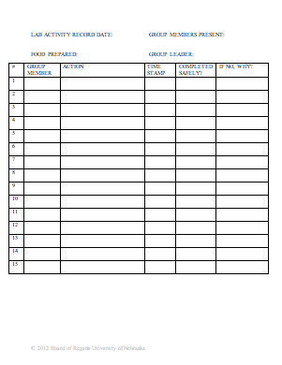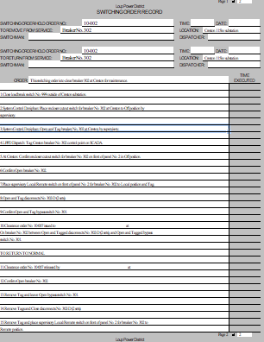

Understanding Learning: (Burning Down the House)

Summary: Students will submit the lab safety record, complete a self-assessment, and take a lab expectation quiz.

Outline:
- Formative Assessment of Laboratory Safety
- Summative Assessment of Laboratory Safety

Activity: Students will complete written and quiz assessments related to laboratory safety.

Formative Assessment: As students are engaged in the lesson ask these or similar questions:
- Are students participating in discussion about the scissors demonstration?
- Are students engaged in discussion about what safety is?
- Are all students included in the “what not to do” skits?
- During the lab, are students reporting to their group leader?
- Is the group leader recording job completion and safety compliance?

Summative Assessment: Students can complete the following writing prompt.
Explain how safety relates to cooking labs done in the kitchen and why safety is so critical.

Students can complete the following quiz:
Students will take a lab expectations quiz concerning safety. They will also complete a lab self-assessment, which covers many aspects of lab expectations and safety features. In the self assessment, students will answer a quantitative Likert scale 1-5 of how they feel they did on each topic. Students will also explain their answer to fulfill a qualitative component to the self-assessment. The self-assessment will not be graded on the numbers the students’ circle, but on their reflection. If a student knows and can explain what they would do differently in the future, they have learned from the lab.

Attachments:
- Lab safety quiz: E041_SHINE_Burning_Down_the_House_U_Expectations_Quiz.doc
- Self assessment quiz: E041_SHINE_Burning_Down_the_House_U_Self_Assessment.doc
