M015: Compound Inequalities
Answers: 1. A, 2. B, 3. D

1. Pat said that the amount of money he has in his pocket is greater than or equal to $5.75 but less than $13.00. Which number line shows the amount of money Pay might have?

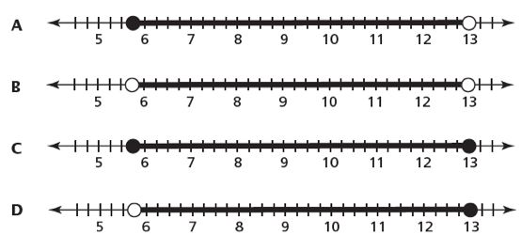

Source: New York State Testing Grade 8, 2005

2. Weather records in a city show the coldest recorded temperature was and the hottest was . Which of the following number line graphs represents the range of recorded actual temperatures in this city?
A.
B.
C.
D.
E.

Source: National Association of Educational Progress Question Summary

3. Hank sells toy cars on a web site. The web site fee is $30. Hank sells each toy car for $4. What inequality does Hank use to determine how many toy cars, c, he must sell to make a profit of at least $50?

A.
B.
C.
D.

Source: New York State Testing Grade 8, 2005

