M002: Linear Functions
Answers: 1. A, 2. C, 3. A
1. The slope of a line is 13. The line contains the point (6, 5). Which of the following are the coordinates of another point on the line?

A. | (3, 4) |  | B. | (3, 6)
C. | (7, 2) |  | D. | (7, 8)

Source: MCAS: 2009, Mathematics - Grade 10
http://www.doe.mass.edu/mcas/testitems.html

2. A line is shown on the coordinate grid below. Which of the following best represents an equation of this line?
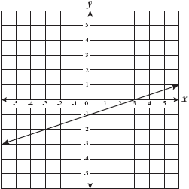

A. |  |  | B.
C. |  |  | D.

Source: MCAS: 2006, Mathematics - Grade 10
http://www.doe.mass.edu/mcas/testitems.html

3. A city planner created the table below to show the total number of seats for different numbers of subway cars.
Seats on Subway Cars
Number of Subway Cars | 6 | 8 | 10 | 12
Total Number of Seats | 180 | 240 | 300 | 360

Which of the following represents the relationship between x, the number of subway cars, and y, the total number of seats, for the data in the table?

A. |  |  | B.
C. |  |  | D.

Source: MCAS: 2006, Mathematics - Grade 8
http://www.doe.mass.edu/mcas/testitems.html

