M005: Pythagorean Theorem
Answers: 1. A, 2. B, 3. B

1. The diagram below shows a triangle and some of its dimensions.
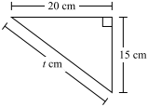
What is the value of t?
A. | 25 | B. | 30
C. | 35 | D. | 40
Source: MCAS: 2010, Mathematics - Grade 10
http://www.doe.mass.edu/mcas/testitems.html

2. The diagram below shows the dimensions of a rectangular field.
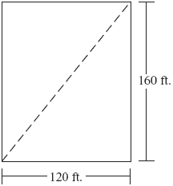
What is the length of a diagonal of the field?
A. | 120 ft. | B. | 200 ft.
C. | 394 ft. | D. | 520 ft.
Source: MCAS: 2006, Mathematics - Grade 8
http://www.doe.mass.edu/mcas/testitems.html

3. The roads connecting the three towns on the map below form a right triangle. Two of the distances are given.
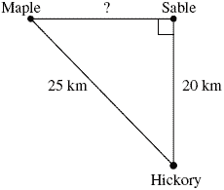
Based on the distances given on the map, what is the distance between Maple and Sable?
A. | 12 km | B. | 15 km
C. | 16 km | D. | 19 km
Source: MCAS: 2005, Mathematics - Grade 8
http://www.doe.mass.edu/mcas/testitems.htmls

