M005: Quadratic Functions
Answers: 1. C, 2. C, 3. A

1. Which quadratic equation has the roots 3 + i and 3 – i?

A.
B.
C.
D.

Source: University of the State of New York, Regents High School Examination: Mathematics B, January 2007
http://www.nysedregents.org/MathematicsB/200700126exam.pdf

2) The solution to the equation is?
A. | 0 only
B. | 6 only
C. | 0 and 6
D.

Source: University of the State of New York, Regents High School Examination: Integrated Algebra, August 2009
http://www.nysedregents.org/IntegratedAlgebra/20090813examw.pdf

3) What are the vertex and axis of symmetry of the parabola shown in the diagram below?
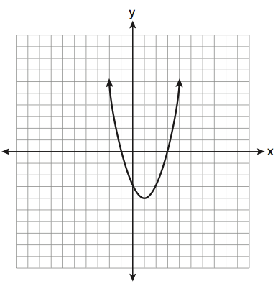

A. | Vertex (1, -4); axis of symmetry; x = 1
B. | Vertex (1, -4); axis of symmetry; x = -4
C. | Vertex (-4, 1); axis of symmetry; x = 1
D. | Vertex (-4, 1); axis of symmetry; x = -4
Source: University of the State of New York, Regents High School Examination: Integrated Algebra, June 2010
http://www.nysedregents.org/IntegratedAlgebra/20100618exam.pdf

