M009: Slope
Answers: 1. D, 2. C, 3. B

1. A line is shown on the coordinate grid below.
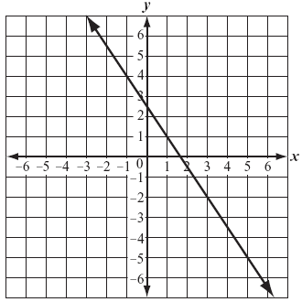
Which of the following best represents the slope of the line?
A. |  |  | B.
C. |  |  | D.

Source: MCAS: 2009, Mathematics - Grade 10
http://www.doe.mass.edu/mcas/testitems.html

2. What is the slope of the line represented by the table of values on the right?  Source: MCAS: 2008, Mathematics - Grade 8  http://www.doe.mass.edu/mcas/testitems.html
  A. | 2 |  | B. | 3
  C. | 10 |  | D. | 20
  x | y
  0 | -20
  1 | -10
  2 | 0
  3 | 30

3. The graph below shows the distance an airplane traveled over time.
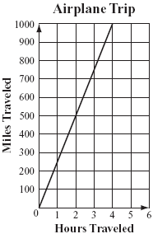
Which of the following is closet to the average speed of the airplane?
A. | 100 miles per hour | B. | 250 miles per hour
C. | 500 miles per hour | D. | 1000 miles per hour

Source: MCAS: 2007, Mathematics - Grade 8
http://www.doe.mass.edu/mcas/testitems.html

