M001: Direct Variation
Answers: 1. D, 2. B, 3. B

1) It takes Tammy 45 minutes to ride her bike 5 miles. At this rate, how long will it take her to ride 8 miles?

A. | 0.89 hour
B. | 1.125 hours
C. | 48 minutes
D. | 72 minutes

Source: University of the State of New York, Regents High School Examination: Integrated Algebra, June 2009
http://www.nysedregents.org/IntegratedAlgebra/20090619exam.pdf

2) If x varies directly as y, and x = 8 when y = 24, what is the value of x when y = 6?
A. | 1
B. | 2
C. | 3
D. | 4
Source: University of the State of New York, Regents High School Examination: Mathematics A, January 2007
http://nysl.nysed.gov/uhtbin/cgisirsi/TJtQgi3Sje/NYSL/107870035/523/76989

3) Which table does not show an example of direct variation?

A. | 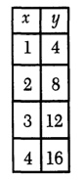 |  | B. | 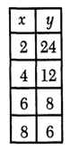
C. | 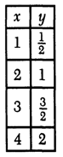 |  | D. | 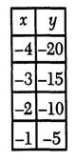
Source: University of the State of New York, Regents High School Examination: Mathematics A, August 2000
http://nysl.nysed.gov/uhtbin/cgisirsi/bEfPJ53TIb/NYSL/107870035/523/48672

