M010: Trigonometric Functions
Answers: 1. B, 2.B, 3. C

1) Right triangle ABC has legs of 8 and 15 and a hypotenuse of 17, as shown in the diagram below. The value of the tangent of is?
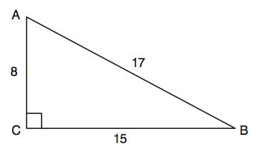
A. | 0.4706 |  | B. | 0.5333
C. | 0.8824 |  | D. | 1.8750
Source: University of the State of New York, Regents High School Examination: Integrated Algebra, August 2010
http://www.nysedregents.org/IntegratedAlgebra/20100818-ia-exam.pdf

2) The center pole of a tent is 8 feet long, and a side of the tent is 12 feet long as shown in the diagram below. If a right angle is formed where the center pole meets the ground, what is the measure of angle A to the nearest degree?
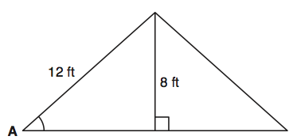
A. | 34 |  | B. | 42
C. | 38 |  | D. | 56
Source: University of the State of New York, Regents High School Examination: Integrated Algebra, June 2008
http://www.nysedregents.org/IntegratedAlgebra/20080617exam.pdf

3) Which equation shows a correct trigonometric ratio for angle A in the right triangle below?
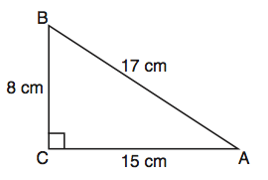
A. |  |  | B.
C. |  |  | D.
Source: University of the State of New York, Regents High School Examination: Integrated Algebra, January 2010
http://www.nysedregents.org/IntegratedAlgebra/20100128exam.pdf

