M018: Central Tendency
Answers: 1. C, 2. D, 3. D

1. The table below shows the average depth of each of the five deepest oceans and seas in the world.
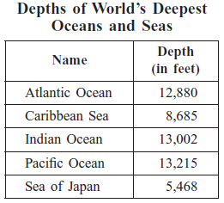
What is the median depth of these five oceans and seas?
A. 13,215 feet
B. 13,002 feet
C. 12,880 feet
D. 10,650 feet

2. Sina’s goal is to exercise a mean of 45 minutes per day for one week. For the first 6 days of the week, she exercised 35, 40, 37, 42, 45, and 50 minutes. What is the number of minutes Sina must exercise on the 7th day of the week to reach her goal exactly?
A. 21 minutes
B. 42 minutes
C. 49 minutes
D. 66 minutes

3. Jiro bowled 7 games in a tournament. The list below shows his scores for those 7 games.
149, 160, 180, 155, 160, 137, 158
What is the mode of Jiro’s scores?
A. 155
B. 157
C. 158
D. 160

Source: MCAS: 2006, Mathematics - Grade 7
http://www.doe.mass.edu/mcas/testitems.html

