M020: Best Fit Curves
Answers: 1. A, 2. B, 3. B
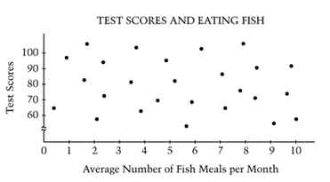
1. For a science project, Marsha made the scatterplot above that gives the test scores for the students in her math class and the corresponding average number of fish meals per month. According to the scatterplot, what is the relationship between test scores and the average number of fish meals per month?
A. | There appears to be no relationship.
B. | Students who eat fish more often score higher on tests.
C. | Students who eat fish more often score lower on tests.
D. | Students who eat fish 4-6 times per month score higher on tests than those who do not eat fish that often.
E. | Students who eat fish 7 times per month score lower on tests than those who do not eat fish that often.
Source: National Association of Educational Progress Question Summary

2. Mr. Thomas wanted to know if the amount of class time that he gave students to study affected their test scores. The scatter plot below shows the results. What kind of relationship between class study time and test scores is shown on the scatter plot?

 | 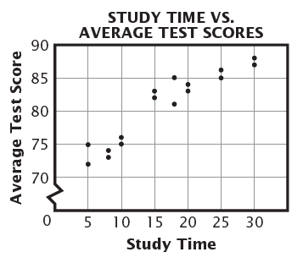
  A. | No correlation.
  B. | Positive correlation.
  C. | Negative correlation.
  D. | Positive and then negative correlation.
Source: Missouri Assessment Program Spring 2006: Mathematics Released Items Grade 8

3. Susan surveyed students to find the amount of time they spent reading and watching TV last week. The scatter plot below shows the results of her survey. According to the data in the scatter plot, how many hours of reading would you expect from a student who watches 6 hours of TV each week?
 | 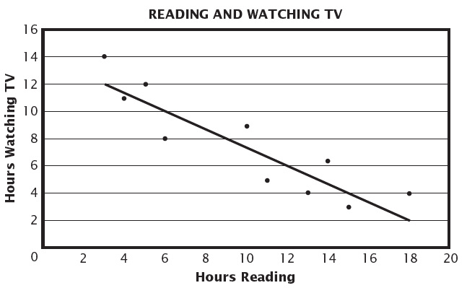
  A. | 8 hours
  B. | 10 hours
  C. | 12 hours
  D. | 14 hours
Source: Missouri Assessment Program Spring 2006: Mathematics Released Items Grade 8

