M027: Inverse Variation
Answers: 1. B, 2. B, 3. B

1. Tracy, a political campaign organizer, realizes that the number of hours needed to get out a mailing for her candidate is inversely proportional to the number of campaign workers she has. If she uses the information in the accompanying graph, how many hours would it take to do the mailing if 125 workers are used?
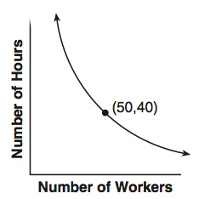
A. | 12 |  | B. | 16
C. | 20 |  | D. | 24
Source: University of the State of New York, Regents High School Examination: Mathematics B, June 2010
http://www.nysedregents.org/MathematicsB/20100615exam.pdf

2) If R is inversely proportional to A, and R = 4 when A = 100, what is the value of R when A = 250?
A. | 0.625 |  | B. | 1.6
C. | 10 |  | D. | 6,250
Source: University of the State of New York, Regents High School Examination: Mathematics B, January 2010
http://www.nysedregents.org/MathematicsB/20100126exam.pdf

3) Jack is driving from New York to Florida. The number of hours that he drives and the speed at which he drives are inversely proportional. Which graph could be used to describe this situation if one axis represents speed and the other represents hours?
A. | 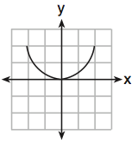 |  | B. | 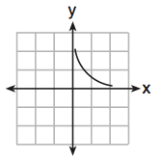
C. | 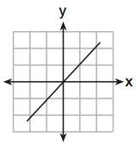 |  | D. | 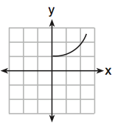
Source: University of the State of New York, Regents High School Examination: Mathematics B, August 2009
http://www.nysedregents.org/MathematicsB/20090813exam.pdf

