M030: Circles
Answers: 1. B, 2. A, 3. A

1. The top of an office desk is in the shape of a semicircle, as shown in the figure below. Based on the dimension given in the figure, which of the following is closest to the area of the top of the office desk? (Use 3.14 for π.)
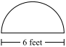

A. | 9.42 square feet |  | B. | 14.13 square feet
C. | 18.84 square feet |  | D. | 56.52 square feet

Source: 2010, Mathematics - Grade 7
http://www.doe.mass.edu/mcas/testitems.html

2. Callie makes wedding cakes with circular bases. She made a large cake with a radius of 12 inches and a small cake with a radius of 6 inches, as shown below. Which of the following statements correctly compares the circumferences of the bases of the two cakes?

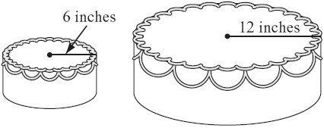

A. | The circumference of the base of the large cake is 2 times that of the small cake.
B. | The circumference of the base of the large cake is 4 times that of the small cake.
C. | The circumference of the base of the large cake is 6 times that of the small cake.
D. | The circumference of the base of the large cake is 8 times that of the small cake.

Source: 2009, Mathematics - Grade 8
http://www.doe.mass.edu/mcas/testitems.html

3. The circumference of Sophie’s circular flower garden is 75 feet. Which of the following is closest to the diameter of her flower garden?
A. | 24 feet |  | B. | 12 feet
C. | 10 feet |  | D. | 5 feet

Source: 2008, Mathematics - Grade 10
http://www.doe.mass.edu/mcas/testitems.html

