M031: Volume
Answers: 1. B, 2. D, 3. A

1. Casey has a cylindrical container with an inside diameter of 6 inches. He filled it with water to a depth of 4 inches, as shown below. To the nearest cubic inch, what is the volume of water in Casey’s container? (Use 3.14 for p.)
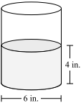
A. | 75 cubic inches |  | B. | 113 cubic inches
C. | 151 cubic inches |  | D. | 452 cubic inches

Source: MCAS: 2010, Mathematics - Grade 7
http://www.doe.mass.edu/mcas/testitems.html

2. The diagram below shows a right rectangular prism that is 7 inches wide, 12 inches long, and 4 inches high. What is the volume, in cubic inches, of the prisim?
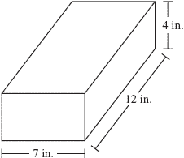
A. | 152 |  | B. | 184
C. | 320 |  | D. | 336

Source: MCAS: 2010, Mathematics - Grade 10
http://www.doe.mass.edu/mcas/testitems.html

3. An artist carved a sphere out of stone. The radius of the sphere is 0.93 meter. Which of the following is closest to the volume of the sphere?

A. | 3.37 m³ |  | B. | 3.62 m³
C. | 10.11 m³ |  | D. | 11.69 m³

Source: MCAS: 2007, Mathematics - Grade 10
http://www.doe.mass.edu/mcas/testitems.html

