M032: Displays of Data
Answers: 1. D, 2. X, 3. X

1) The accompanying diagram is an example of which type of graph?
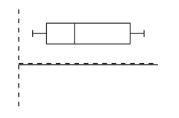

A. | Bar graph
B. | Stem-and-leaf plot
C. | Histogram
D. | Box-and-whisker plot

Source: University of the State of New York, Regents High School Examination: Mathematics A, June 2002
http://nysl.nysed.gov/uhtbin/cgisirsi/trm6JWlFJl/NYSL/107870035/523/48677

