M033: Exponential Functions
Answers: 1. C, 2. A, 3. A

1. The family of curves shown in the accompanying graph illustrates the transformation of a function. Which type of function could be the original function?
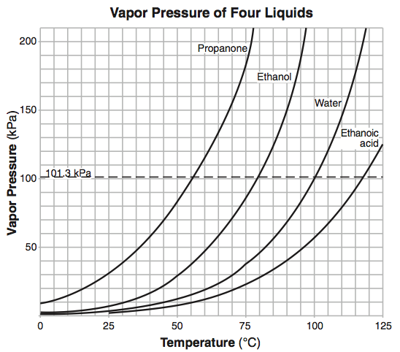
A. | Linear |  | B. | Tangent
C. | Exponential |  | D. | Sinusoidal
Source: University of the State of New York, Regents High School Examination: Mathematics B, August 2008
http://www.nysedregents.org/MathematicsB/20080813exam.pdf

2) Which type of function could be used to model the data shown in the accompanying graph?
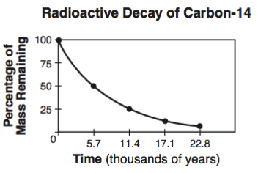
A. | Exponential |  | B. | Quadratic
C. | Trigonometric |  | D. | Linear
Source: University of the State of New York, Regents High School Examination: Mathematics B, August 2007
http://www.nysedregents.org/MathematicsB/200700816exam.pdf

3) Which equation best represents the accompanying graph?
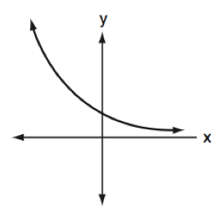
A. |  |  | B.
C. |  |  | D.
Source: University of the State of New York, Regents High School Examination: Mathematics B, January 2007
http://www.nysedregents.org/MathematicsB/200700126exam.pdf

