M034: Perimeter
Answers: 1. C, 2. B, 3. D

1. A polygon and expressions representing its dimensions, in meters, are shown below. Which of the following represents the perimeter, in meters, of the polygon?
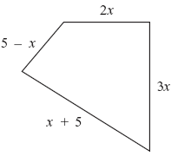

A. | 5x |  | B. | 15x
C. | 5x + 10 |  | D. | 7x + 10
Source: 2008, Mathematics - Grade 10
http://www.doe.mass.edu/mcas/testitems.html

2. The perimeter of the parallelogram shown below is 24 inches. Based on the given dimensions of the parallelogram, what is the length of side SR?
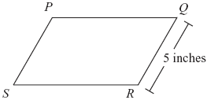

A. | 4.8 inches |  | B. | 7 inches
C. | 9 inches |  | D. | 9.5 inches
Source: 2008, Mathematics - Grade 7
http://www.doe.mass.edu/mcas/testitems.html

3. What is the perimeter of a regular pentagon with a side whose length is x + 4?

A. |  |  | B.
C. |  |  | D.
Source: University of the State of New York, Regents High School Examination: Integrated Algebra, August 2010
http://www.nysedregents.org/IntegratedAlgebra/20100818-ia-exam.pdf

