Circles

A circle is defined to be the set of all points in a plane equidistant from a point called the center. Thus to define a circle you must have a point (center) and a distance from the center (radius).

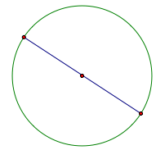 | Diameter – A chord of a circle that contains the center. Note a diameter is the longest chord.
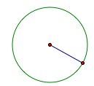 | Radius – distance from the center to the circle. Note: Diameter = 2 radii
Distance “around” the circle | Circumference =
Portion of the circumference  with a central angle of m degrees | Arc length =
 | Area =
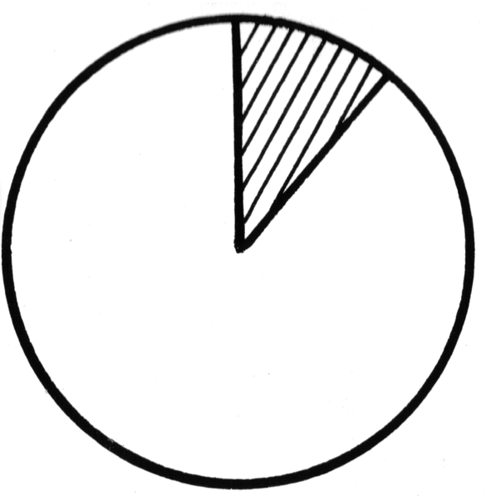 | A_{sector} =
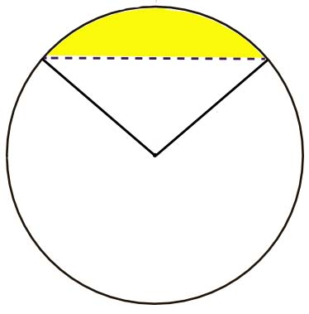 | A_{segment} = A_{sector} – Area Triangle
 | Measure central angle = measure subtended arc.
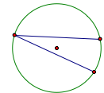 | m(inscribed angle) =
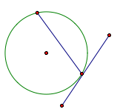 | m(tangent/chord angle) =
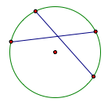 | m(chord/chord angle) = (sum of the intercepted arcs)
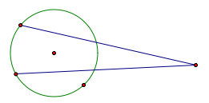 | m(secant/secant) = (difference of the intercepted arcs)

