Surface Area and Volume of right solids with regular bases
Surface Area: The measure of how much exposed area a solid object has, expressed in square units.
Volume: How much three-dimensional space a shape occupies or contains, expressed in cubic units.

These formulas apply to right solids. If the solid is oblique it is much more difficult to find the SA and V. If the base is not regular these formulas apply but the LA is more difficult to find. You have to find the area of each face separately and add them together.
Right prism with base  regular polygon  Surface Area = LA + 2 BA  Volume = BA * h | 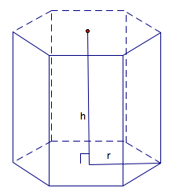 | BA = base area  LA = lateral area = perimeter base*h  h = height
Note: If the prism is rectangular then:
V =
Note: If the prism is a cube then:
SA = and V =
Right Pyramid with base regular polygon  SA = LA + BA  Volume = BA * h | 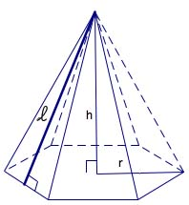 | BA = base area  LA=lateral area =  h = height  = slant height
Right Cylinder  Surface Area = 2 BA + LA  Volume = | 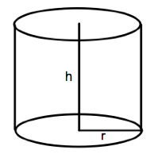 | BA = base area =  LA = lateral area =  r = radius of base  h = height
Right Cone  Surface Area = LA + BA  Volume = | 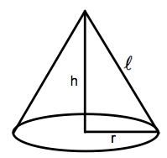 | BA = base area =  LA= lateral area =  r = radius  = slant height  h = height
Sphere  Surface Area =  Volume = | 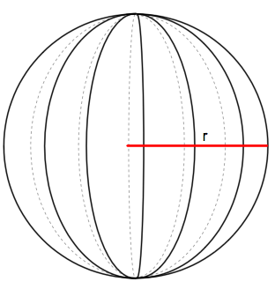 | r = radius

